1. [Roman to Integer](https://leetcode.com/problems/roman-to-integer/)

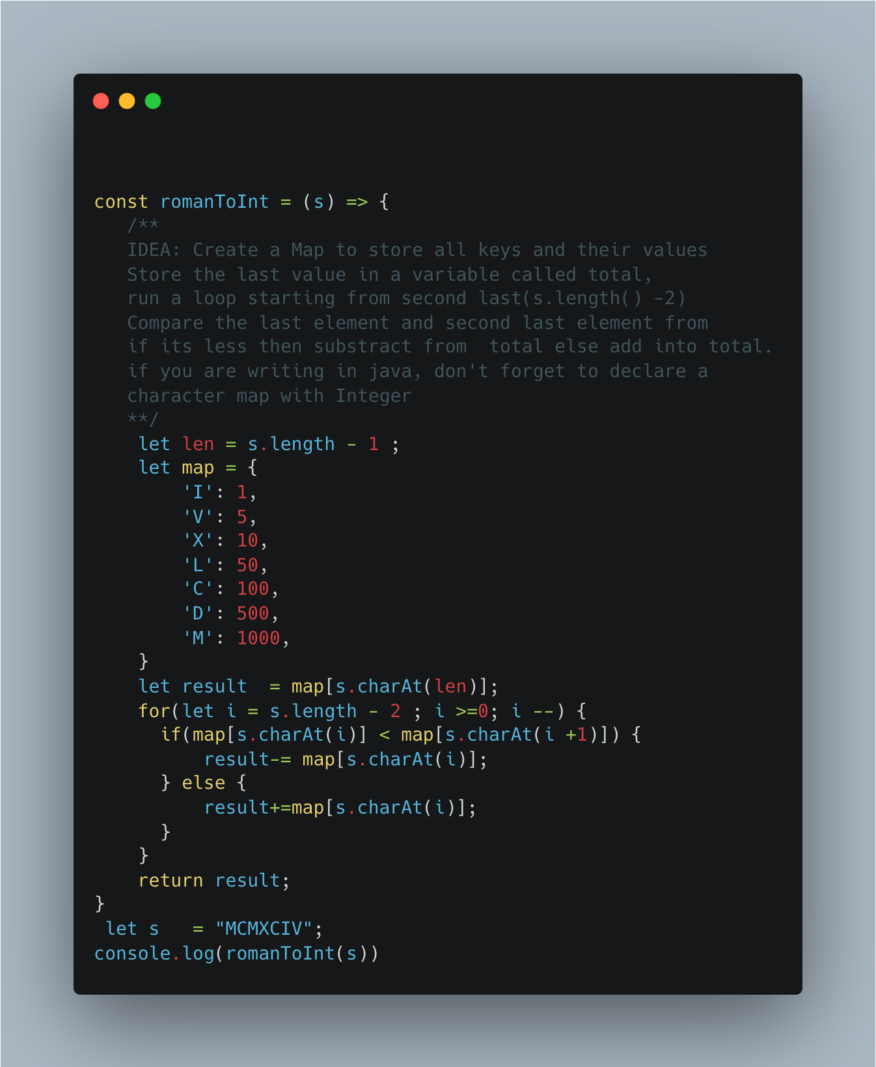

1. Merge Sort Top Down – [Sort an array](https://leetcode.com/problems/sort-an-array/)

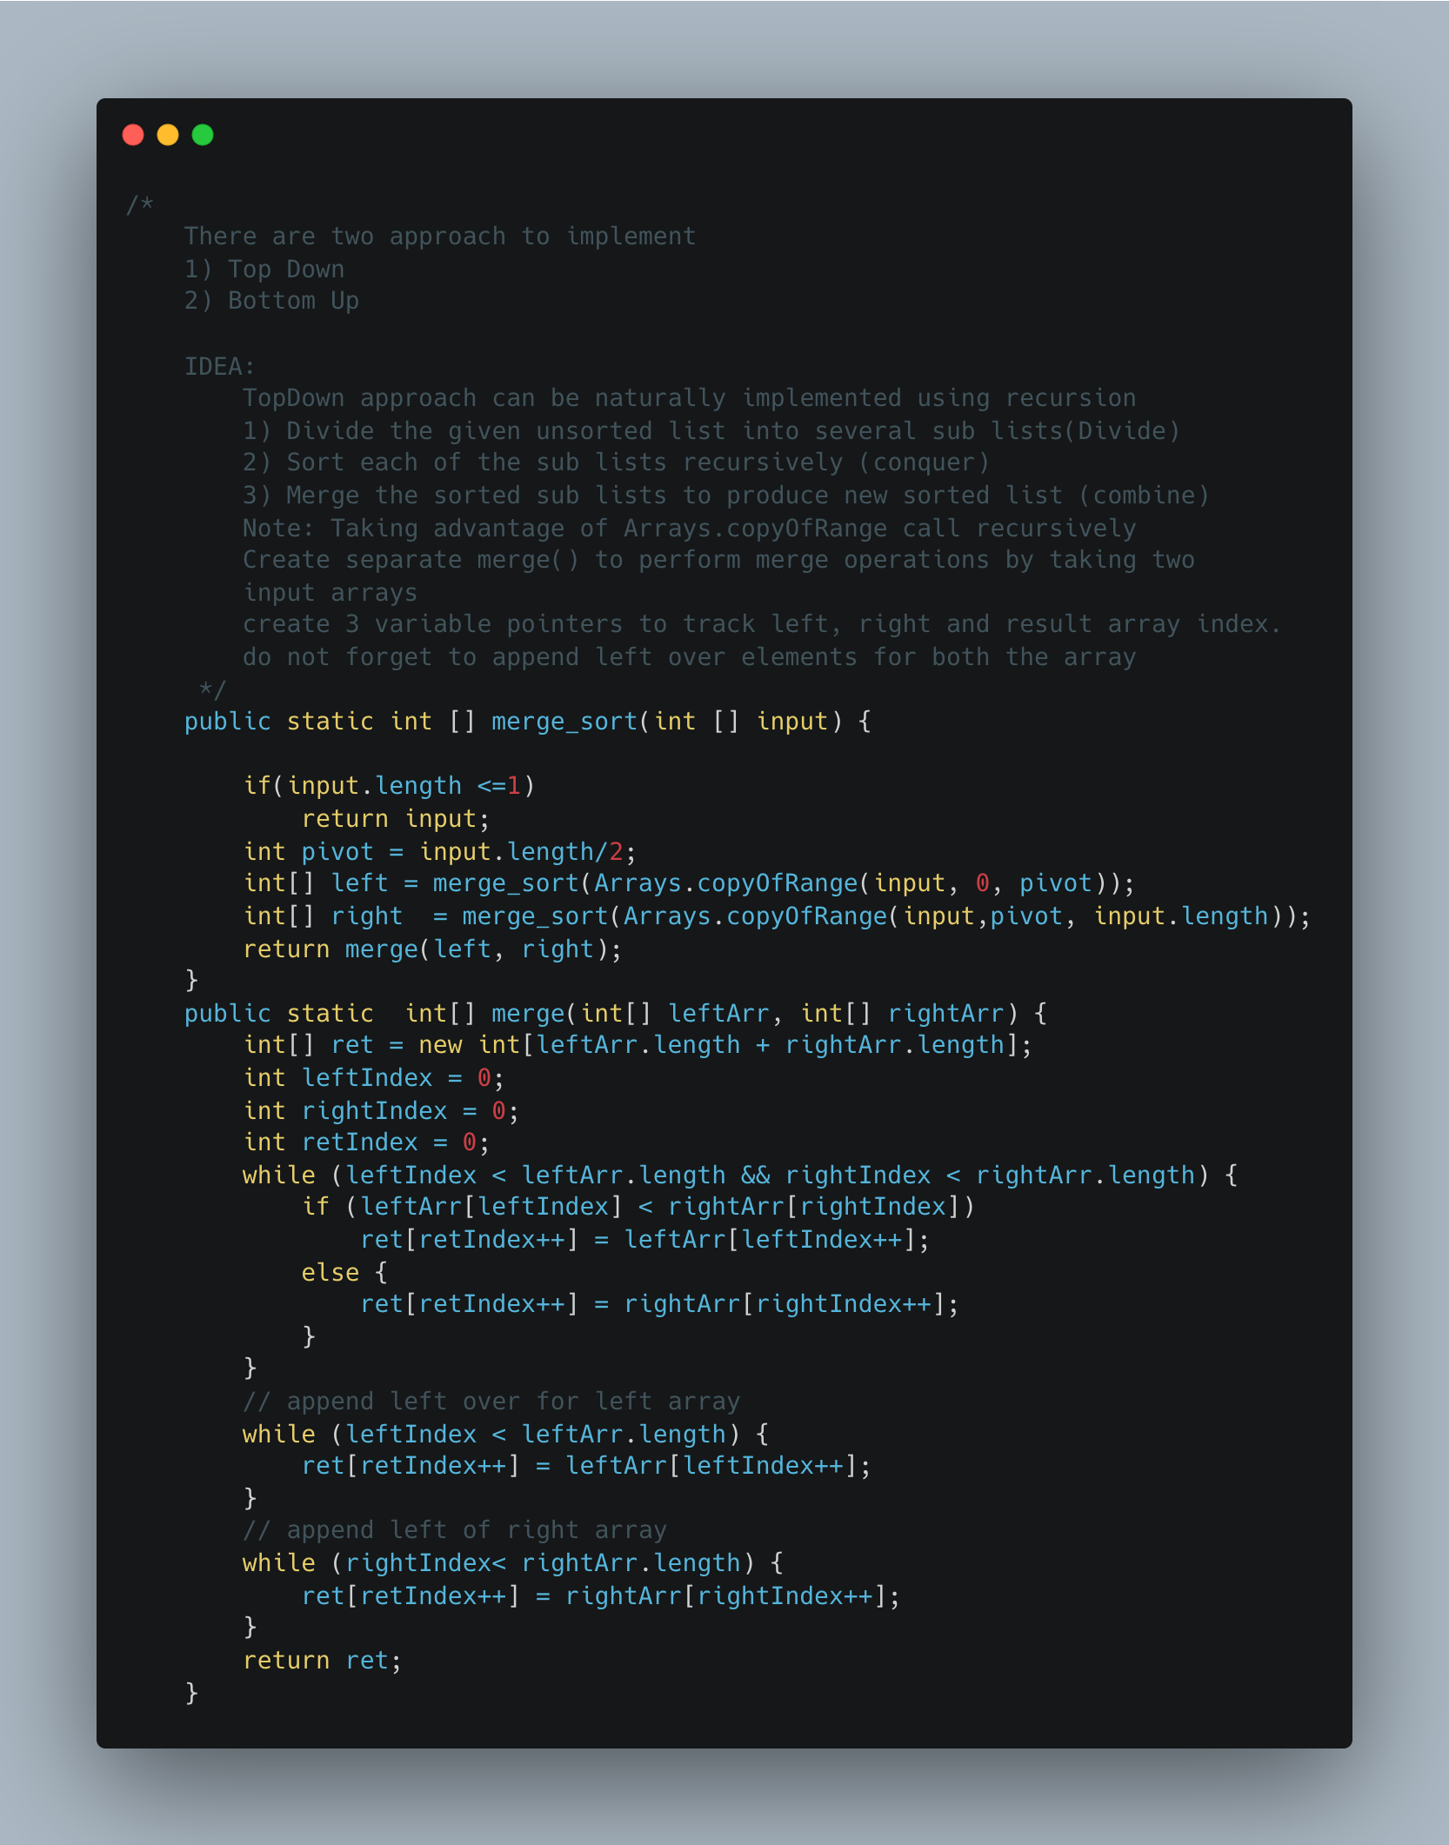

1. [Hamming Distance](https://leetcode.com/problems/hamming-distance/)

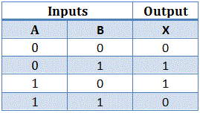

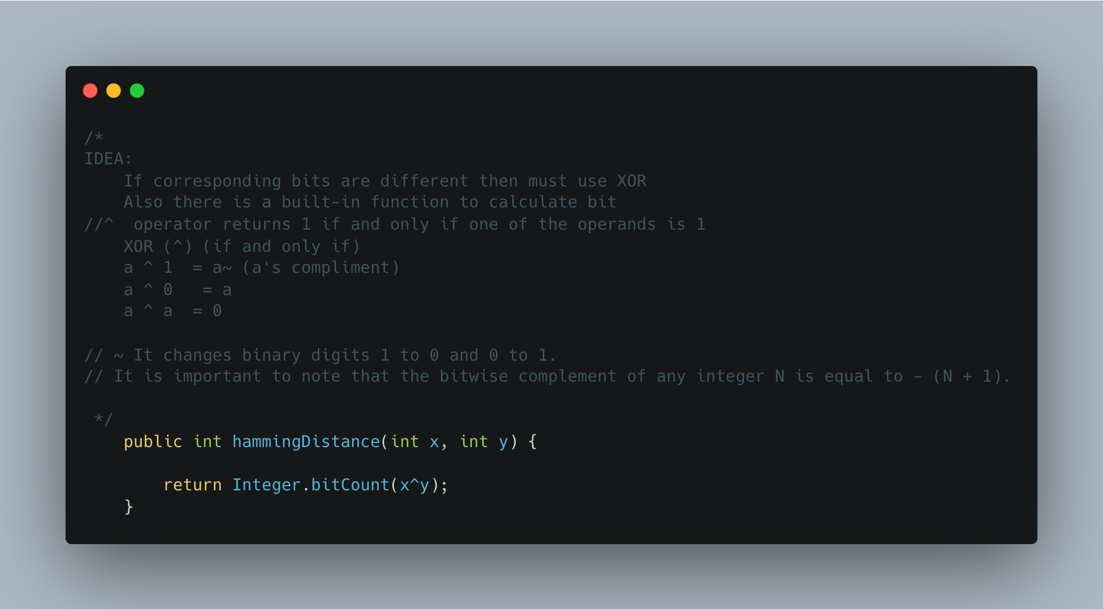

1. [Delete Node in BST](https://leetcode.com/problems/delete-node-in-a-bst/)

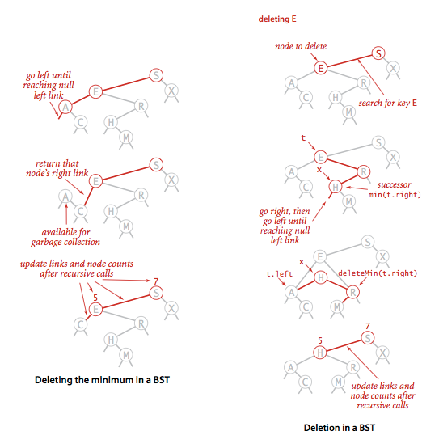

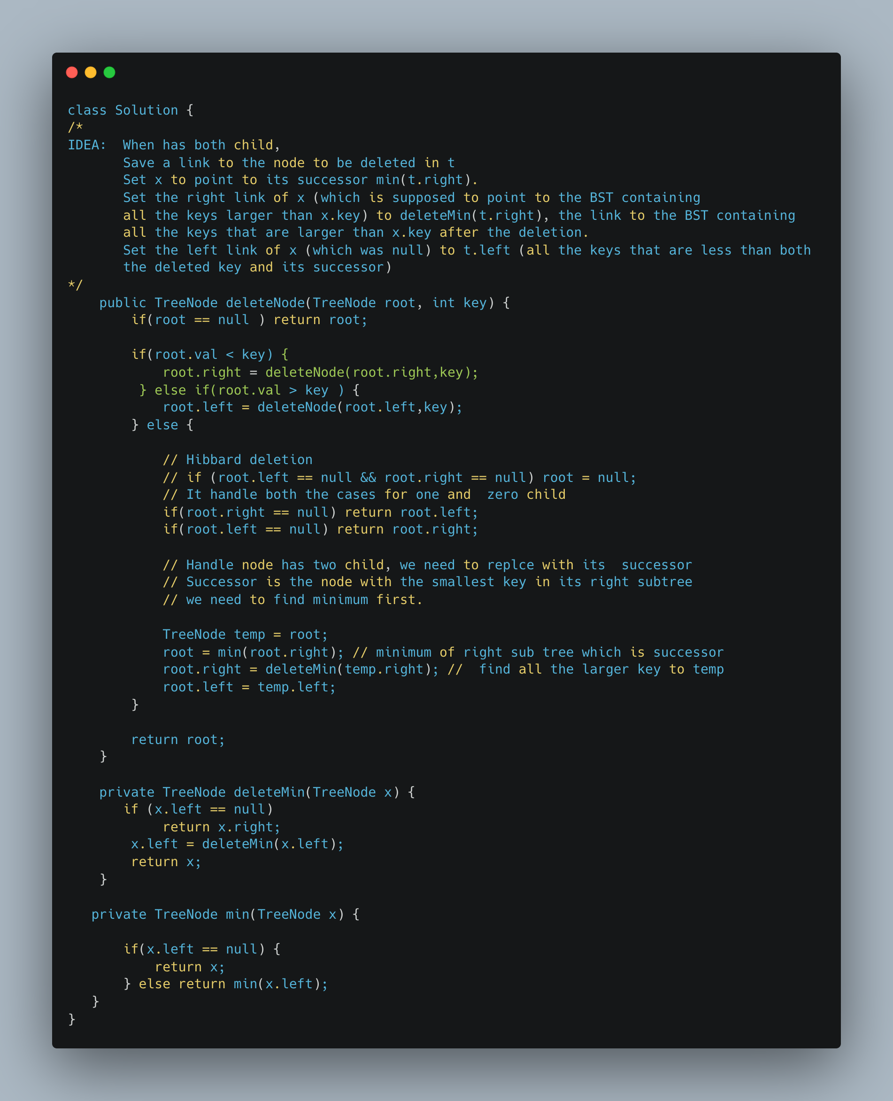

1. [Container with Most Water](https://leetcode.com/problems/container-with-most-water/)

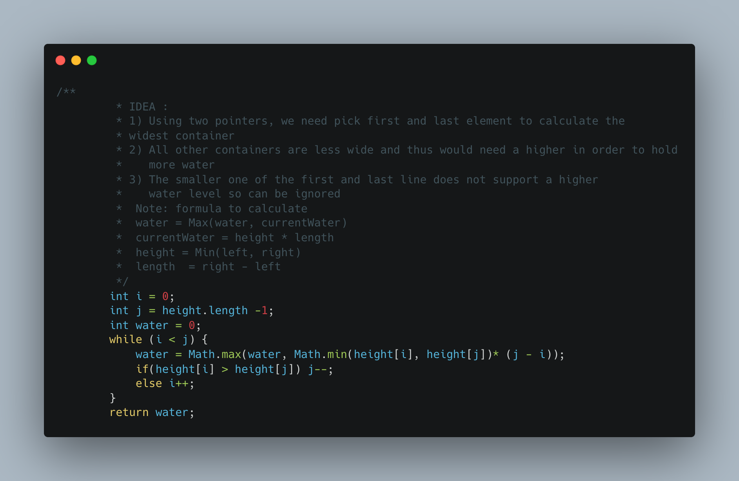

1. [**1362. Closest Divisors**](https://leetcode.com/problems/closest-divisors/)

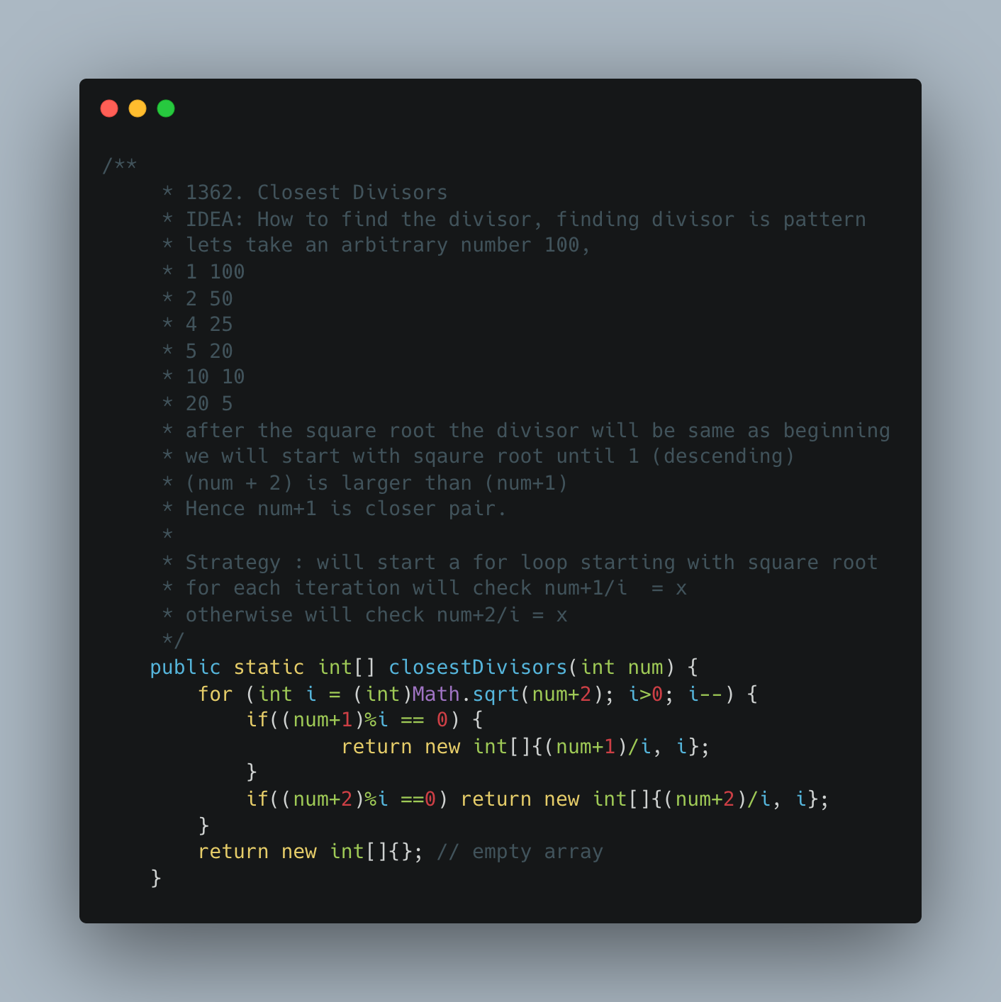

1. [**98. Validate Binary Search Tree**](https://leetcode.com/problems/validate-binary-search-tree/)

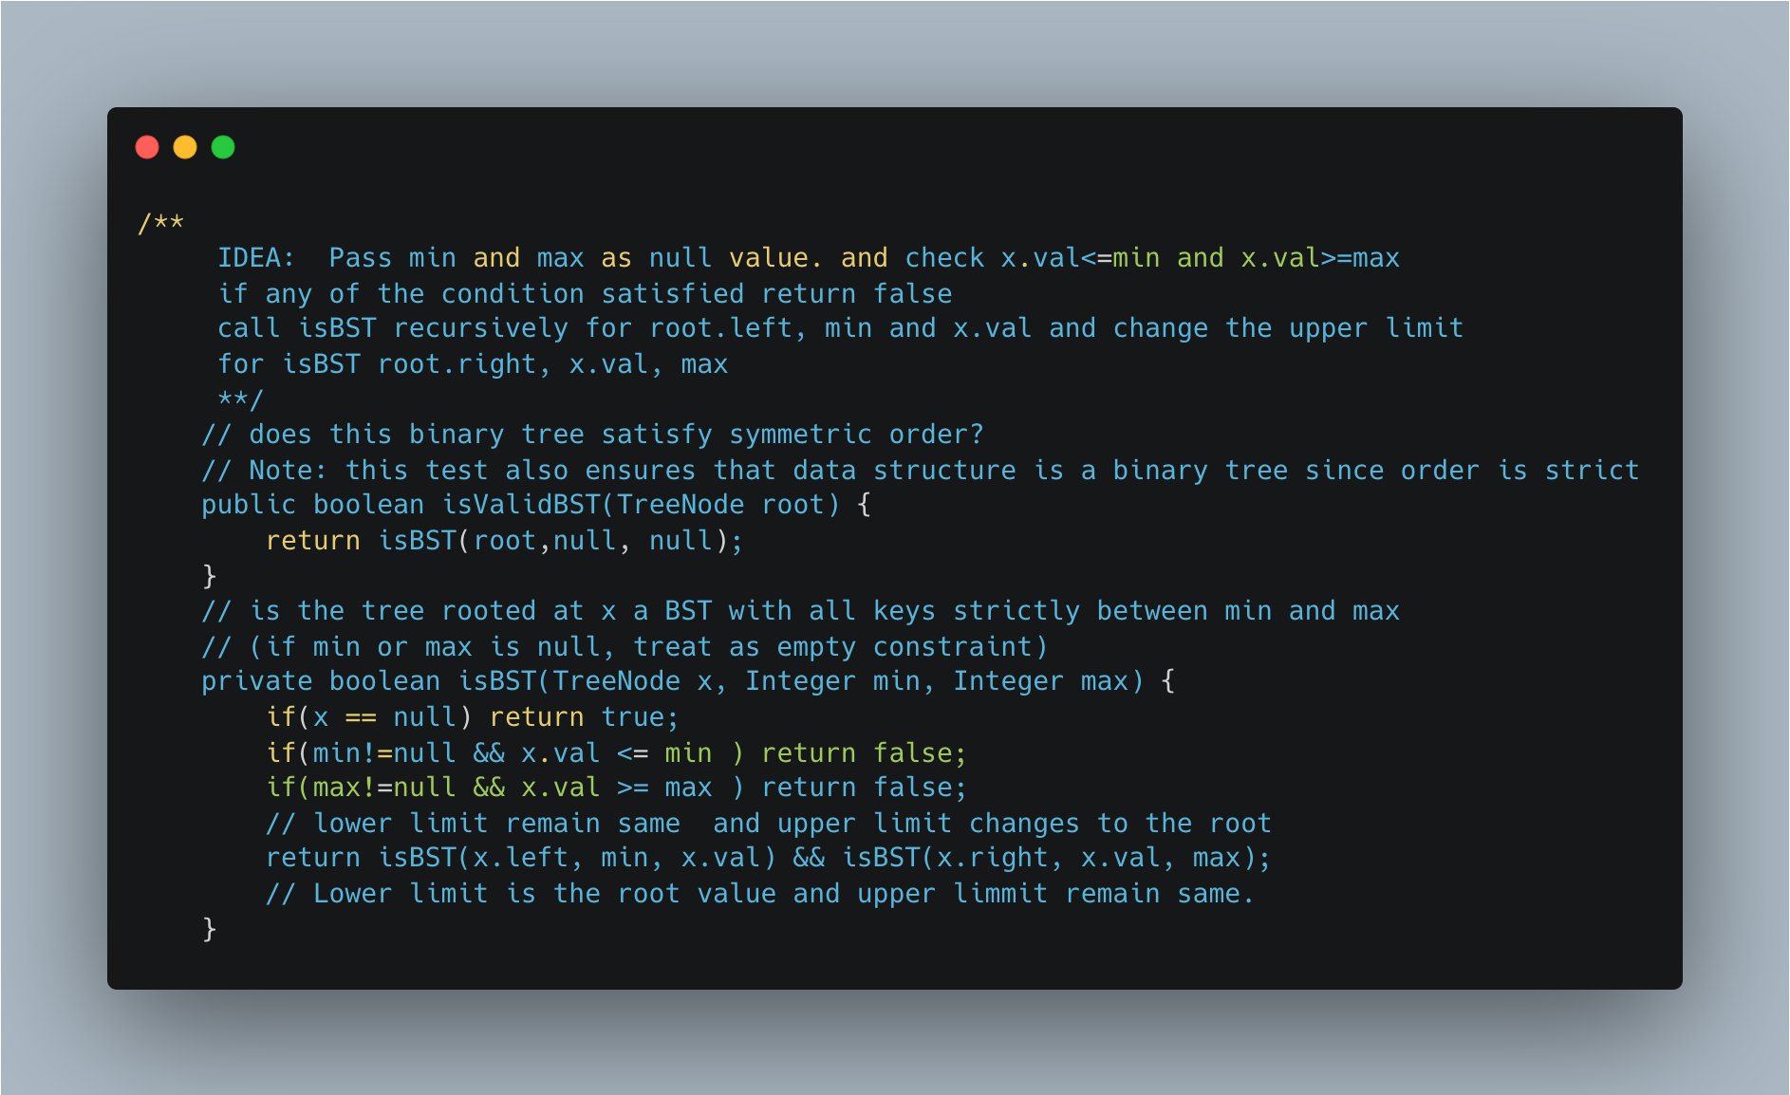

1. [Remove Sub folder from the file System](https://leetcode.com/problems/remove-sub-folders-from-the-filesystem/)

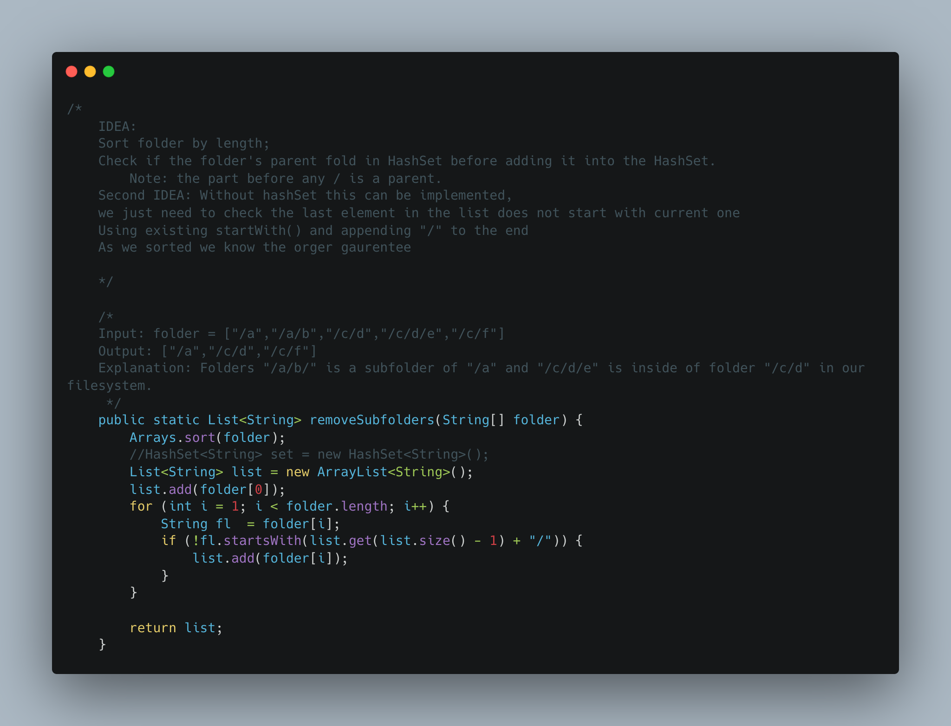

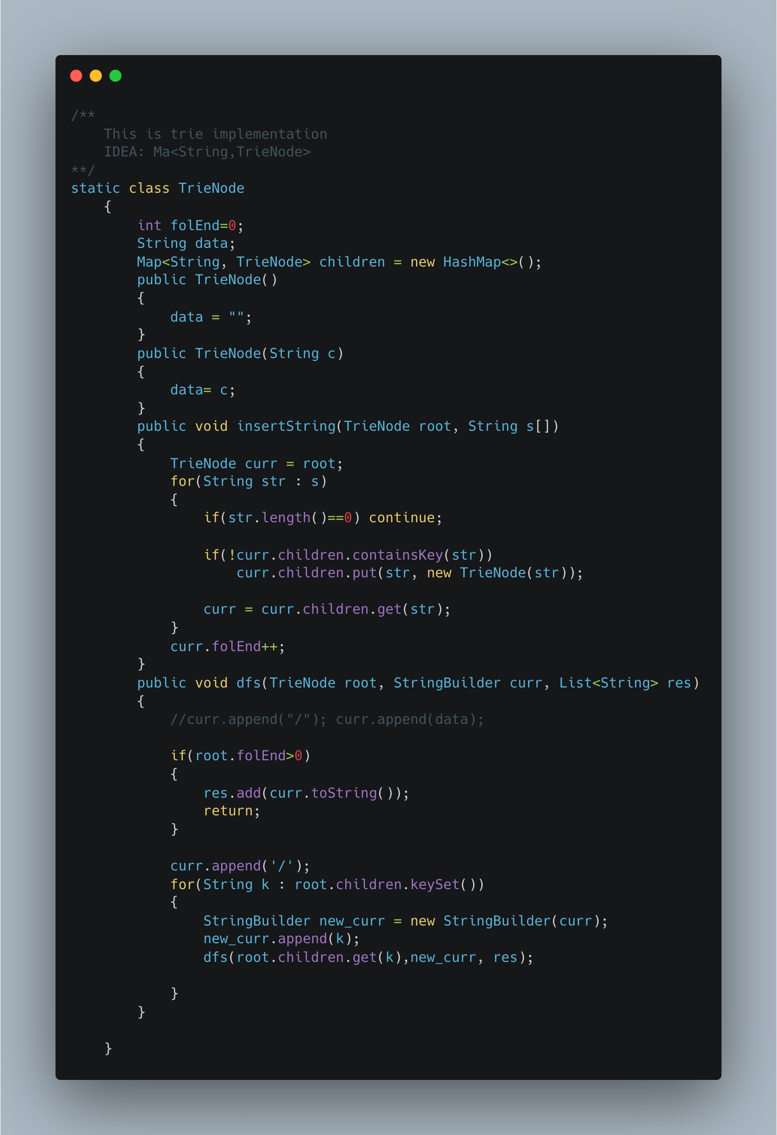

1. [**N-ary Tree Postorder Traversal**](https://leetcode.com/problems/n-ary-tree-postorder-traversal/)

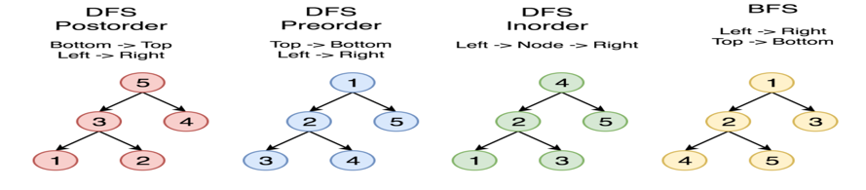

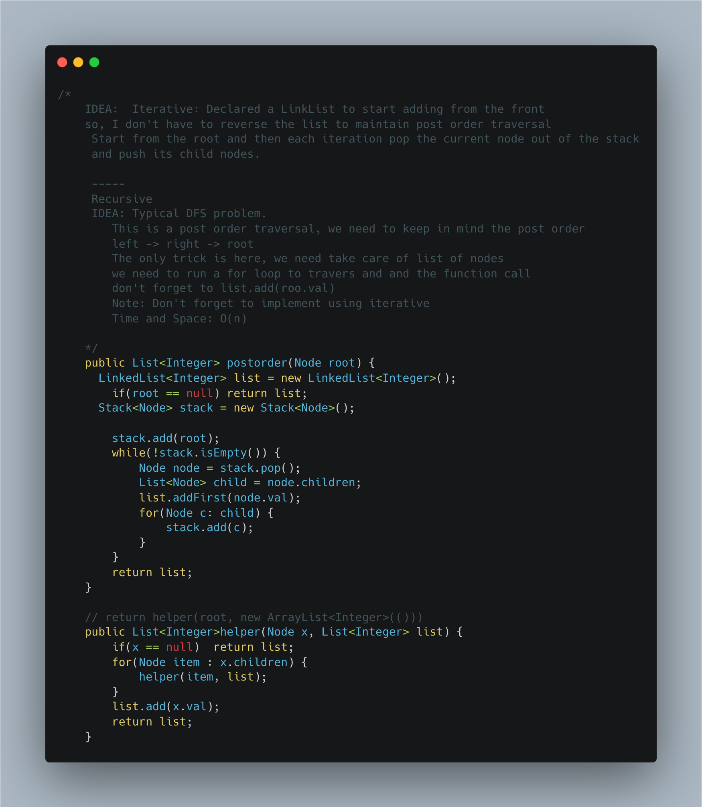

1. Palindrome String check using recursion.

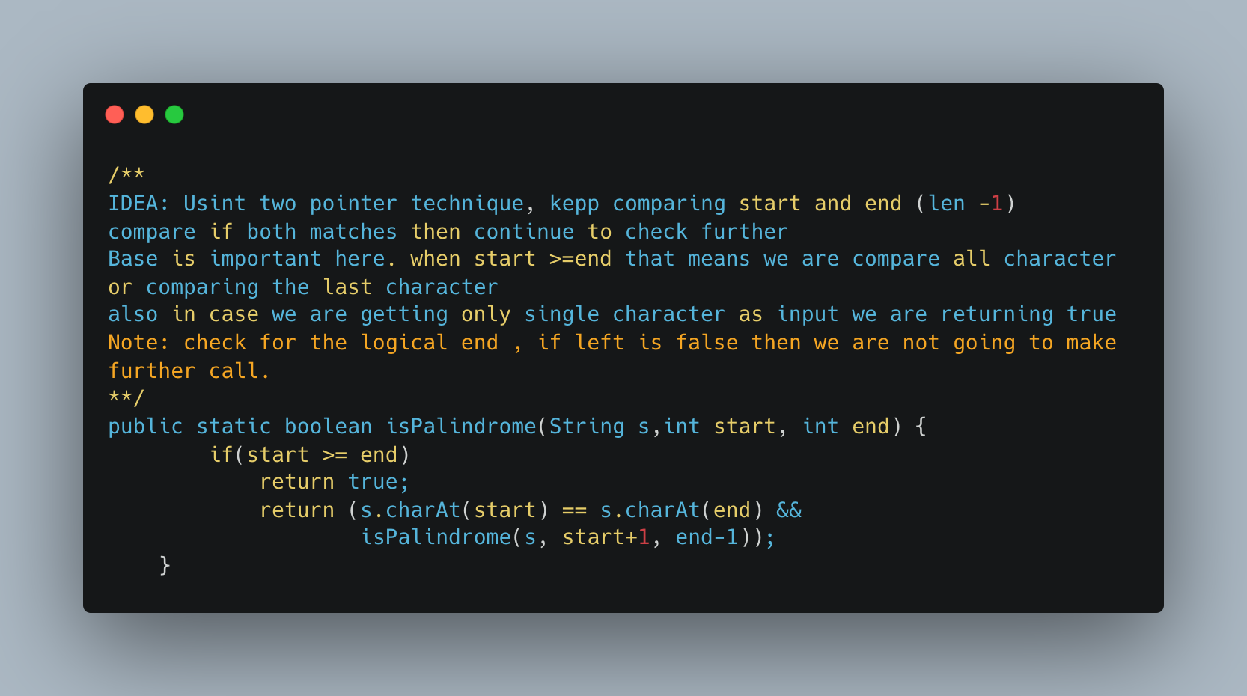

1. Cutting Rope Cutting

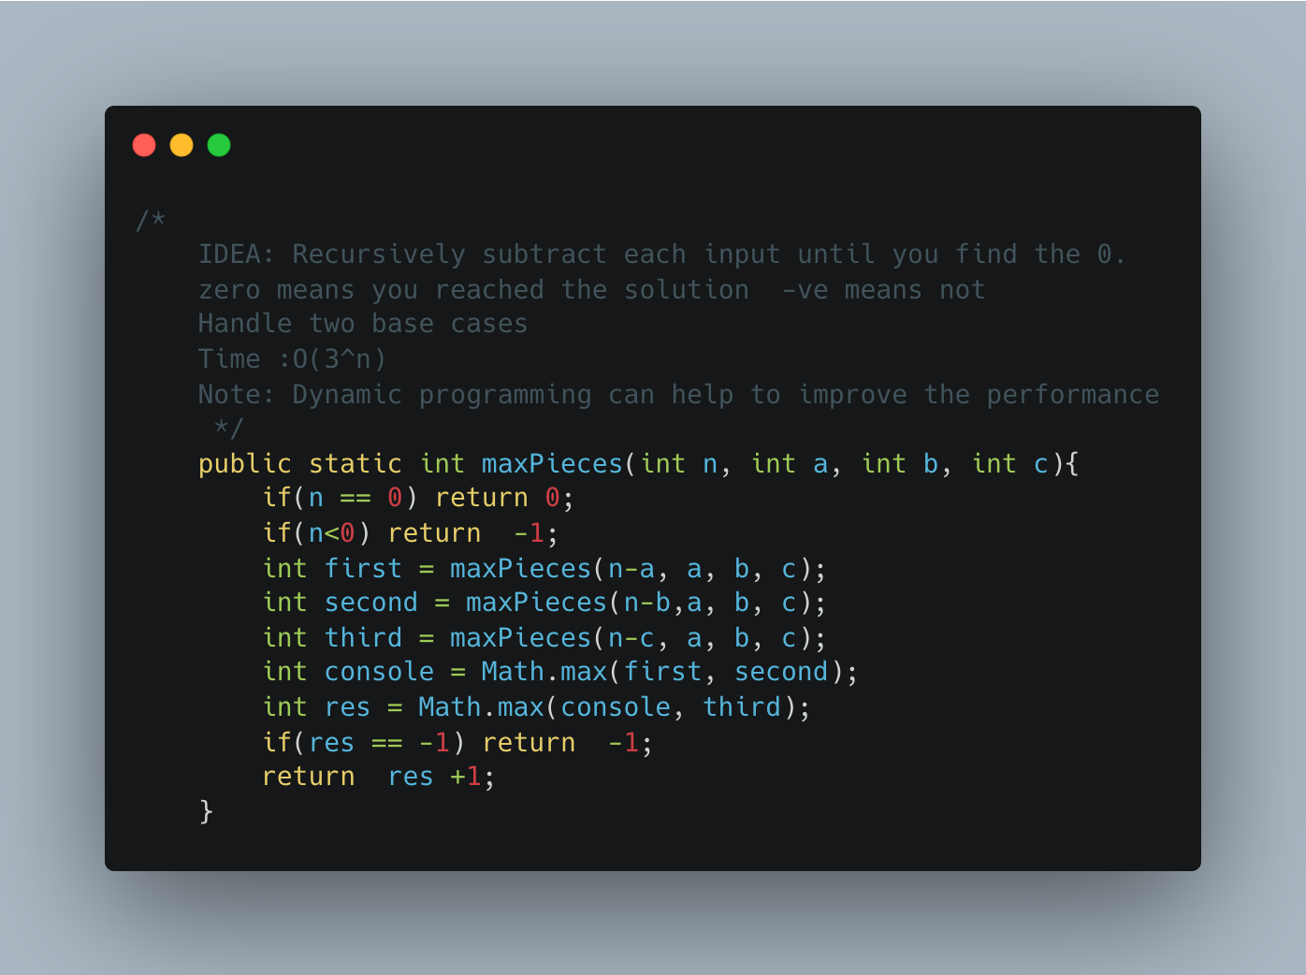

1. Generate Subsets of a given string

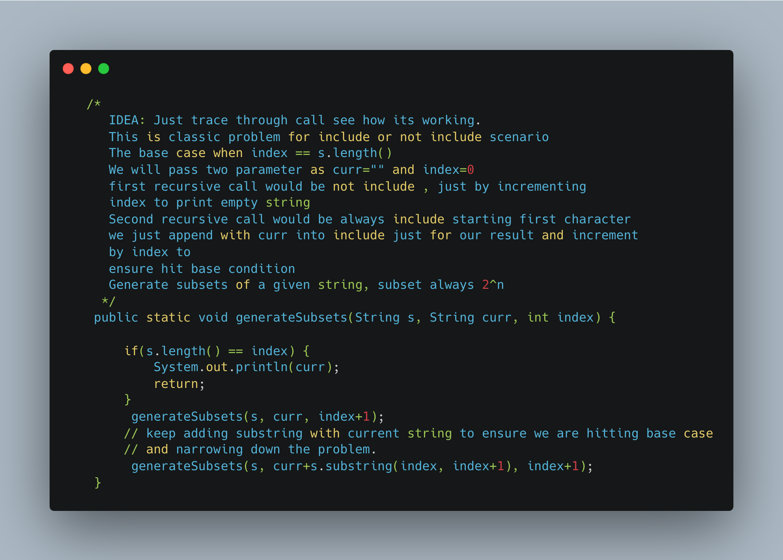

1. Array Dequeue

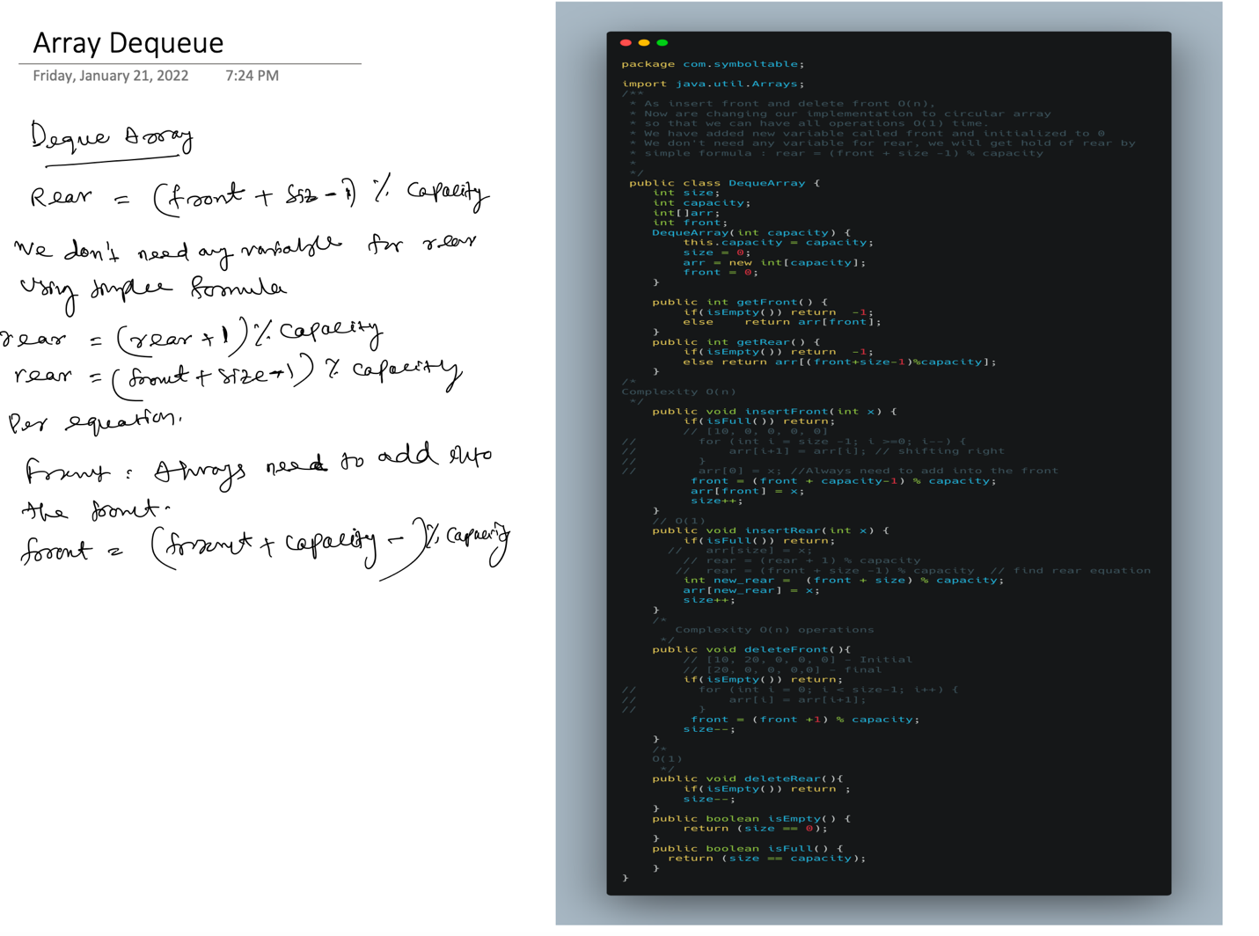

1. [Distant Barcodes](https://leetcode.com/problems/distant-barcodes/)

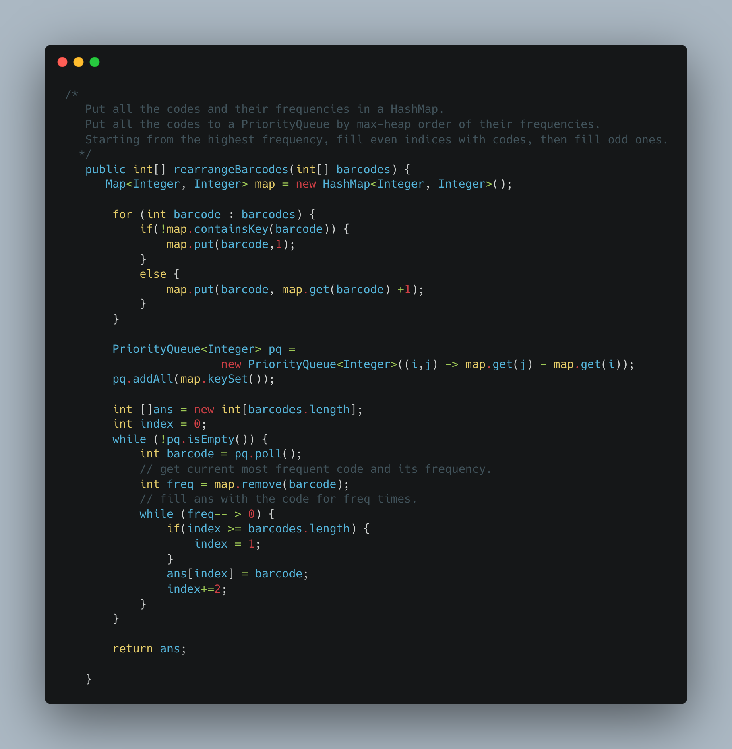

1. [Simplify Path](https://leetcode.com/problems/simplify-path/)

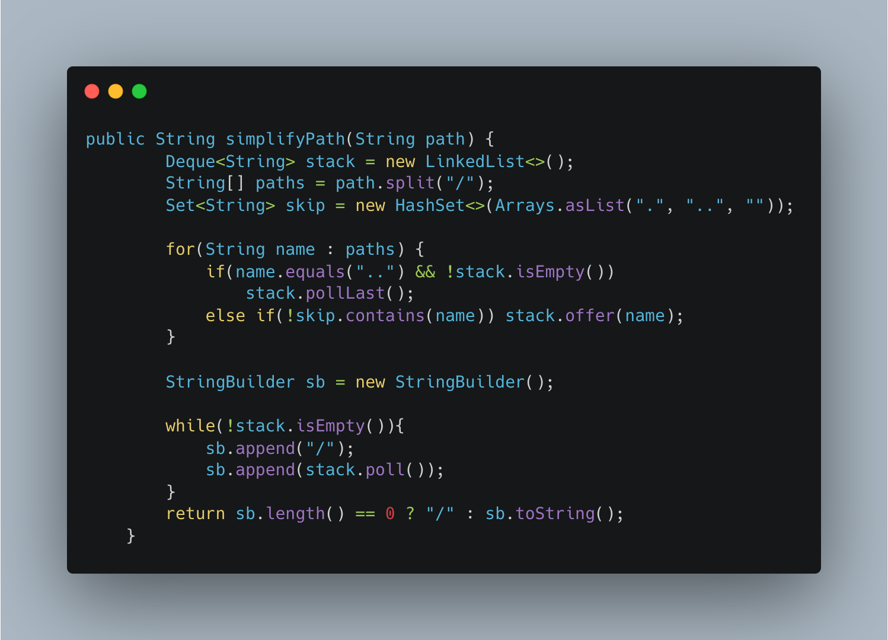

1. Maximum Activity – Greedy

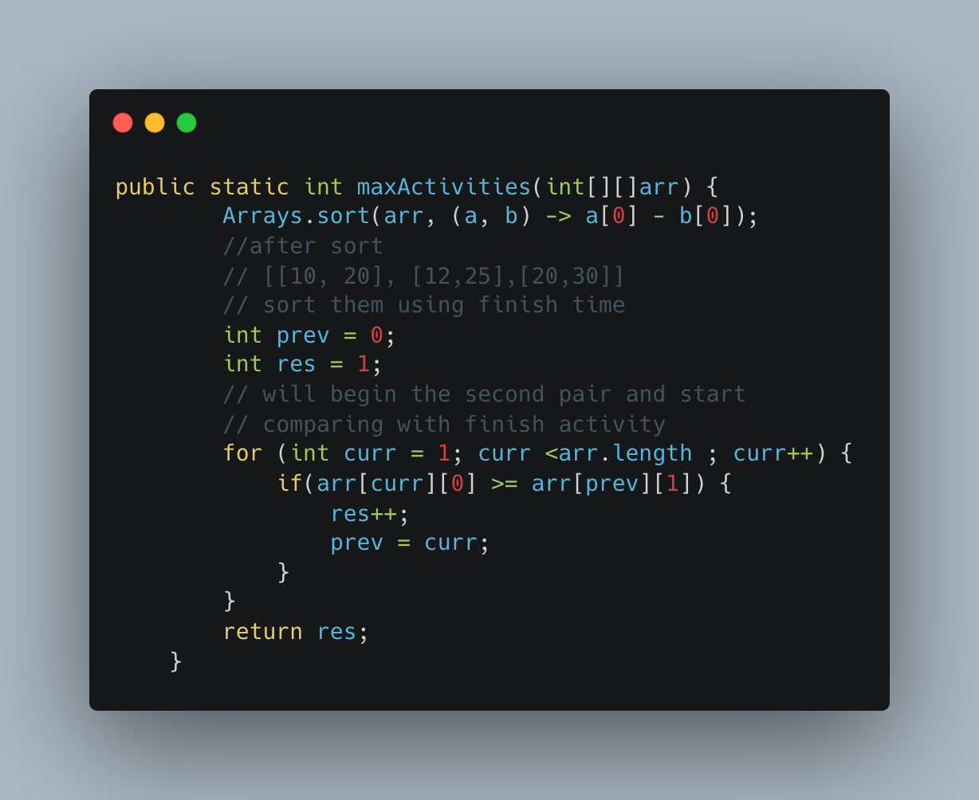

1. Another way of implementing

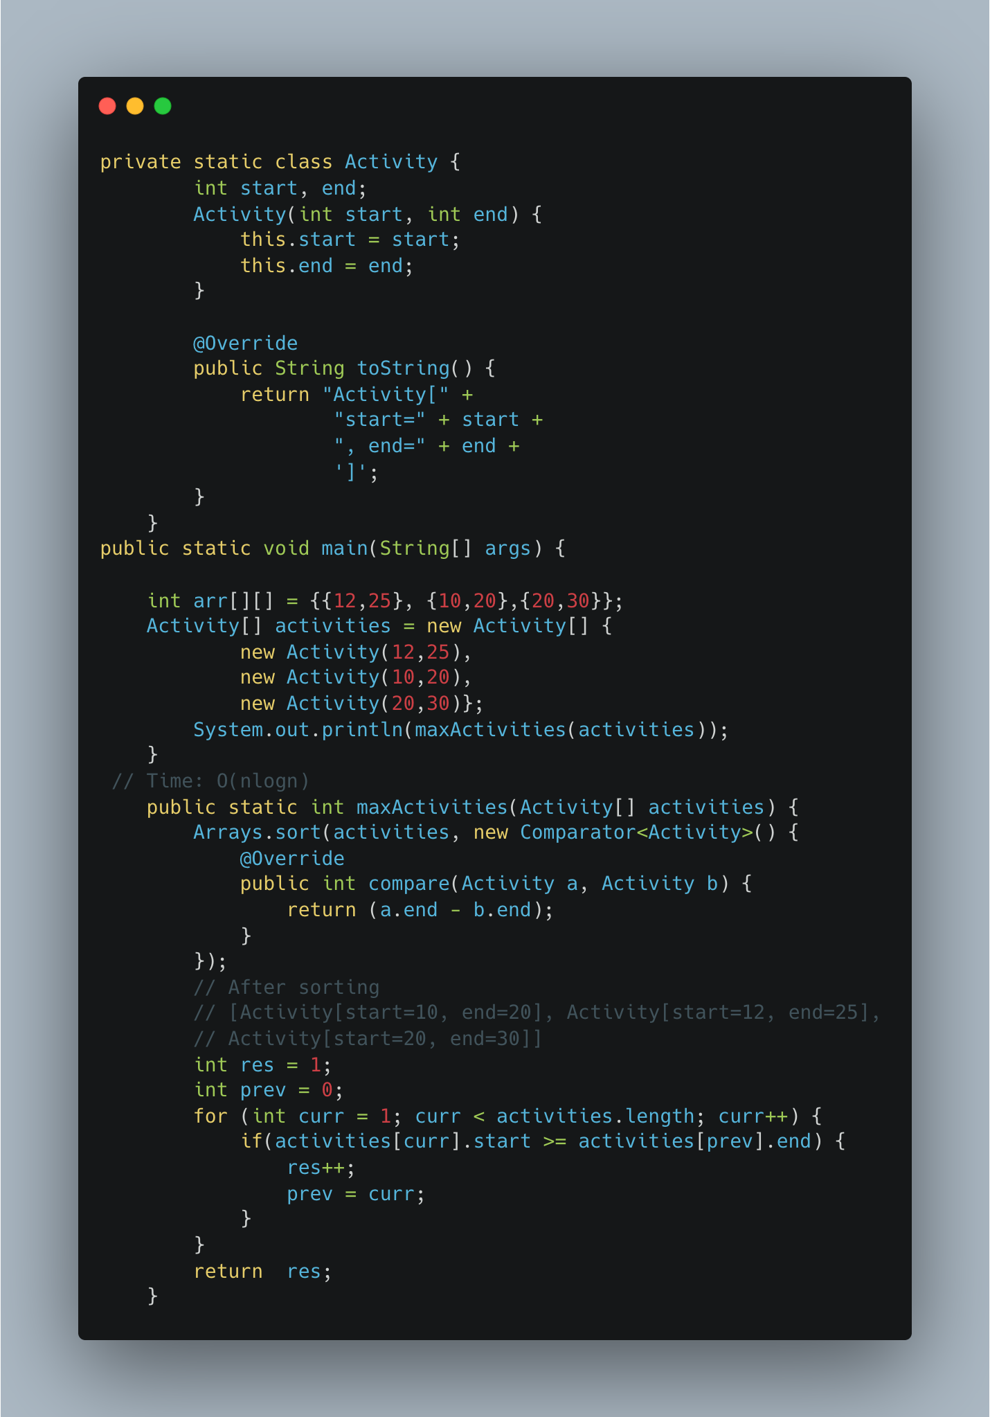

1. [Fractional Knapsack](https://www.geeksforgeeks.org/fractional-knapsack-problem/)

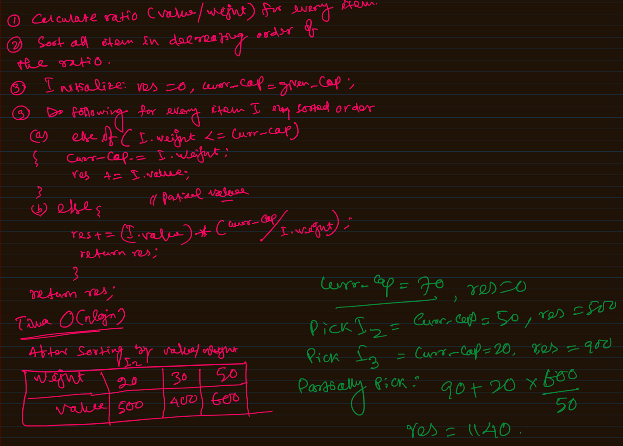

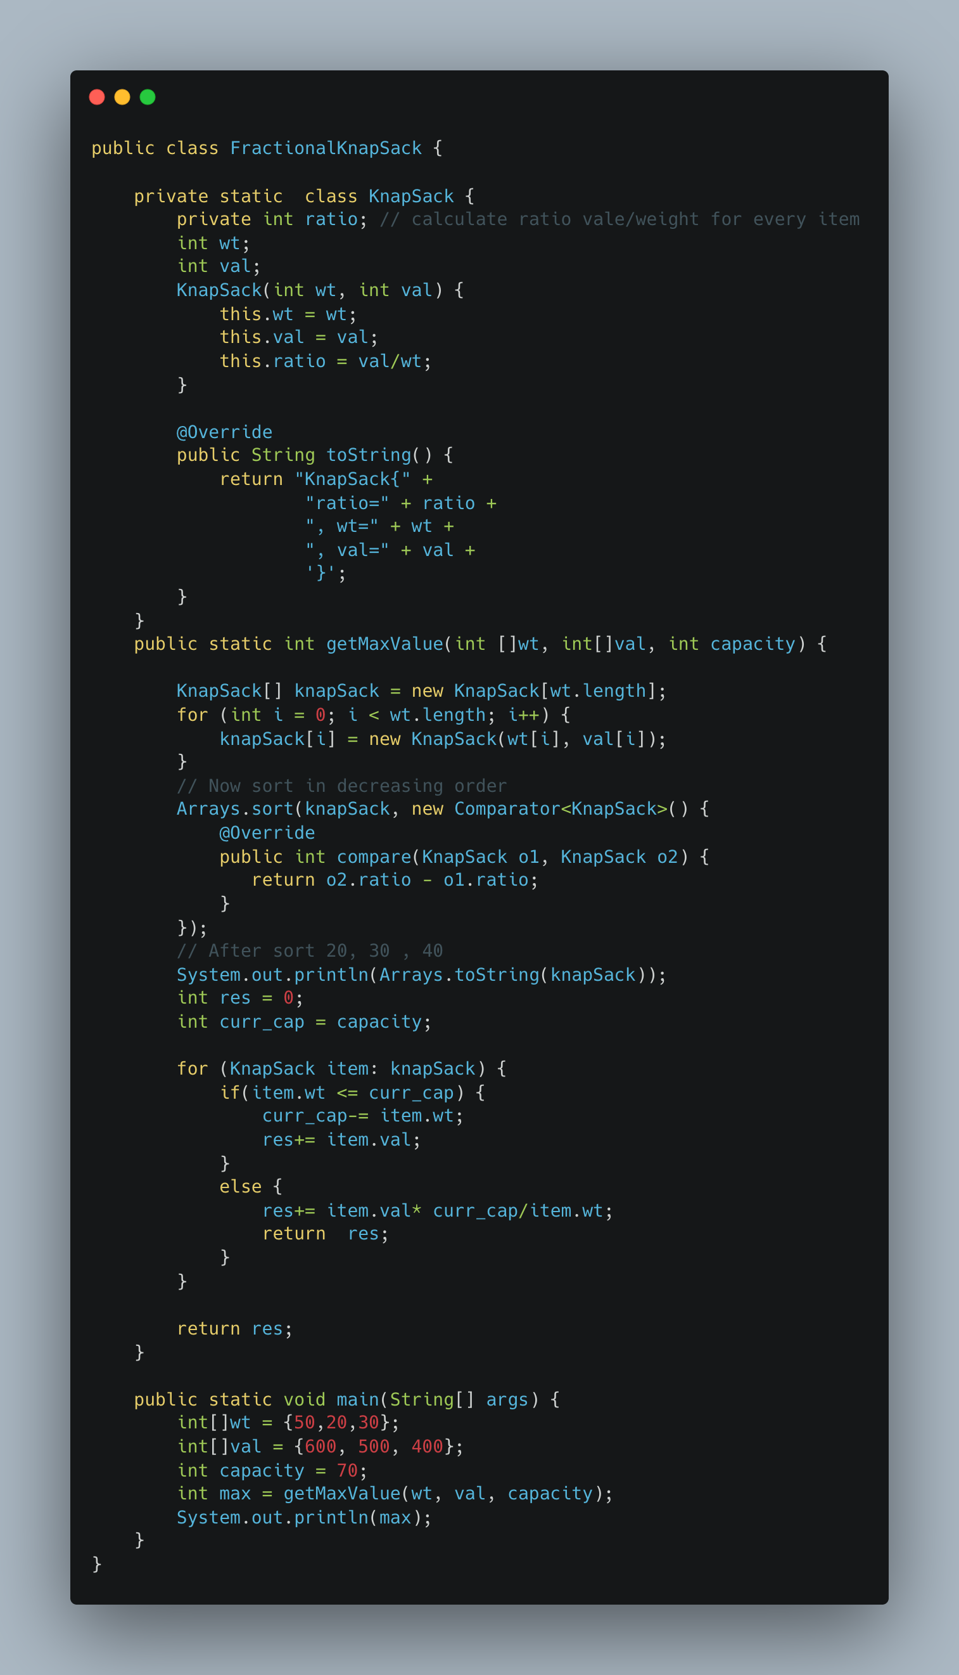

1. [Print Word Vertically](https://leetcode.com/problems/print-words-vertically/)

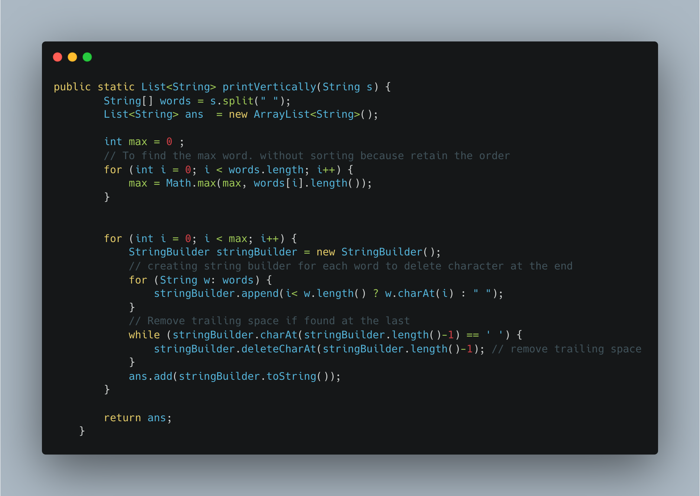

1. [Two Sum II Array is Sorted](https://leetcode.com/problems/two-sum-ii-input-array-is-sorted/)

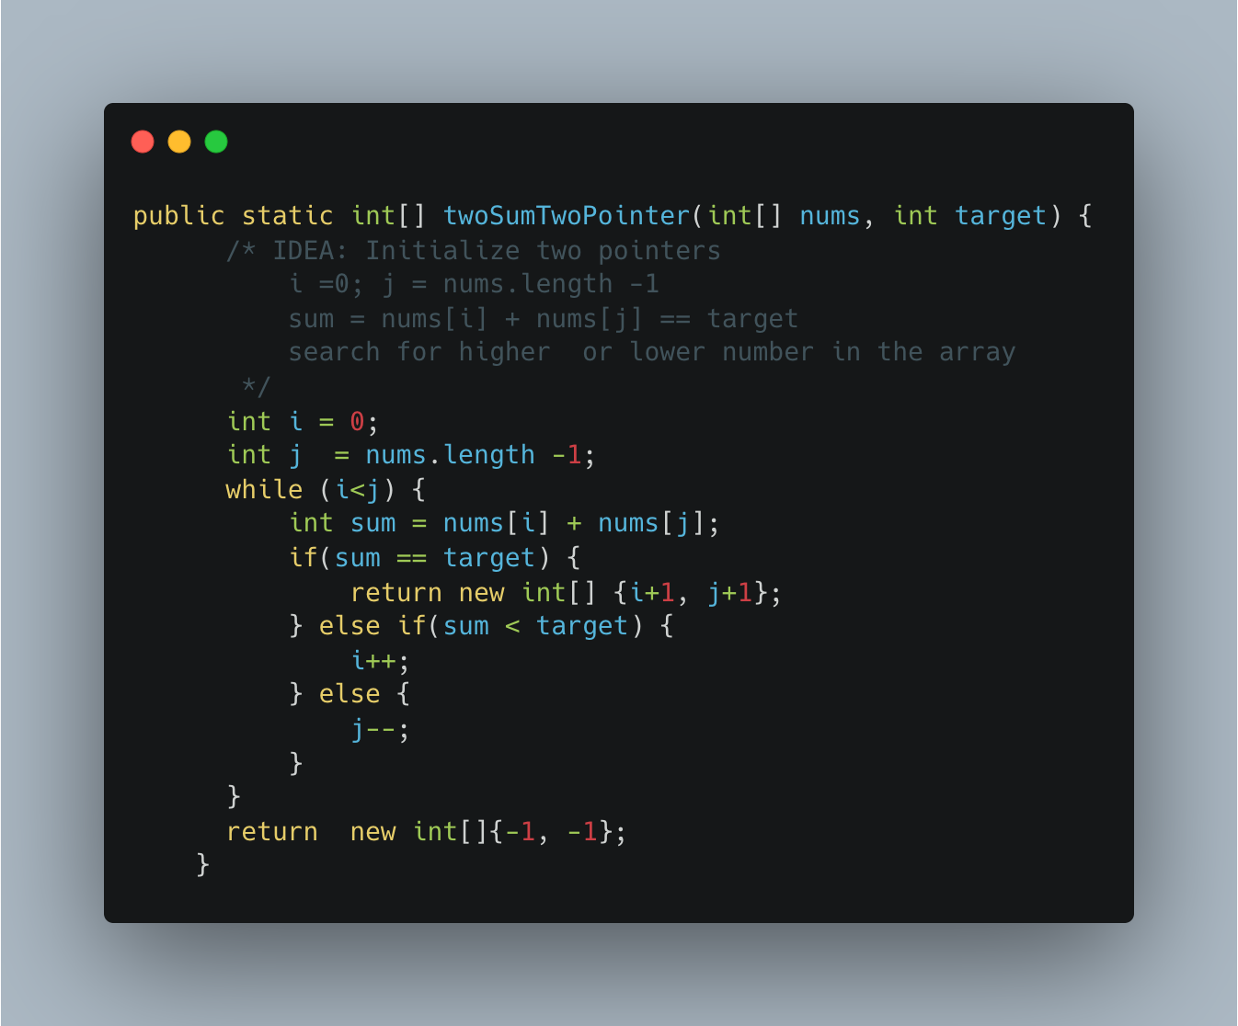

1. [Minimum Moves to Equal Array elements II](https://leetcode.com/problems/minimum-moves-to-equal-array-elements-ii/)

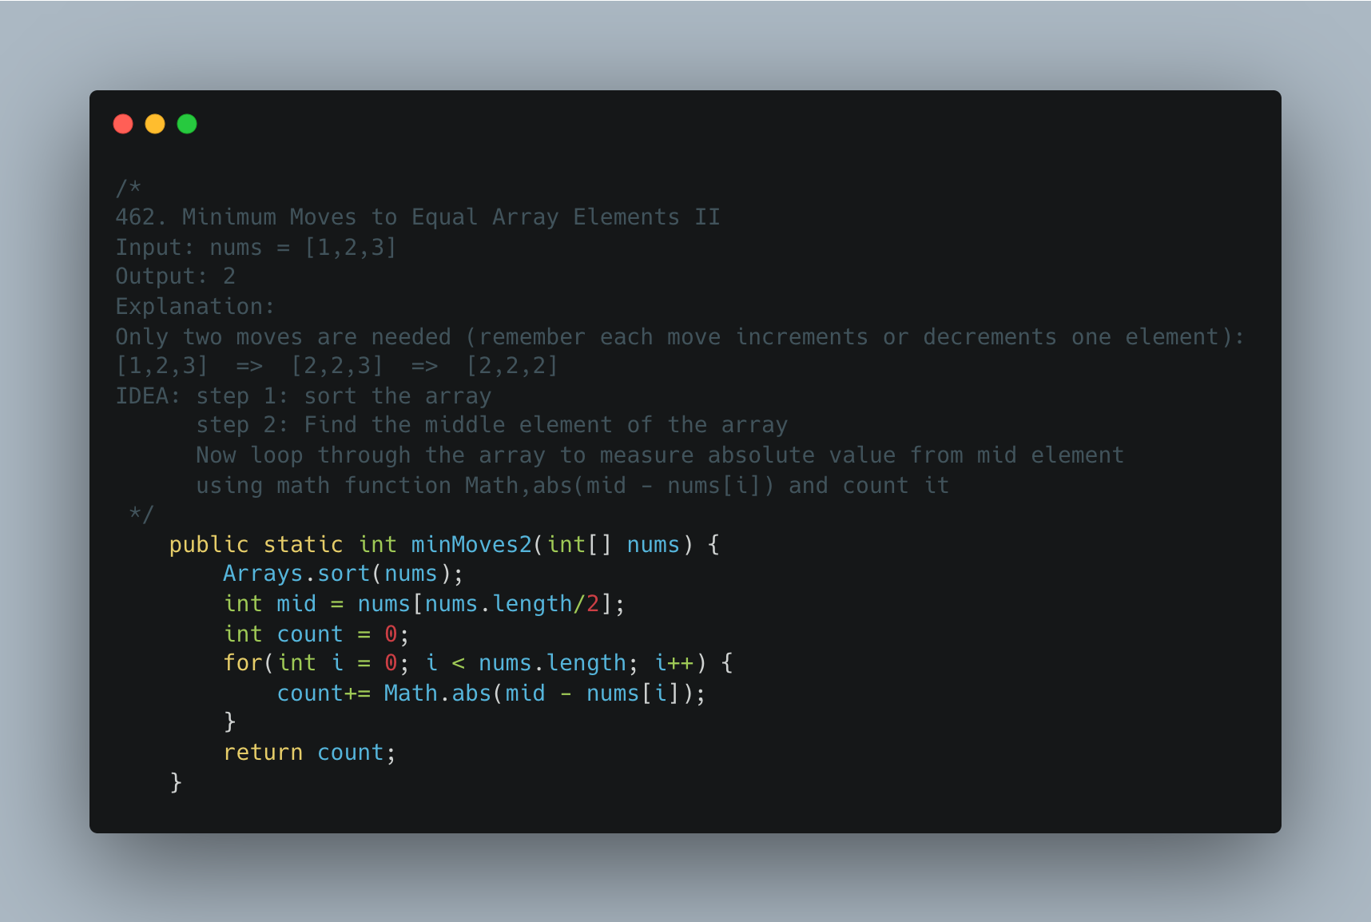

1. [Same Tree](https://leetcode.com/problems/same-tree/)

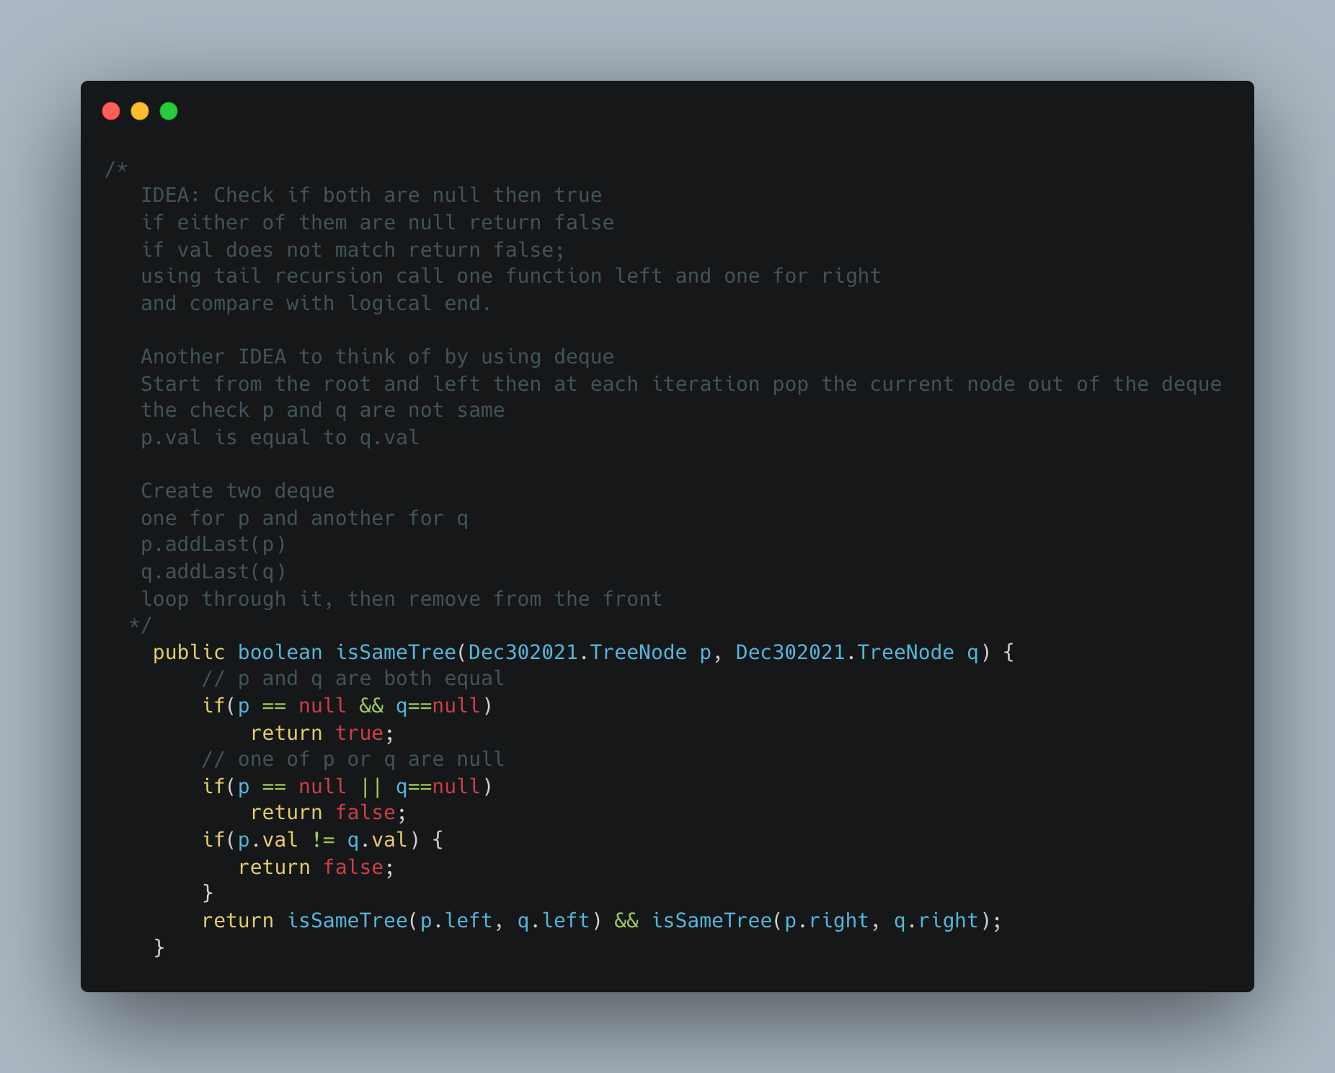

1. Maximize the number of toys that can be purchased with amount K using min Heap

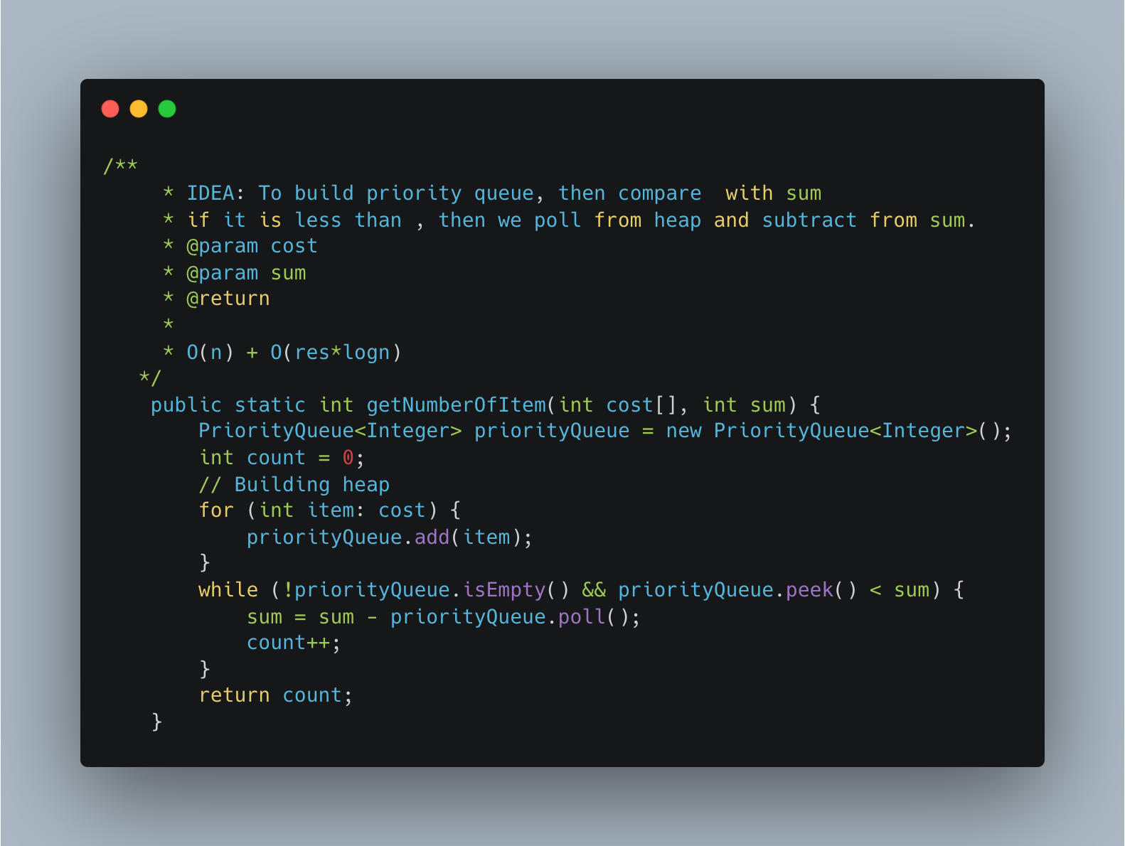

1. [Find K Closest Elements](https://leetcode.com/problems/find-k-closest-elements/)

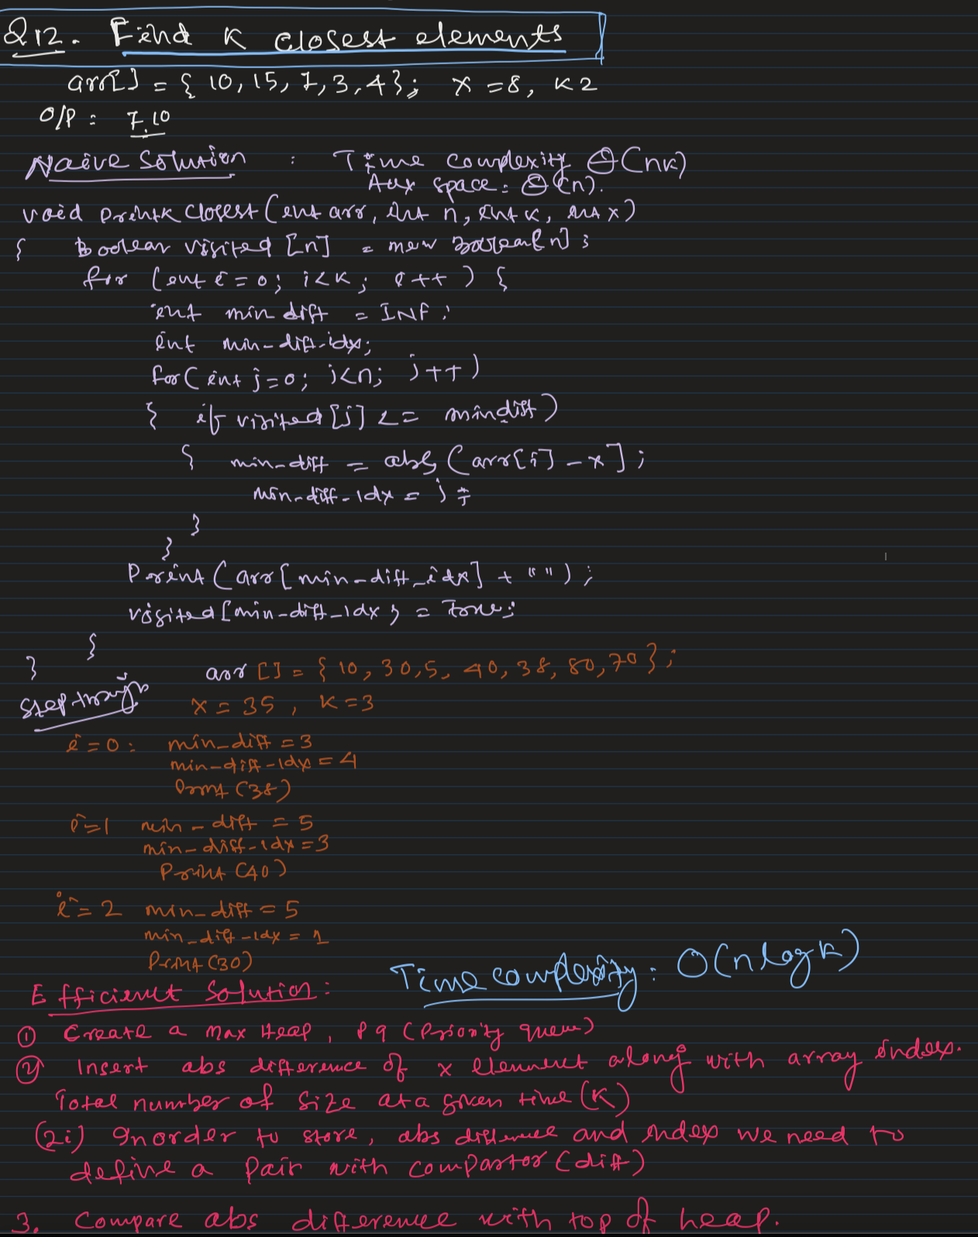

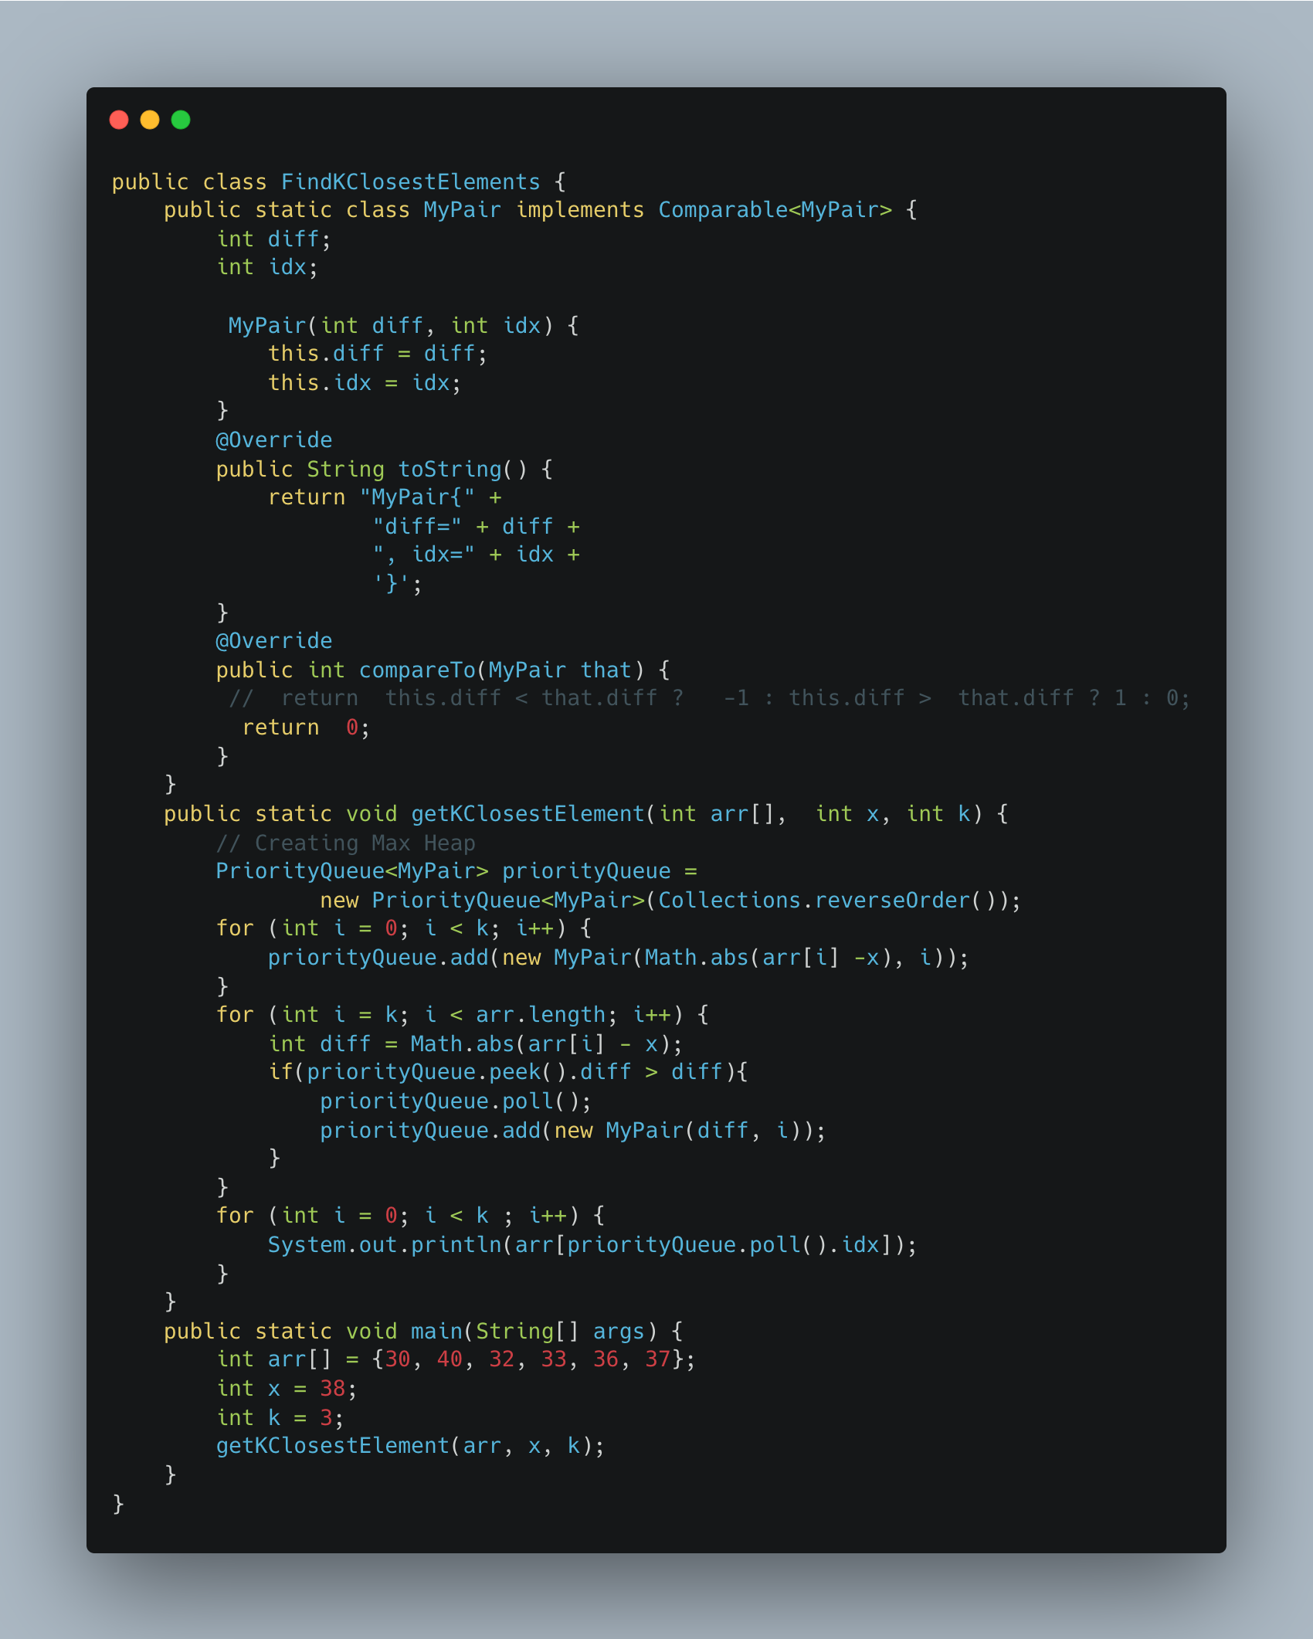

1. [Partition into Minimum Number of Deci -Binary Numbers](https://leetcode.com/problems/partitioning-into-minimum-number-of-deci-binary-numbers/)

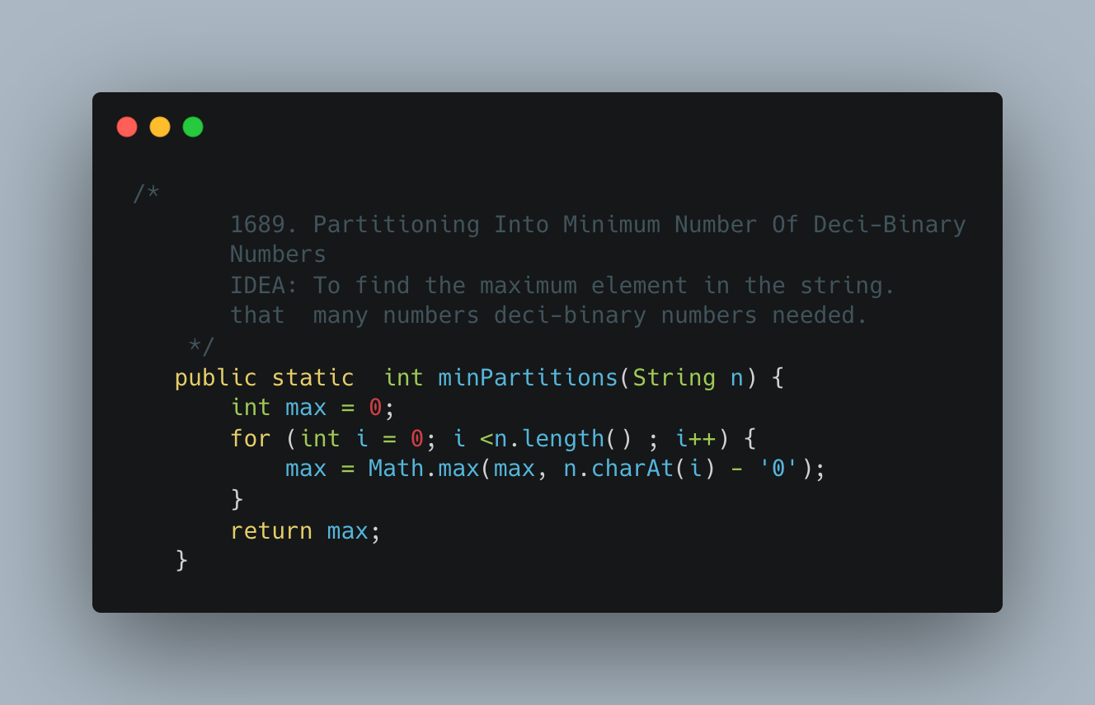

1. [Number of Closed Islands](https://leetcode.com/problems/number-of-closed-islands/)

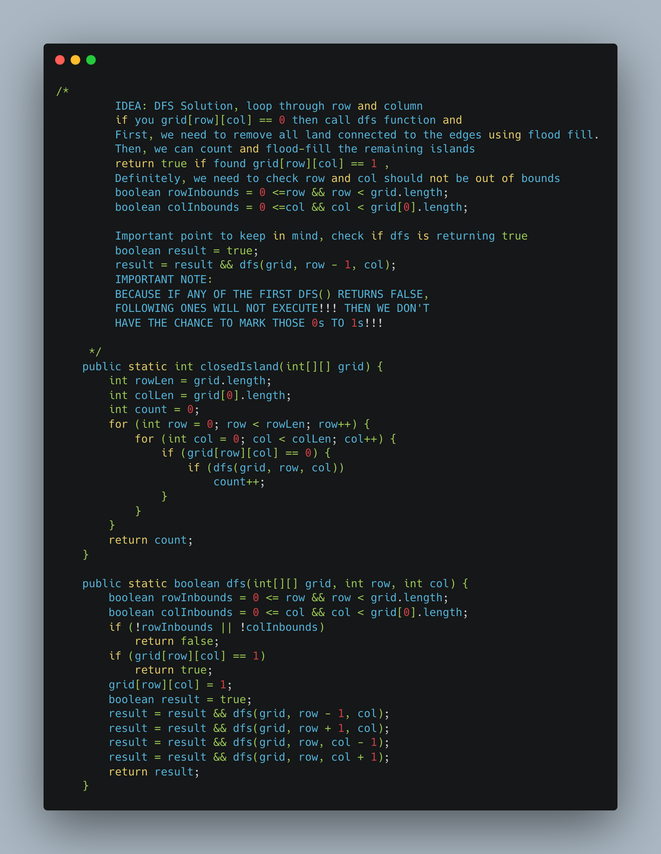

1. [Rank Transform of an Array](https://leetcode.com/problems/rank-transform-of-an-array/)

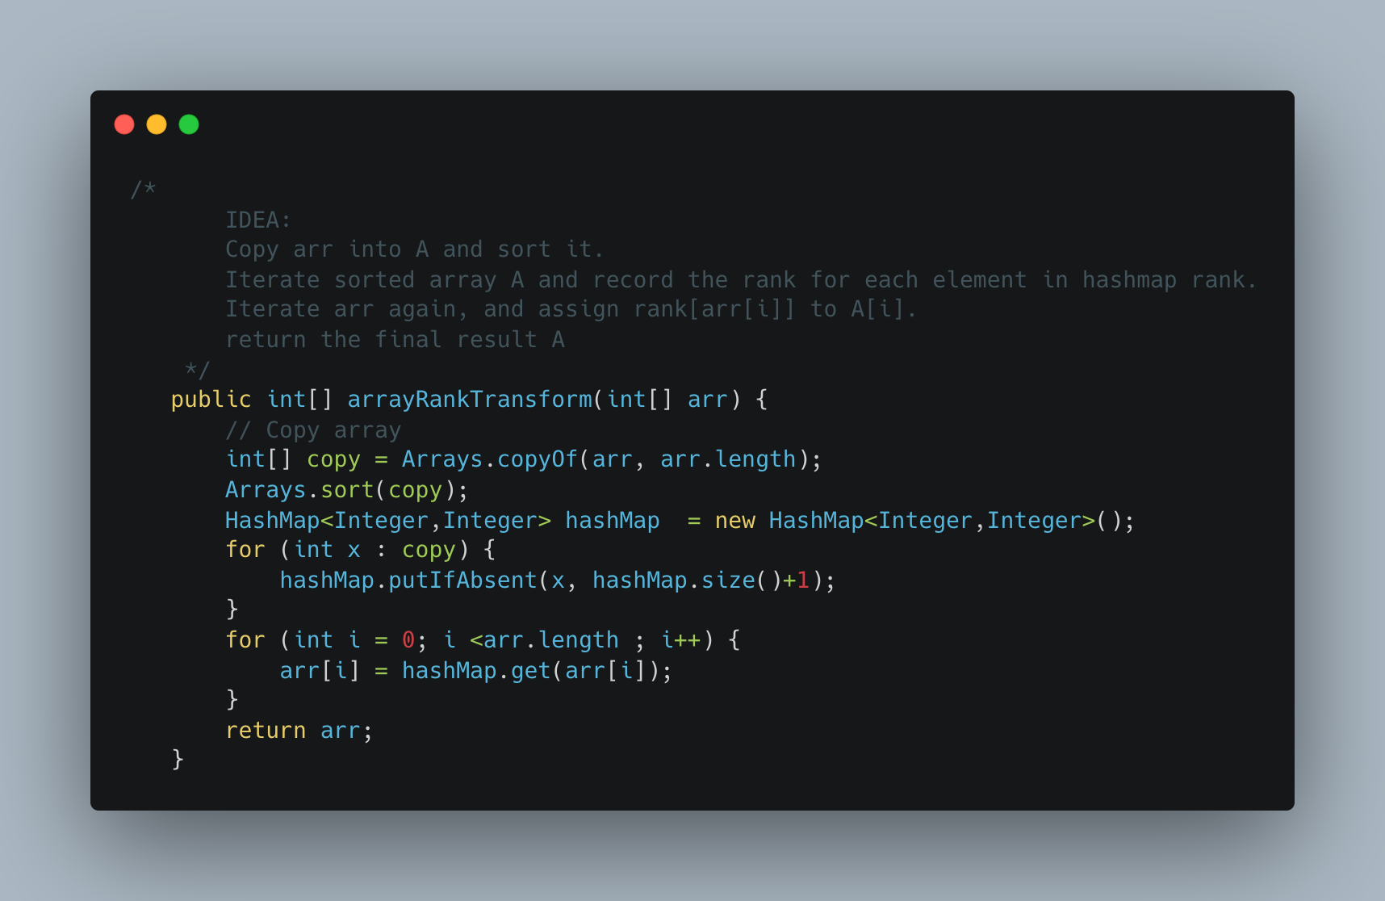

1. [Numbers with Same consecutive differences](https://leetcode.com/problems/numbers-with-same-consecutive-differences/)

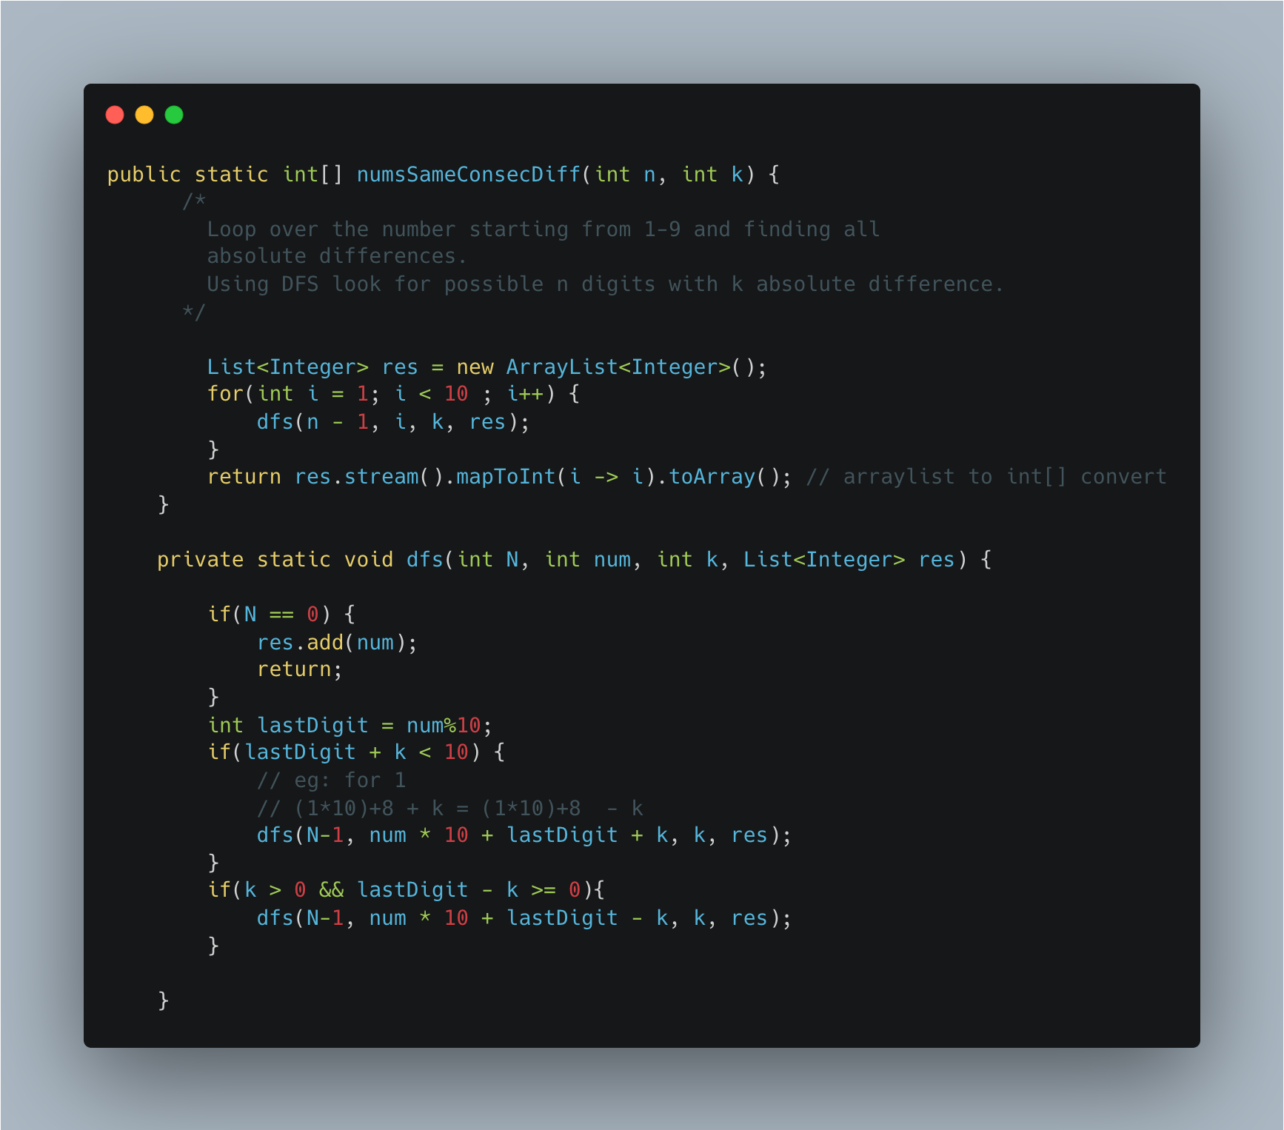

1. [Word Search](https://leetcode.com/problems/word-search/submissions/)

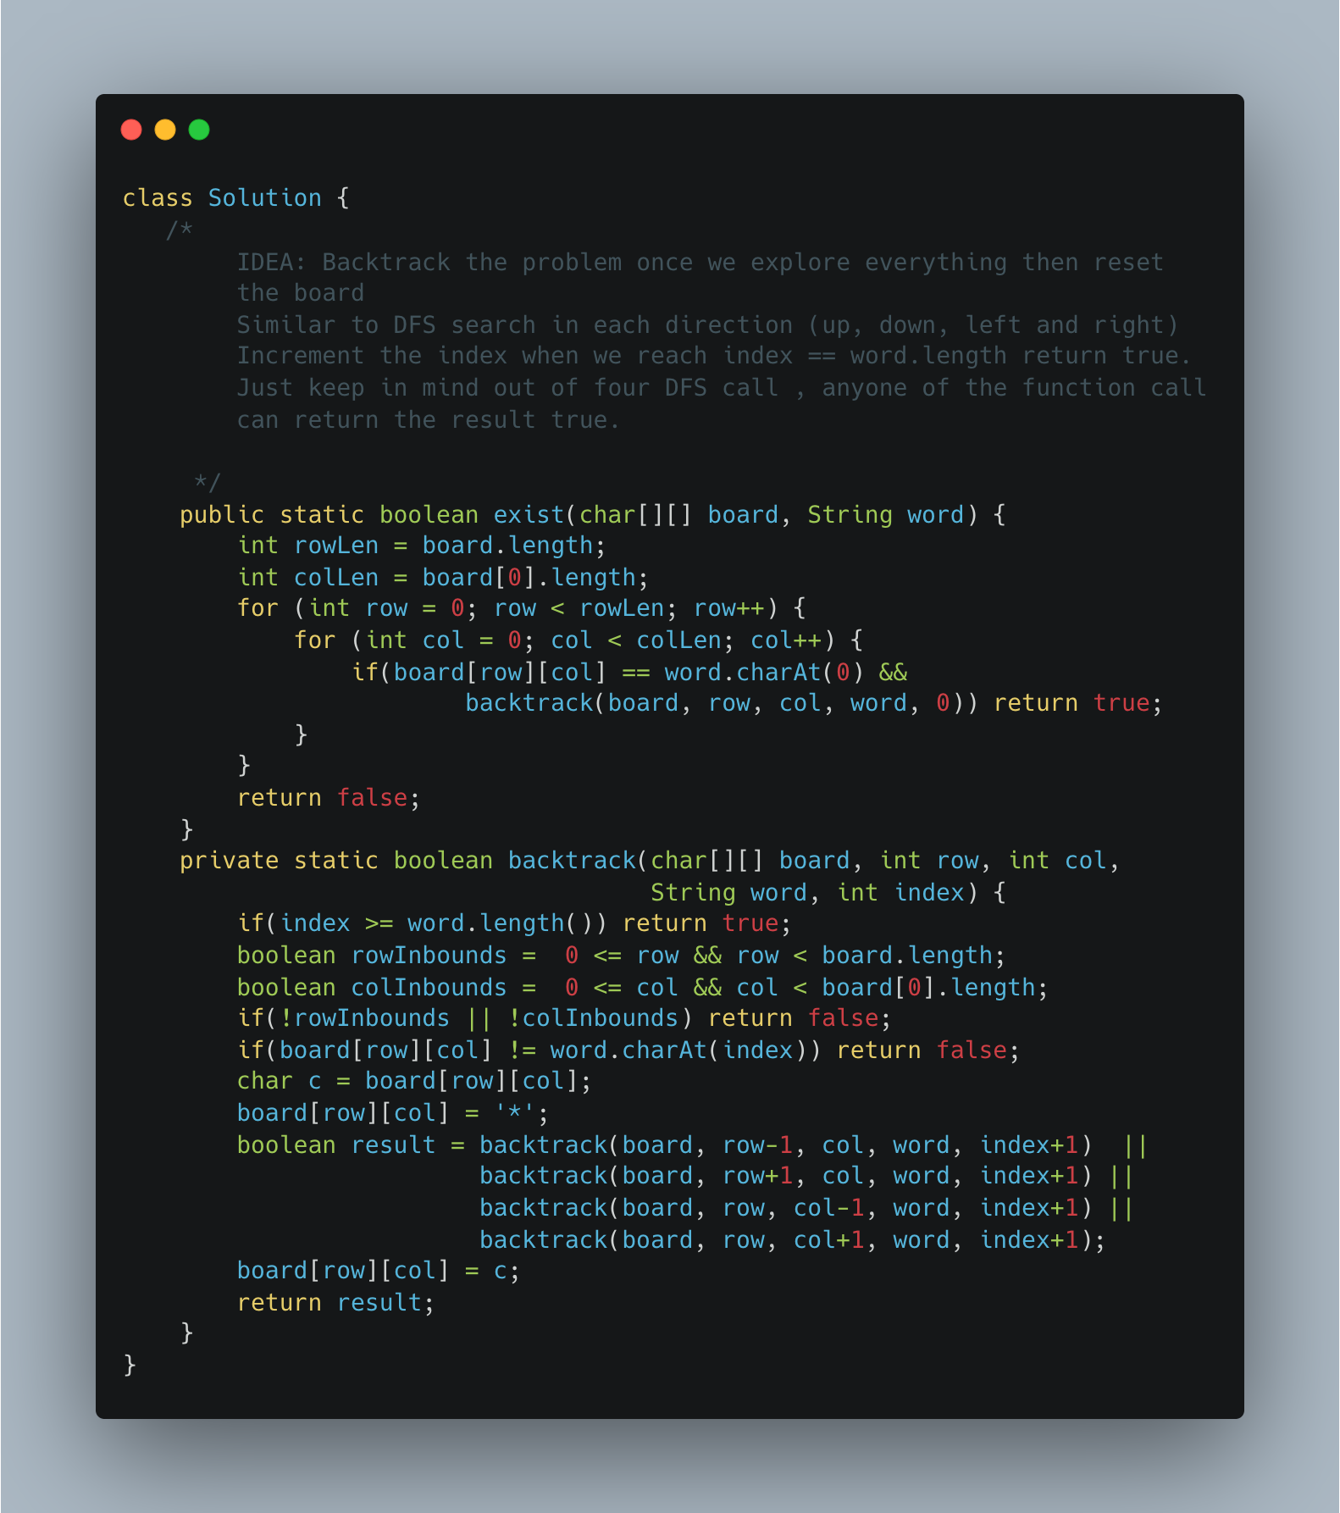

1. [Find Minimum in Rotated Sorted Array](https://leetcode.com/problems/find-minimum-in-rotated-sorted-array/)

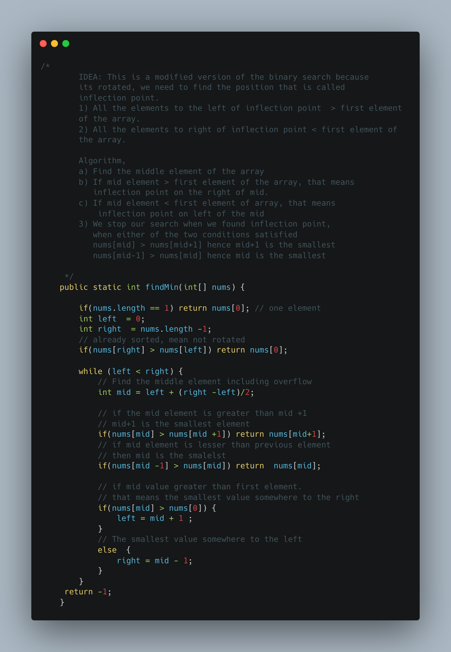

1. [Relative Sort Array](https://leetcode.com/problems/relative-sort-array/)

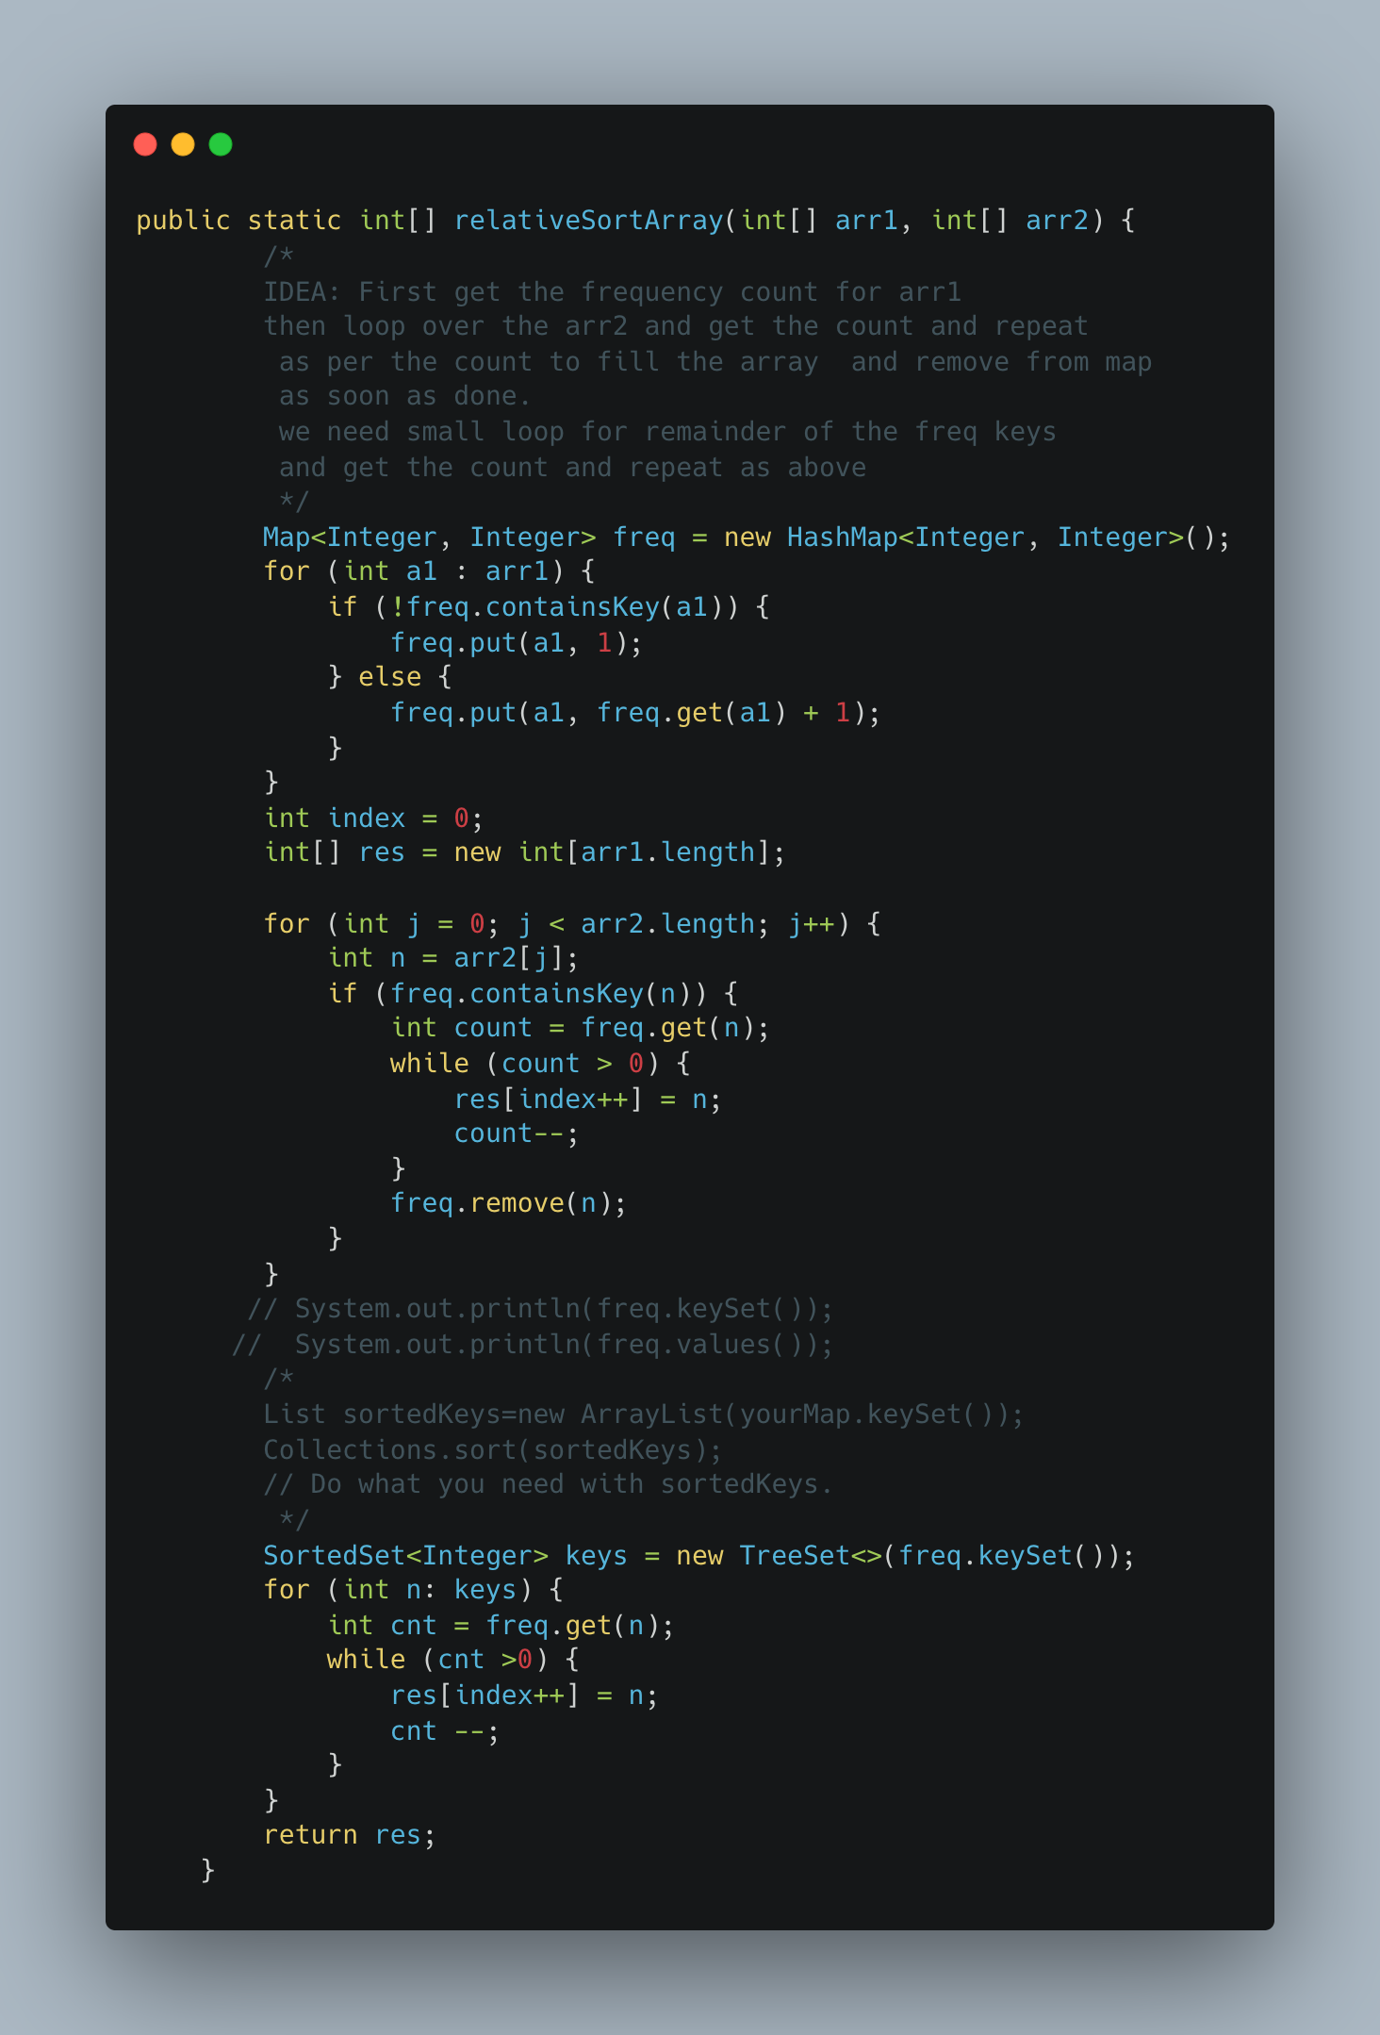

1. [Remove K Digits](https://leetcode.com/problems/remove-k-digits/)

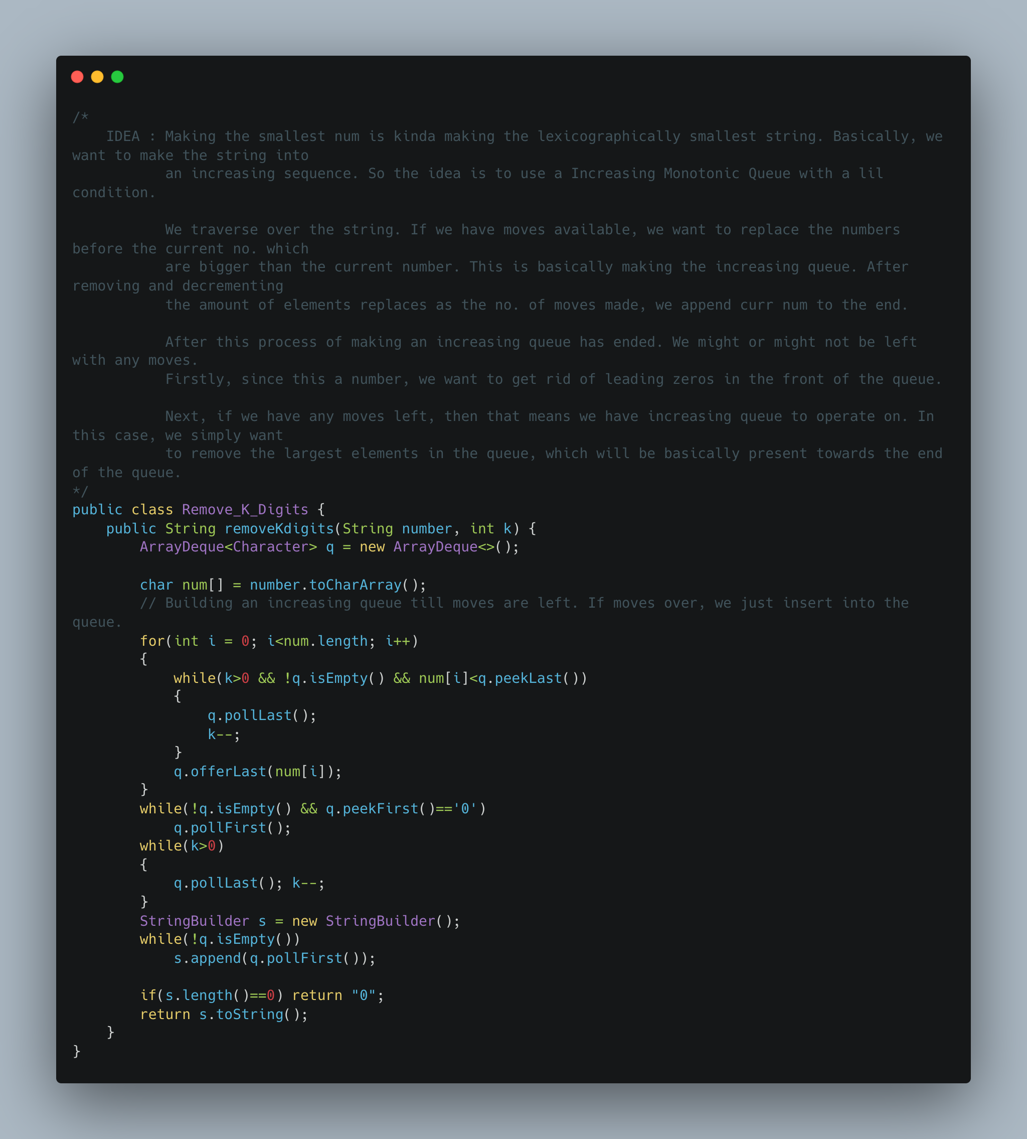

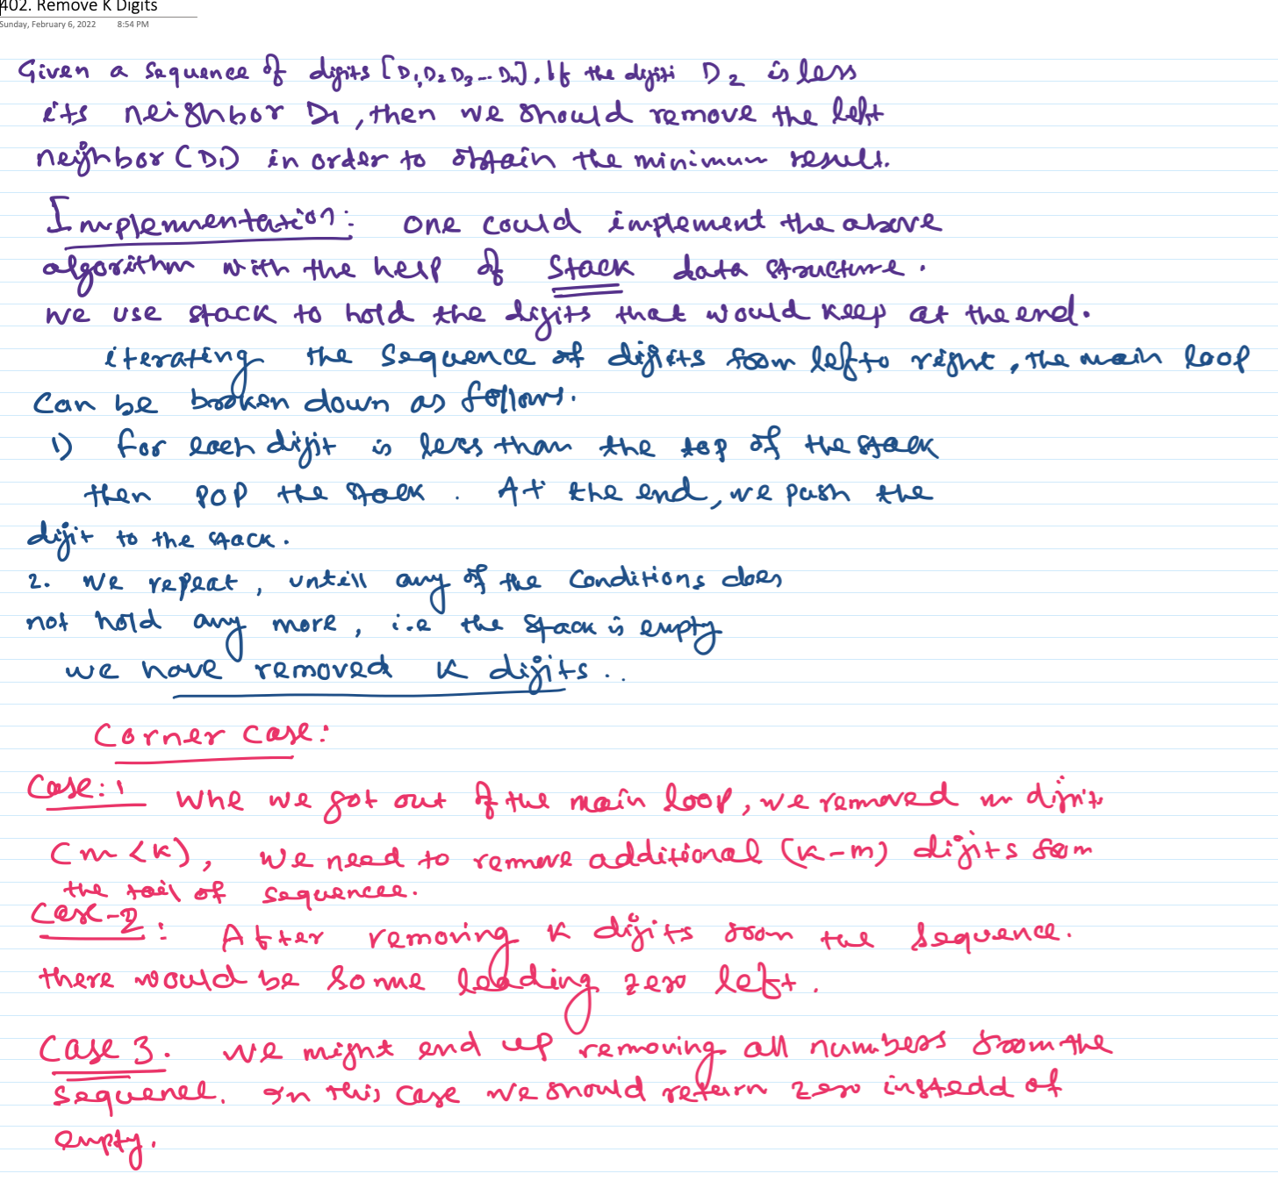

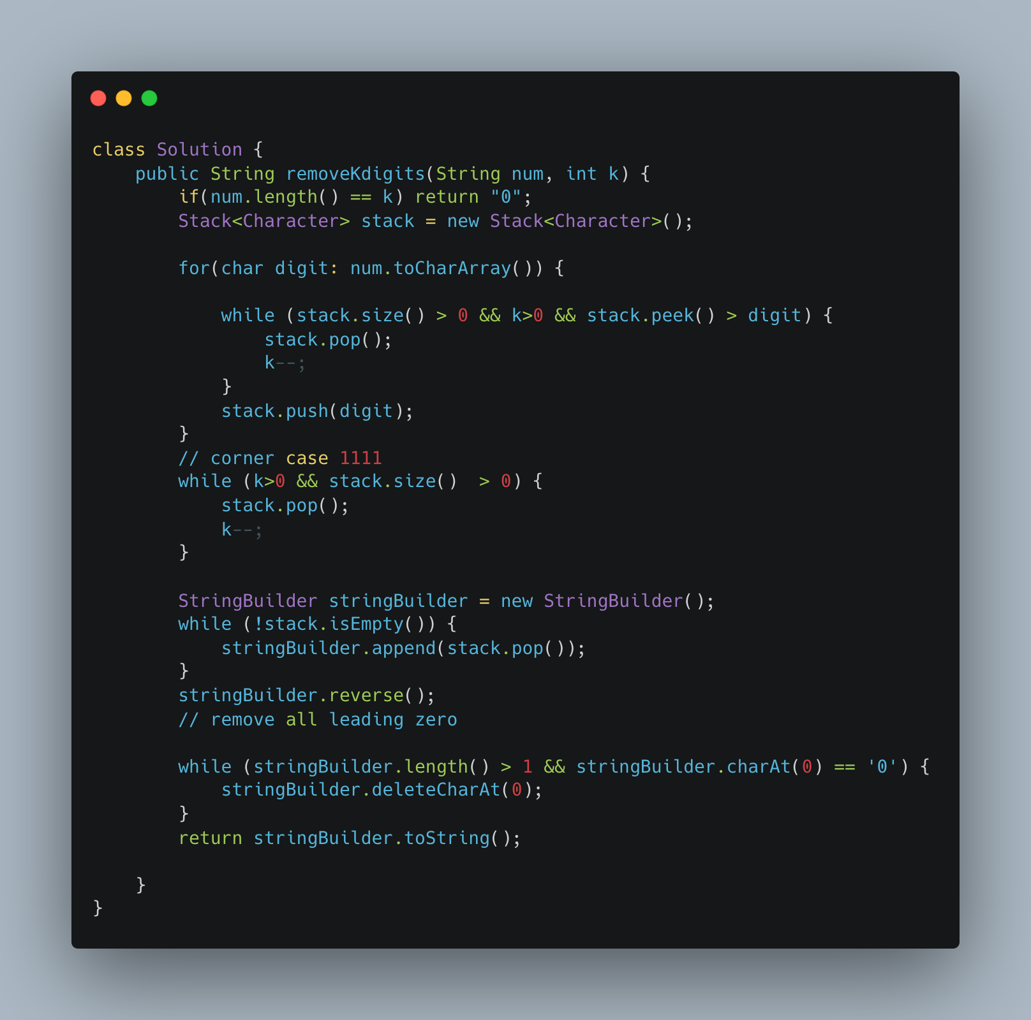

1. [Partition Labels](https://leetcode.com/problems/partition-labels/)

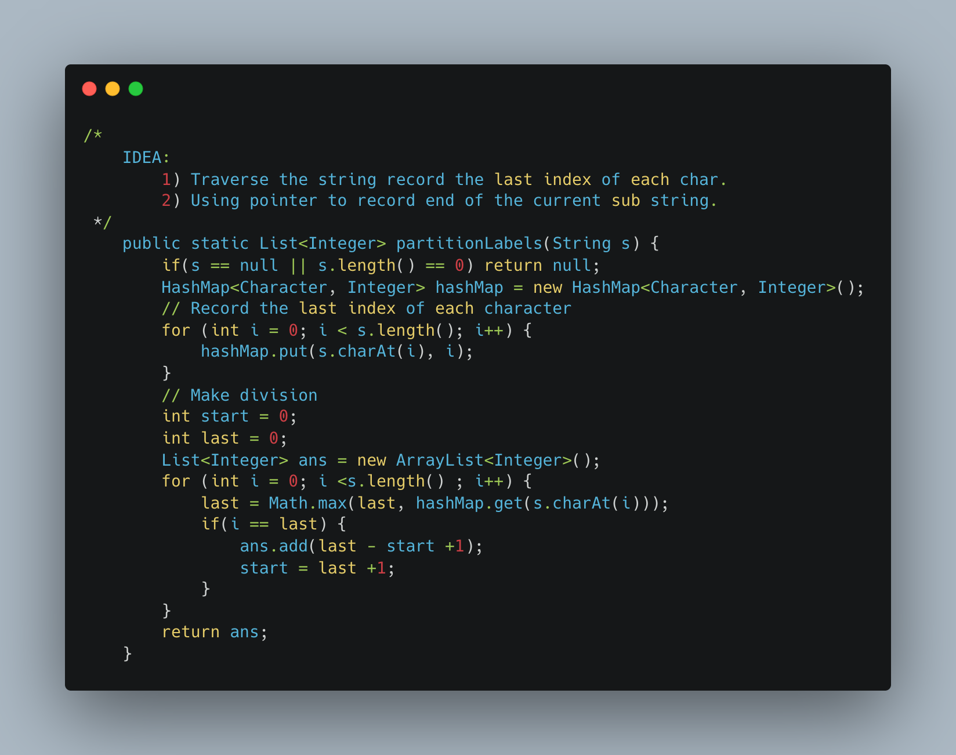

1. Fibonacci Dynamic Programming

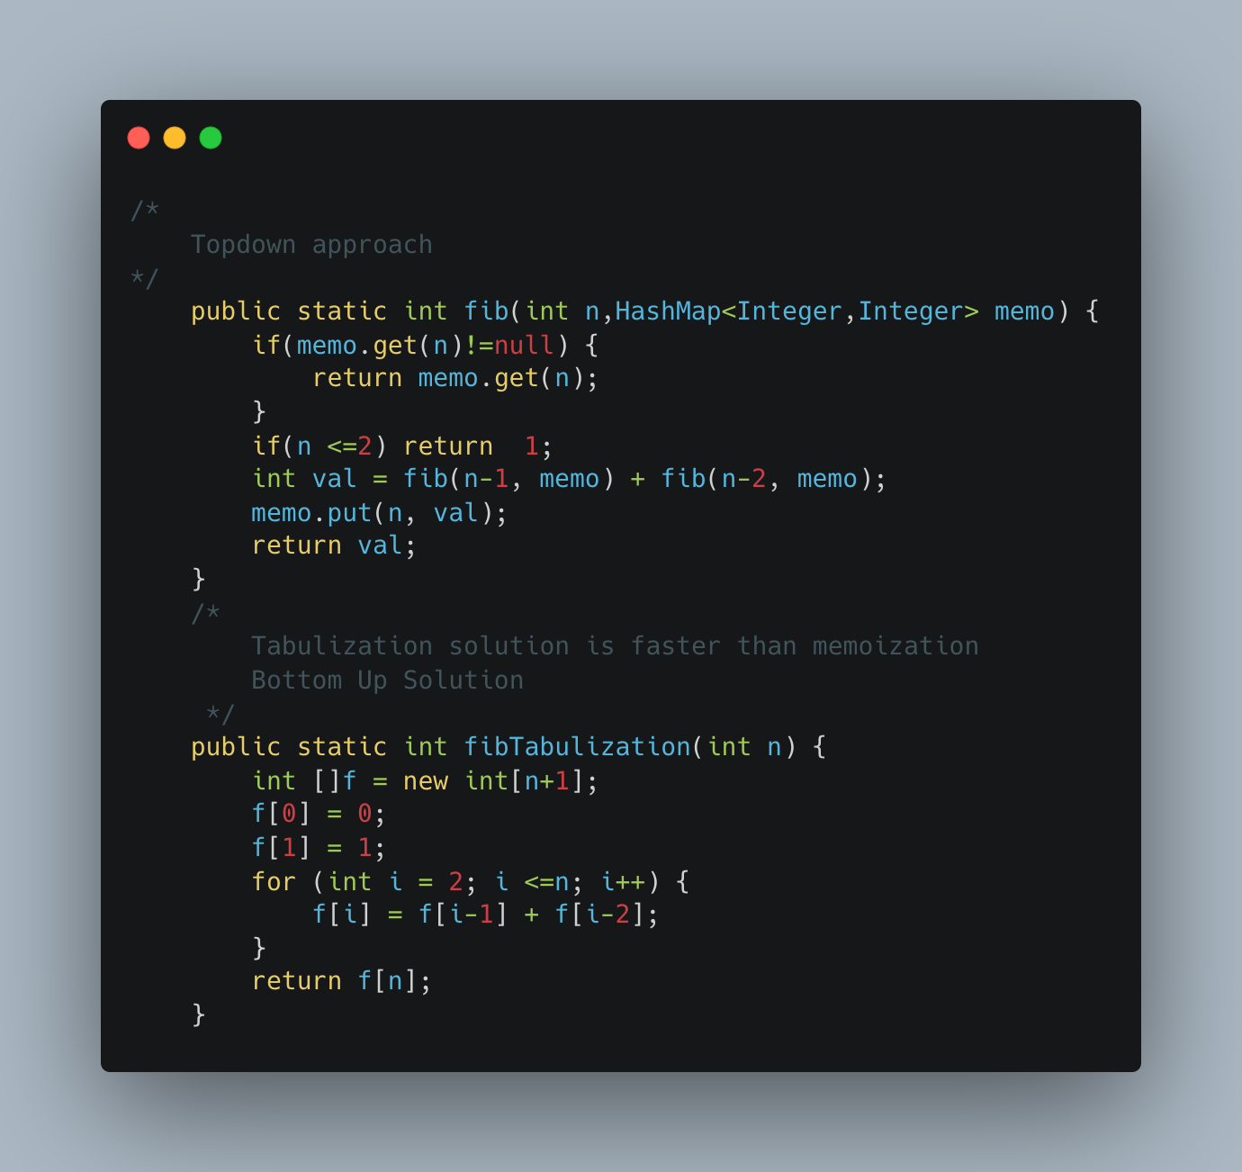

1. Distribute Coins in Binary Tree

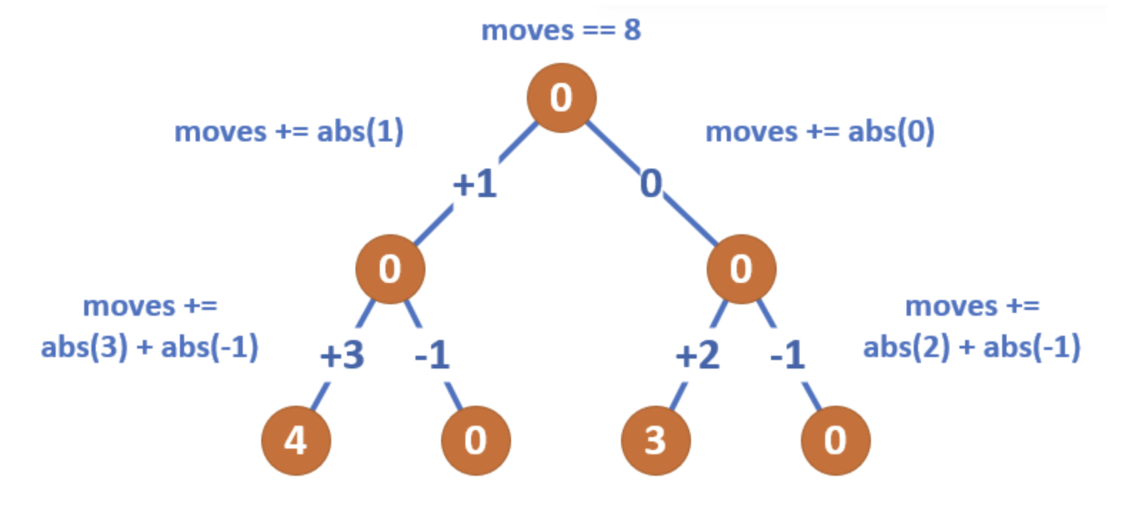

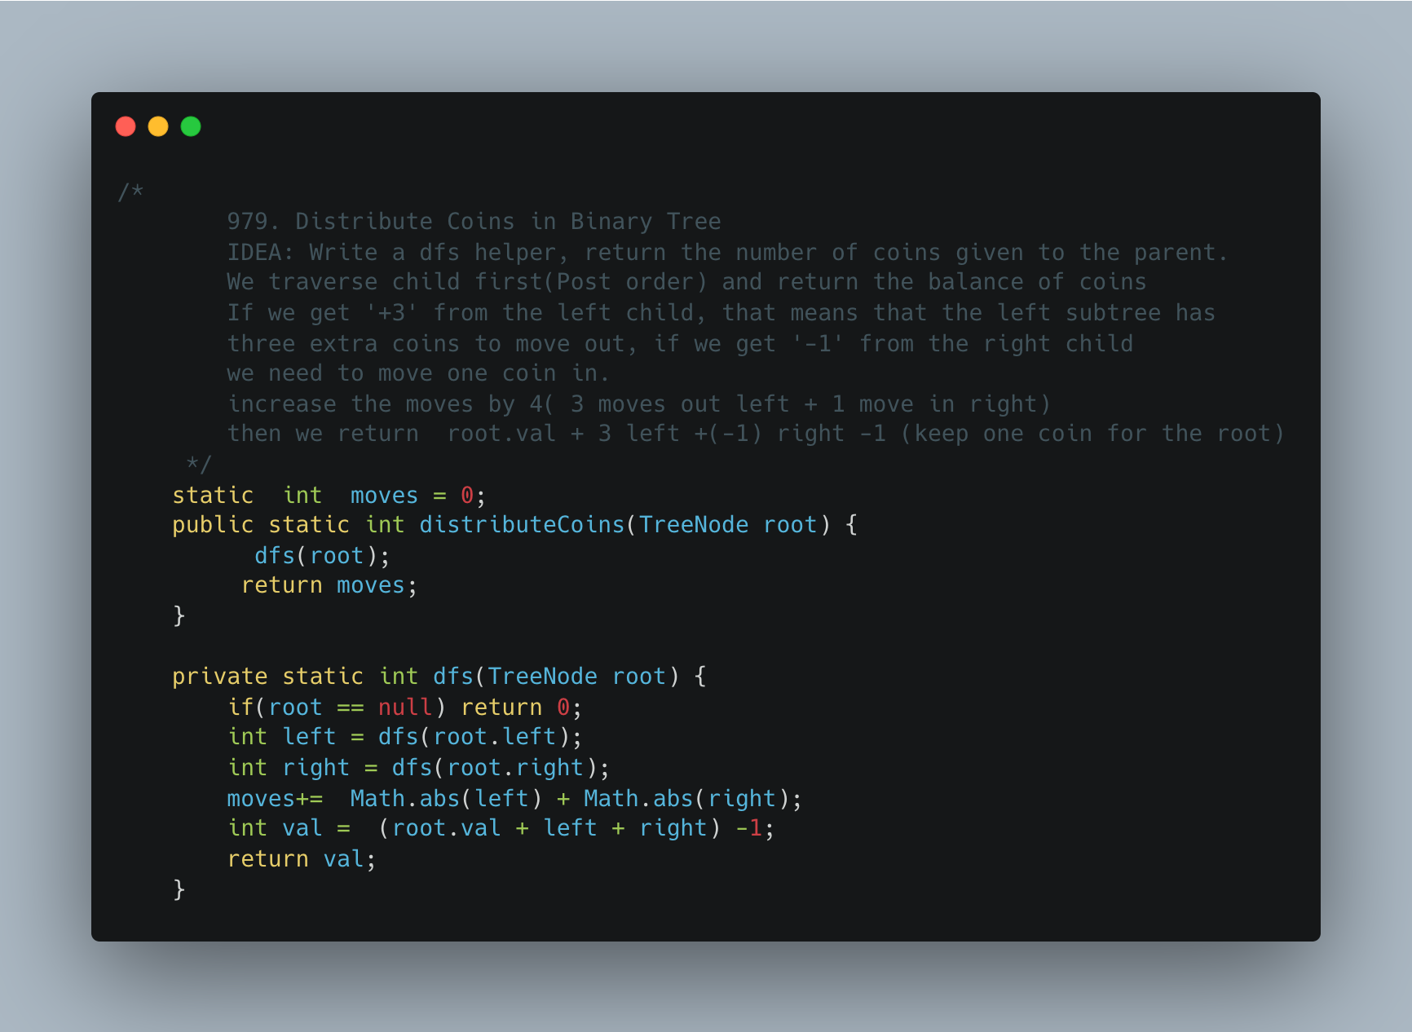

1. [Sorted Matrix](https://practice.geeksforgeeks.org/problems/sorted-matrix2333/1)

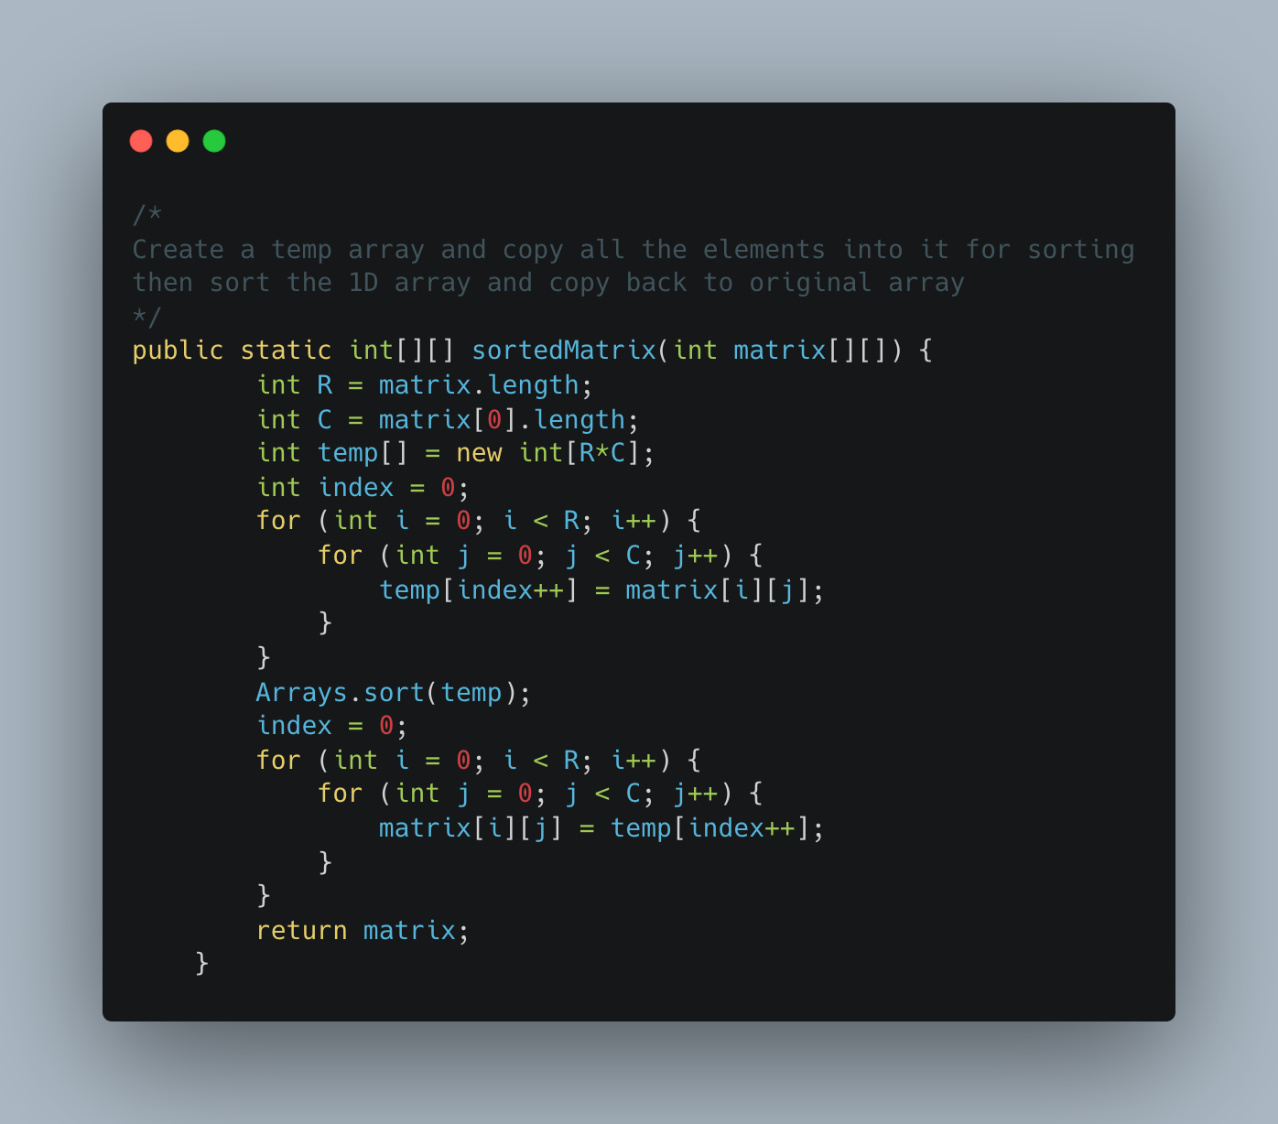

1. [Row with Max 1s](https://practice.geeksforgeeks.org/problems/row-with-max-1s0023/1)

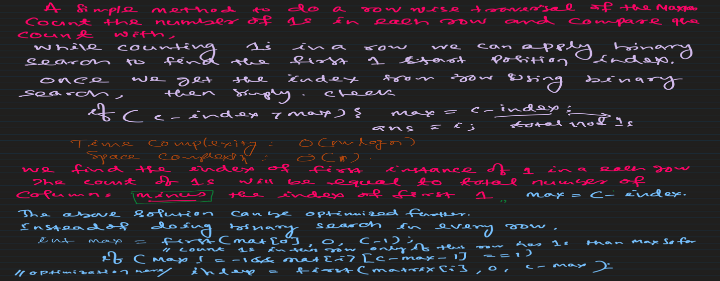

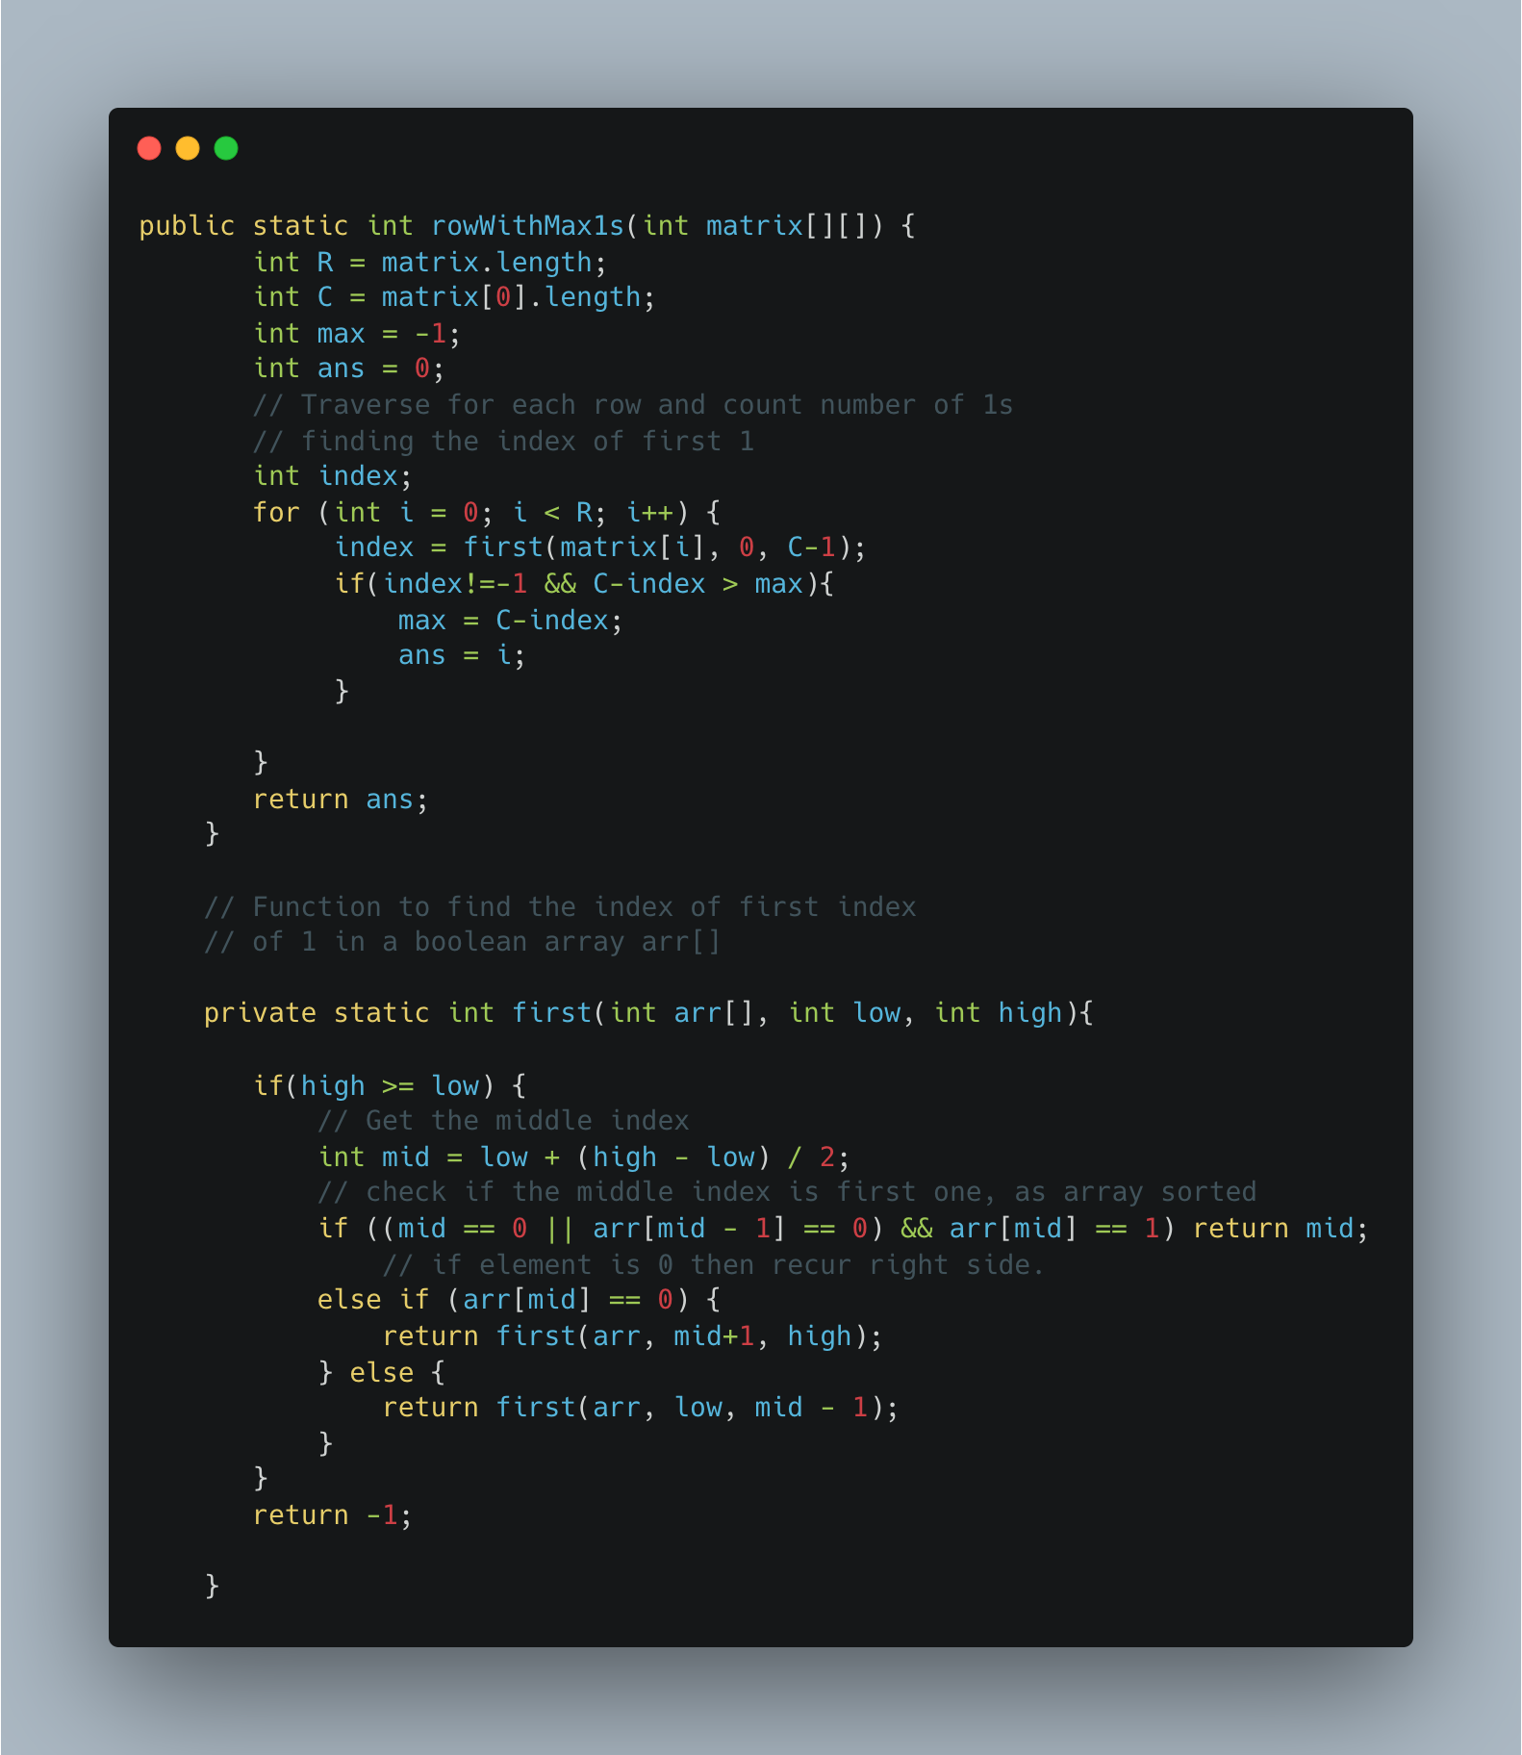

1. [Search a 2D Matrix](https://leetcode.com/problems/search-a-2d-matrix/)

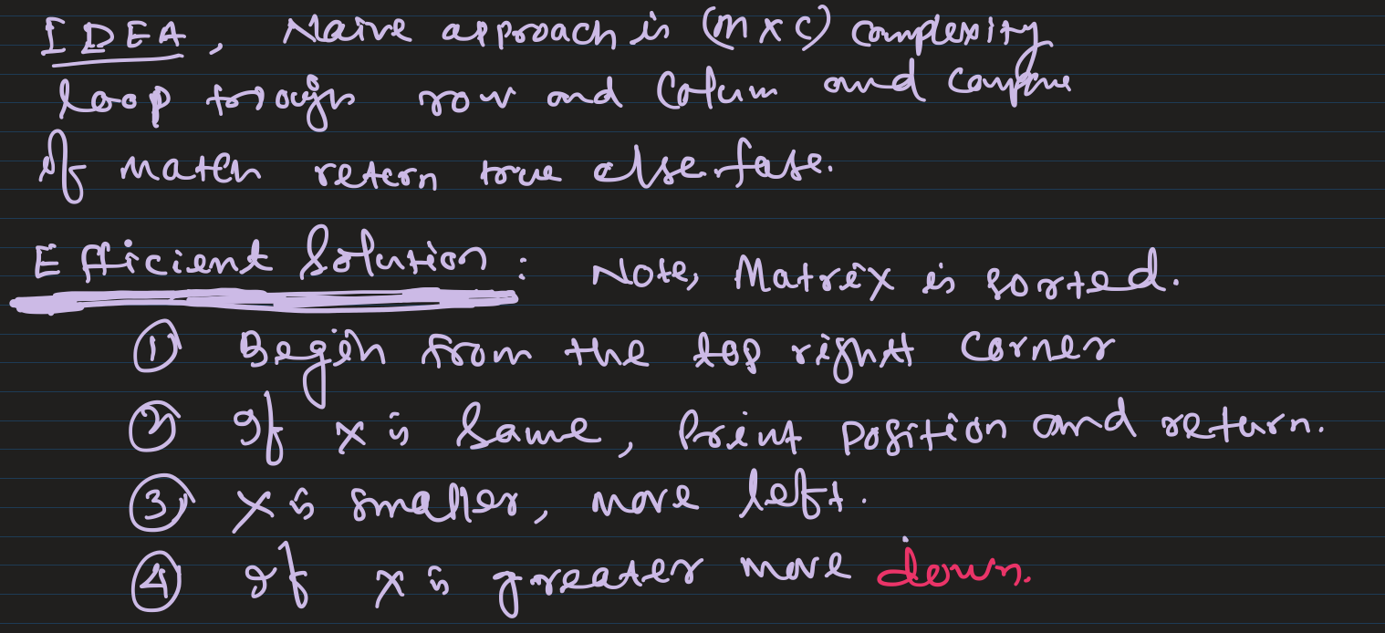

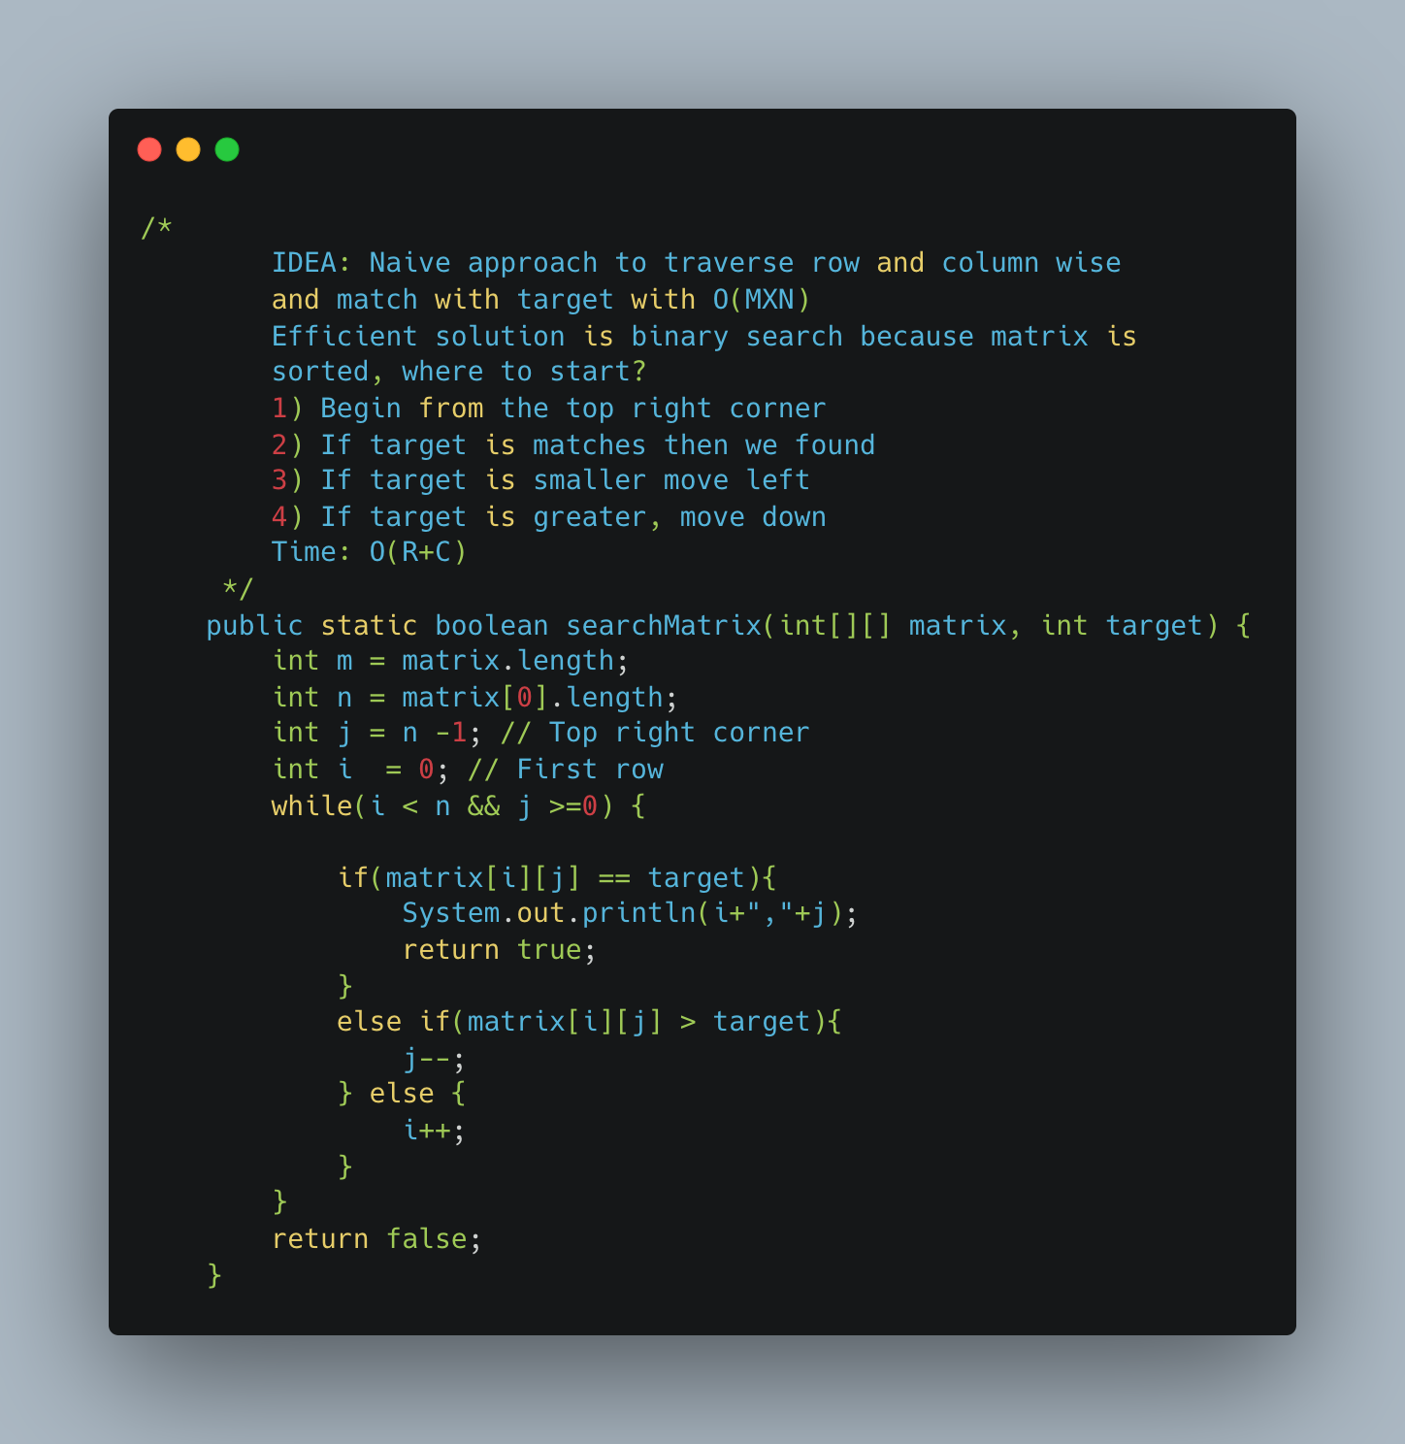

1. [Spirally Traversing a Matrix](https://practice.geeksforgeeks.org/problems/spirally-traversing-a-matrix-1587115621/1)

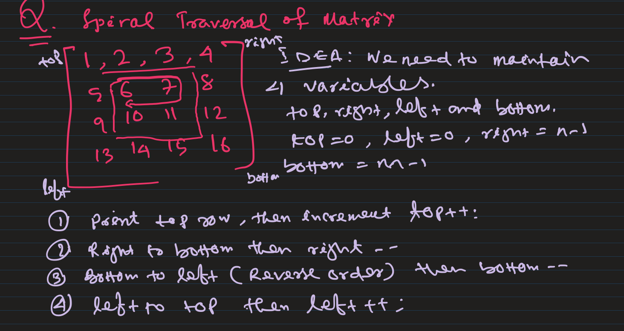

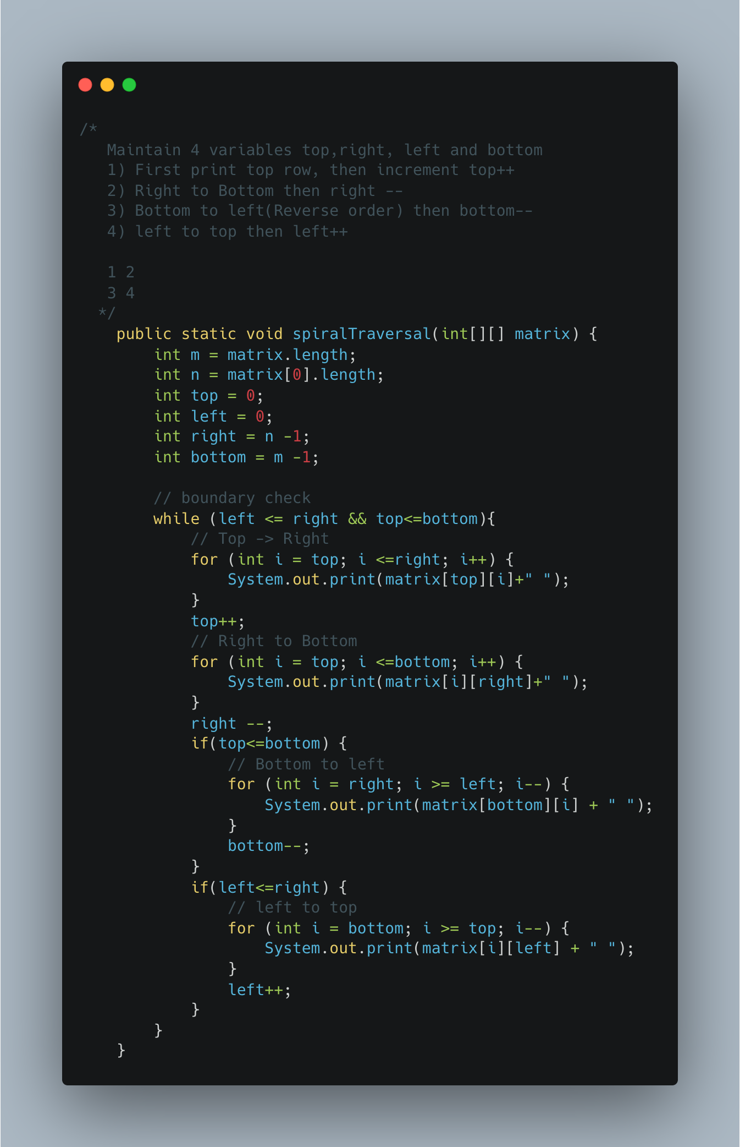

1. Transpose a Matrix

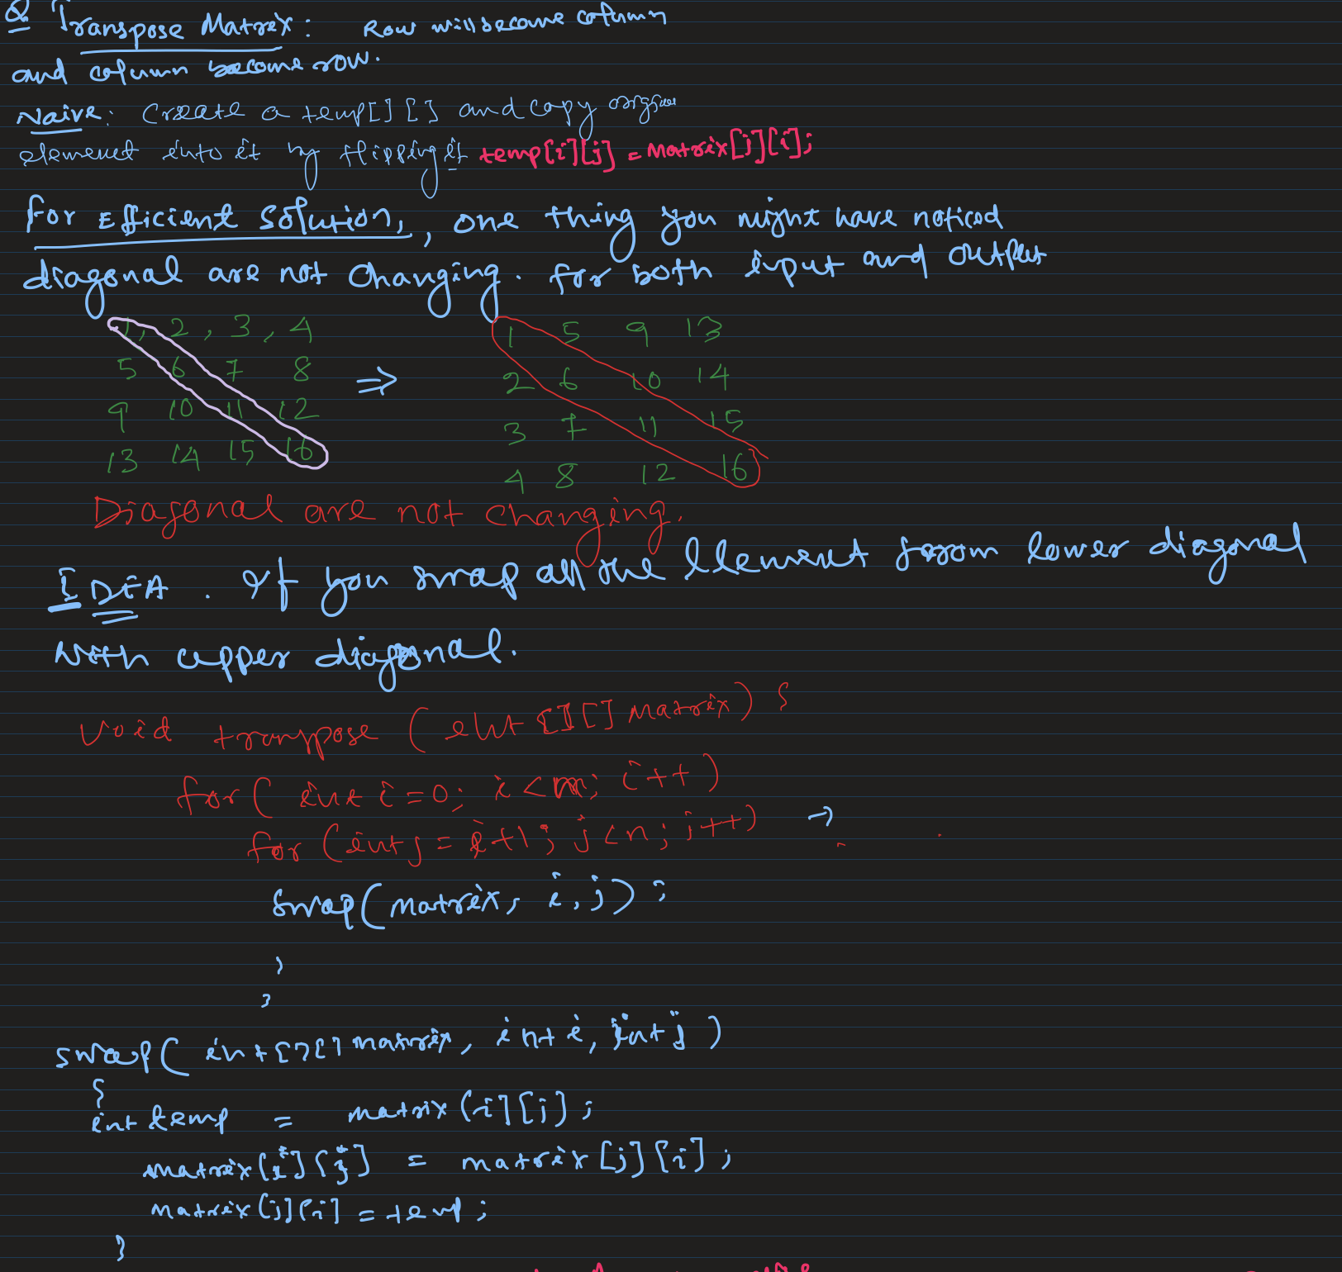

1. Rotate Matrix by 90* Anticlockwise

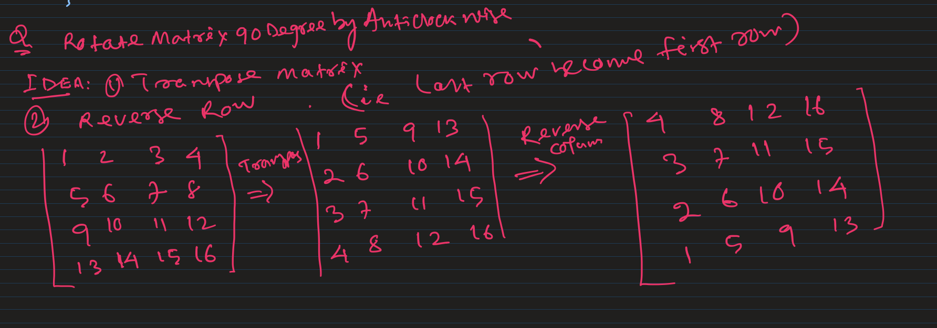

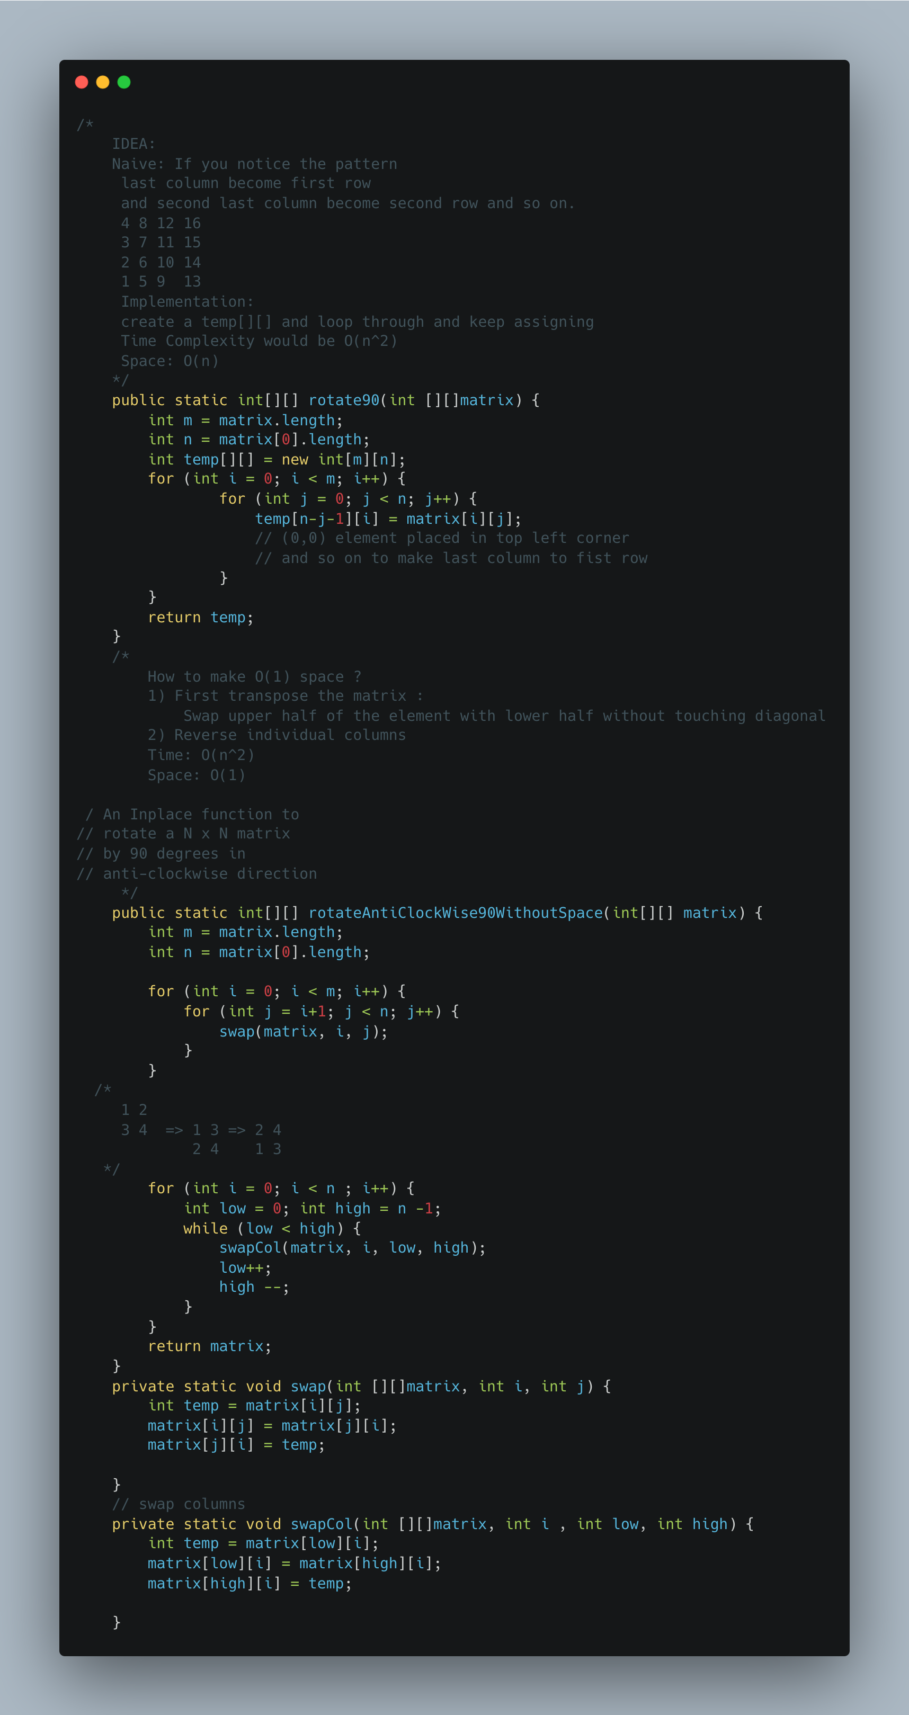

1. [Rotate a matrix by 90 Degree Clockwise](https://www.geeksforgeeks.org/rotate-a-matrix-by-90-degree-in-clockwise-direction-without-using-any-extra-space/)

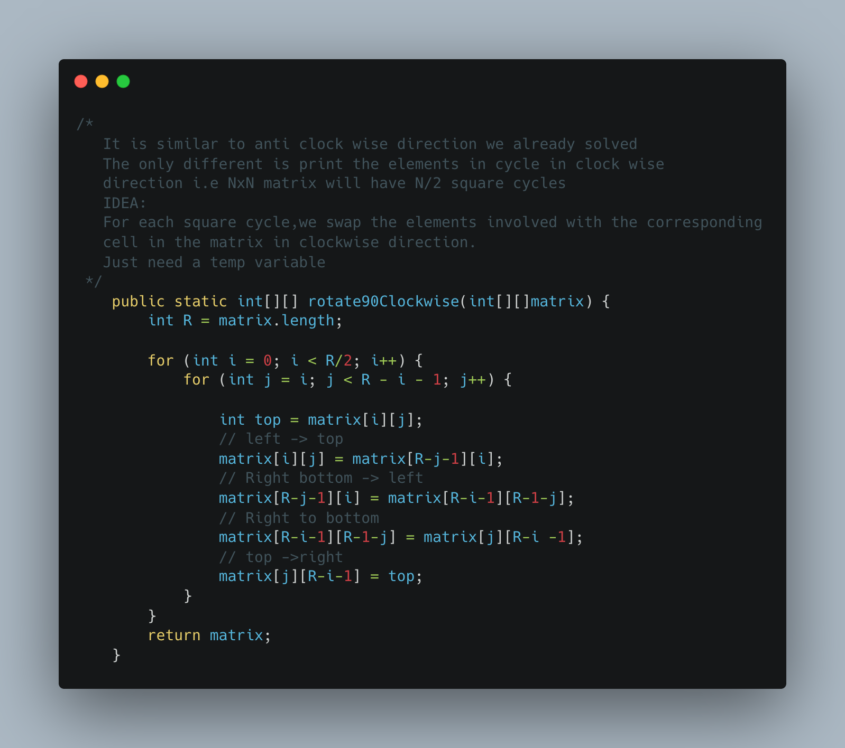

1. [Lemonade Change](https://leetcode.com/problems/lemonade-change/)

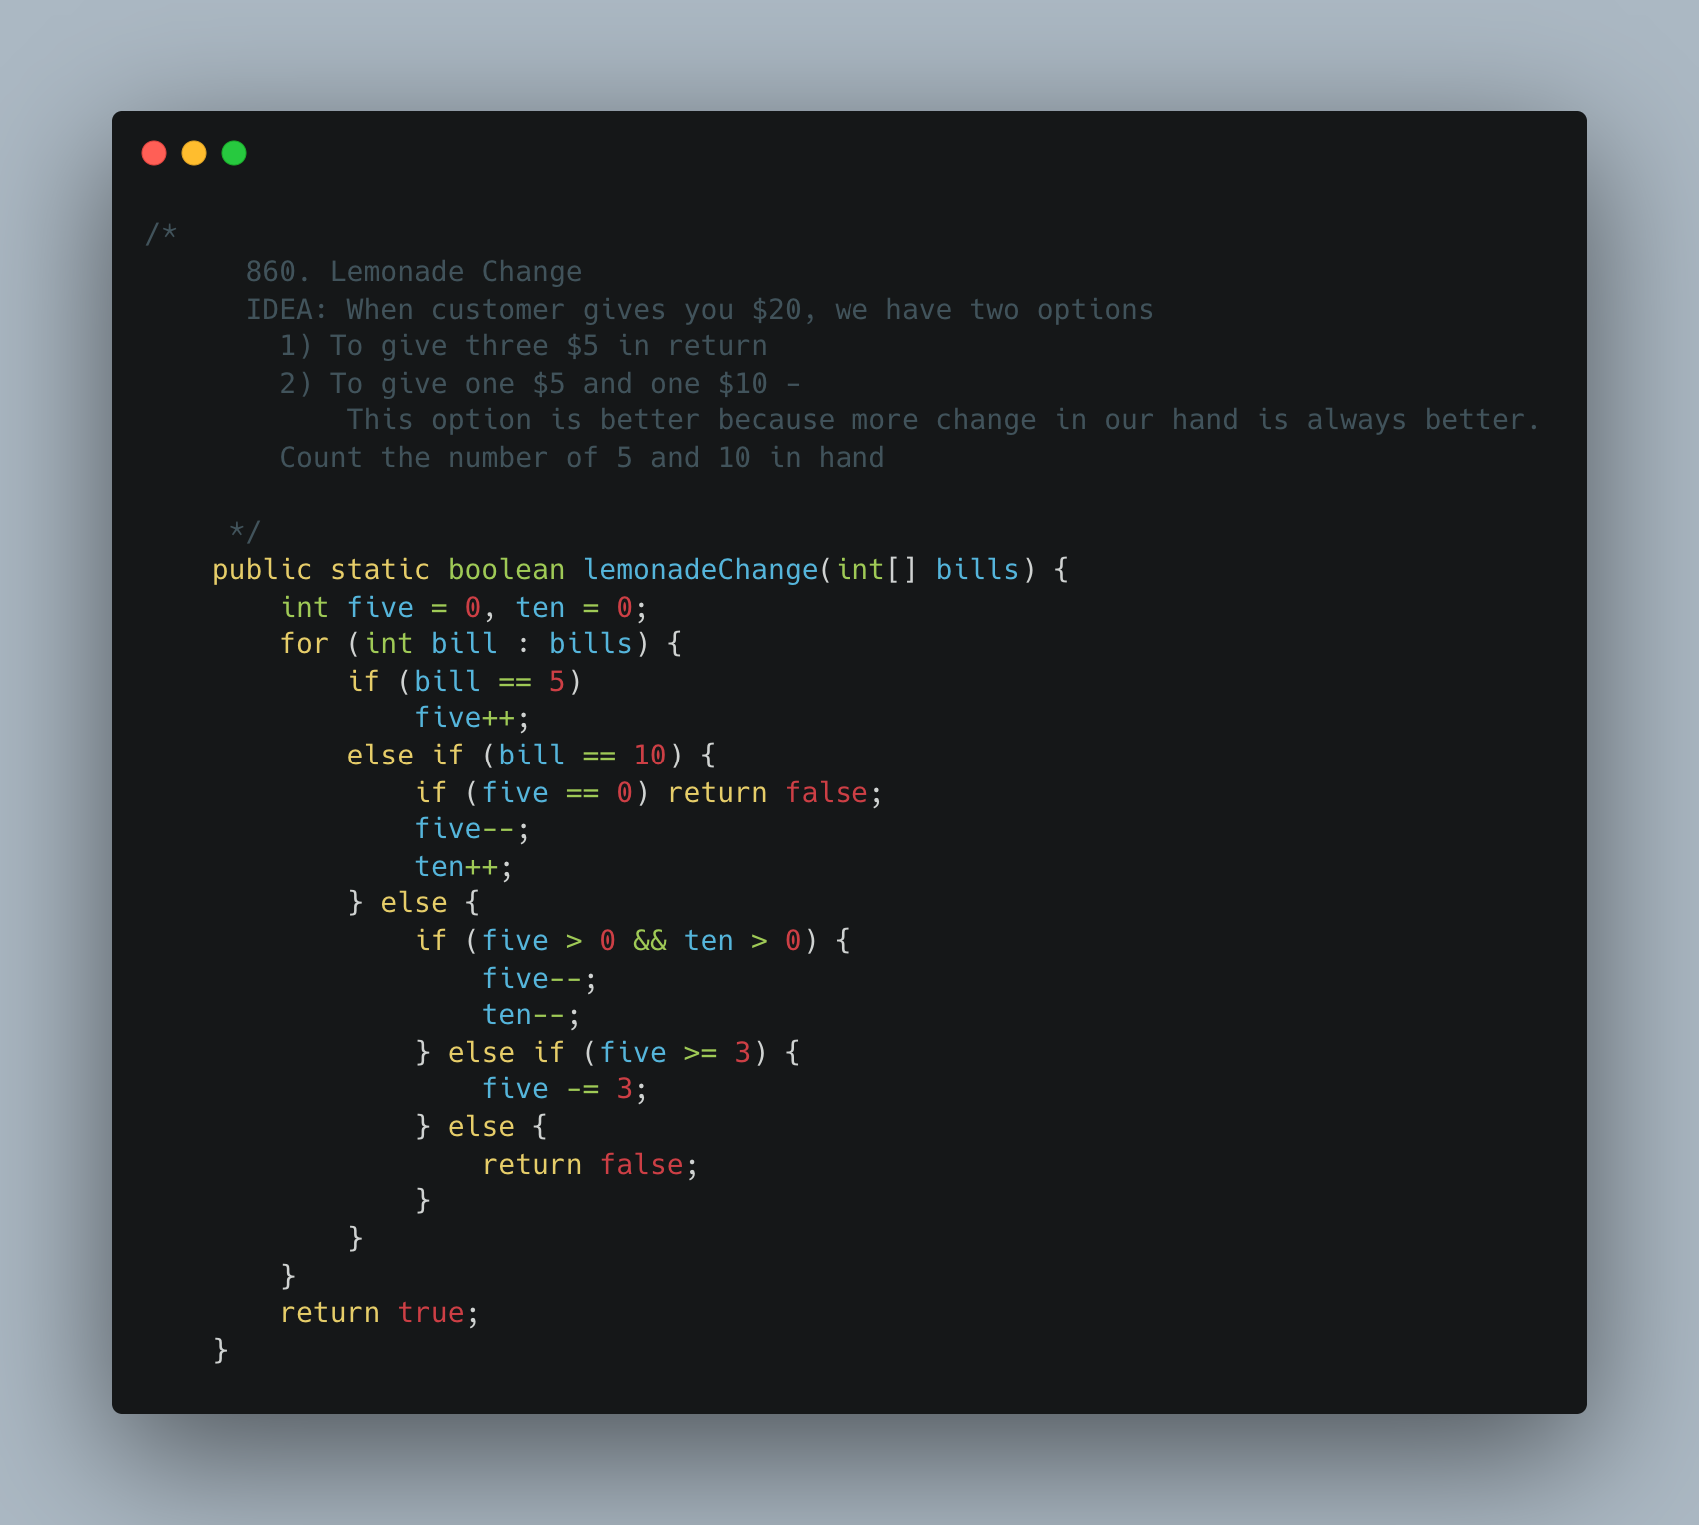

1. [Keys and Rooms](https://leetcode.com/problems/keys-and-rooms/)

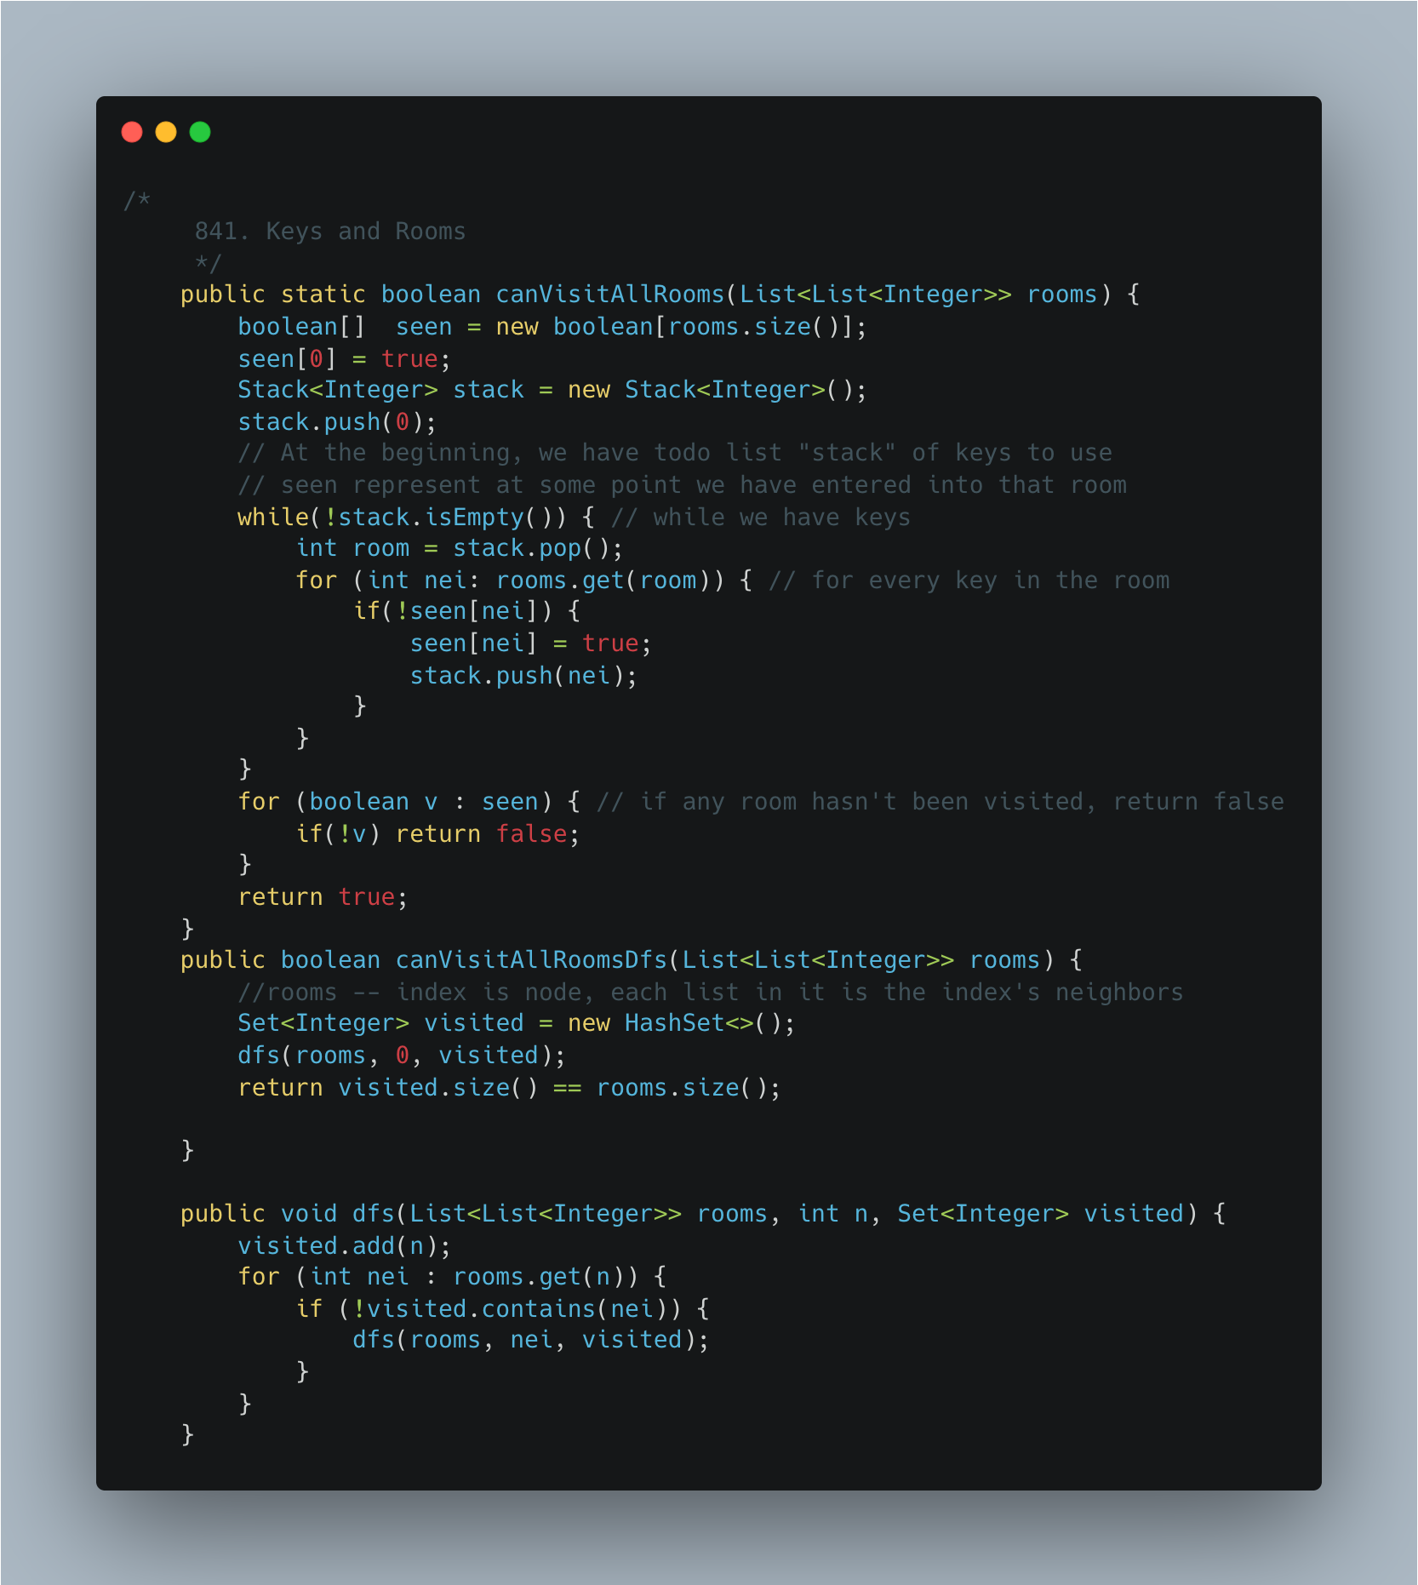

1. [Largest Rectangle](https://leetcode.com/problems/largest-rectangle-in-histogram/)

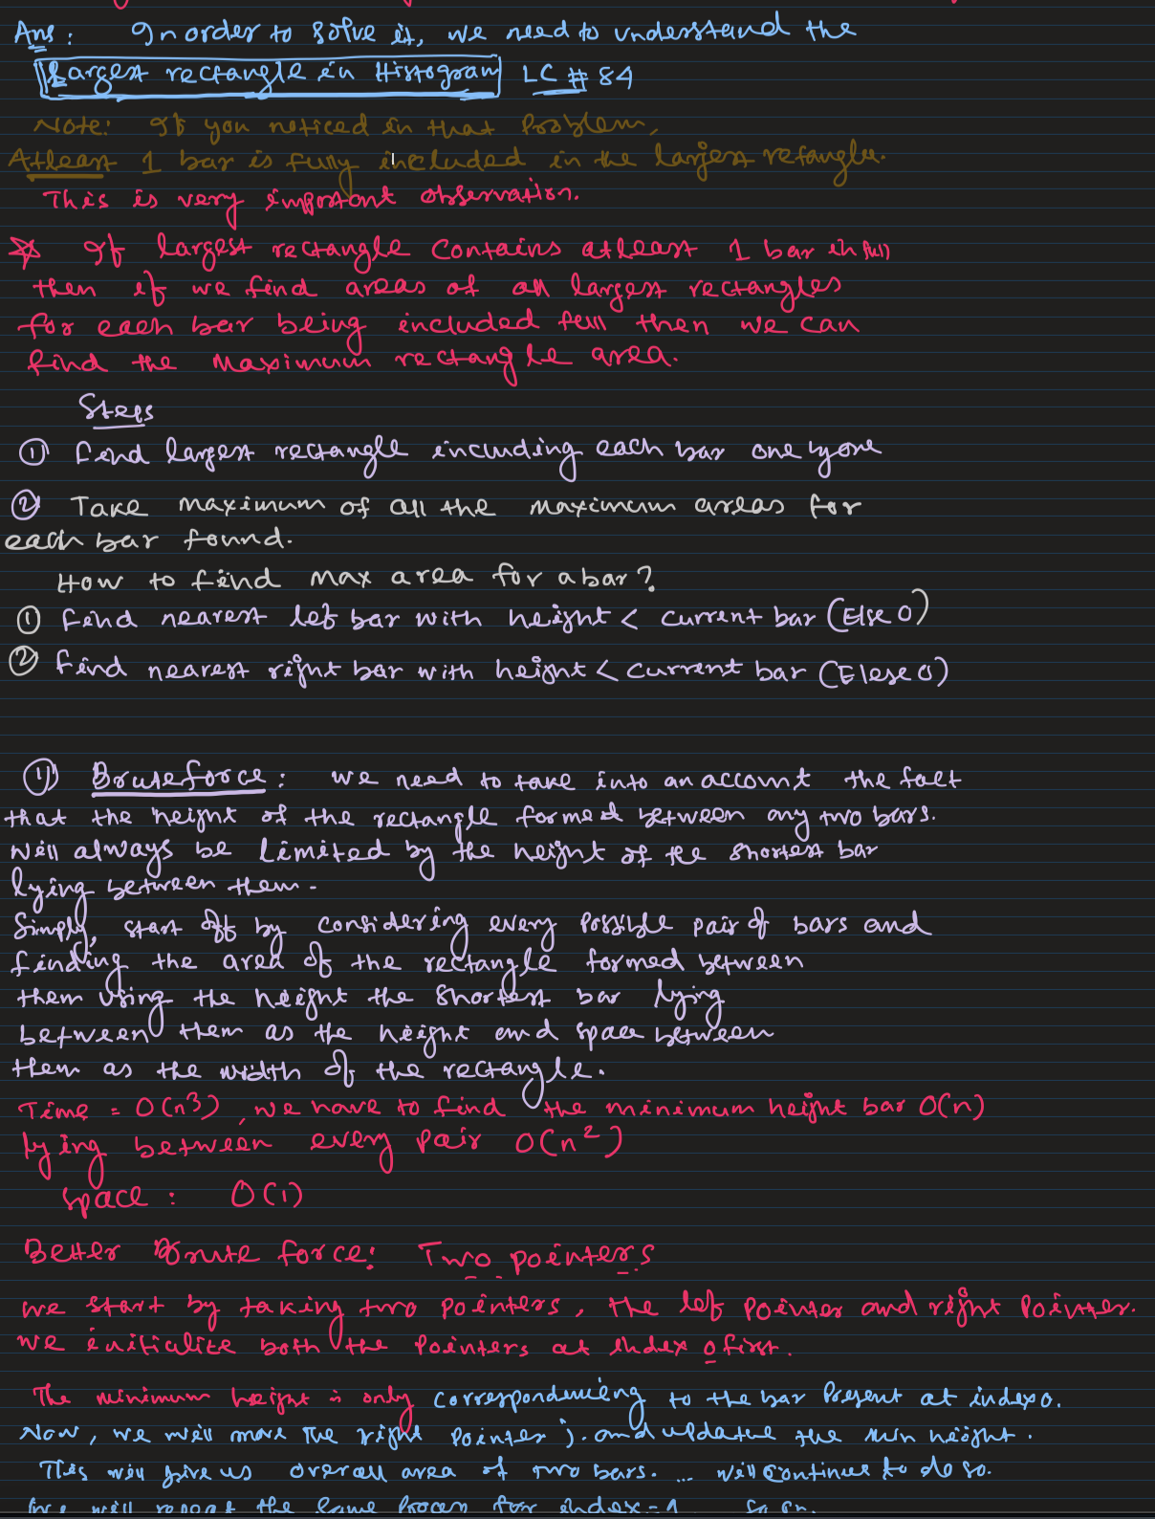

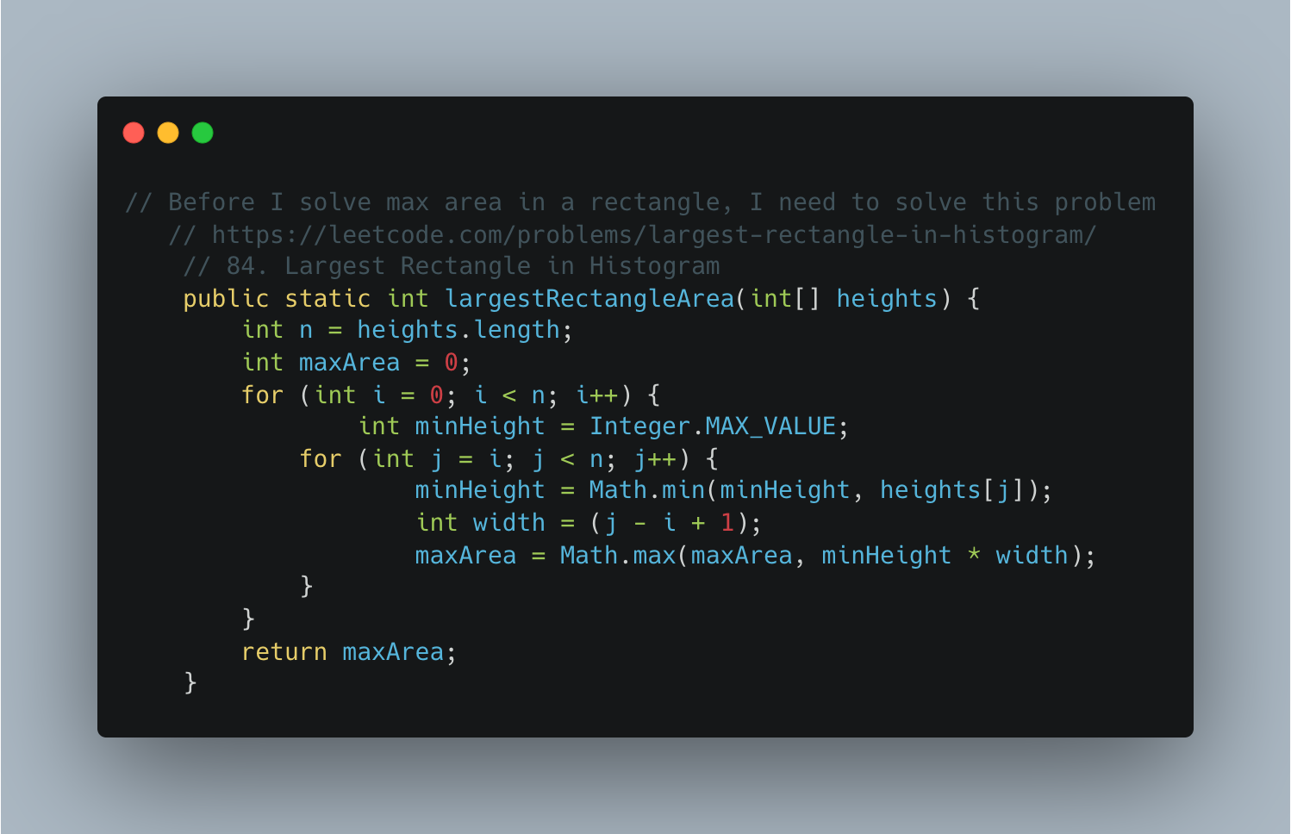

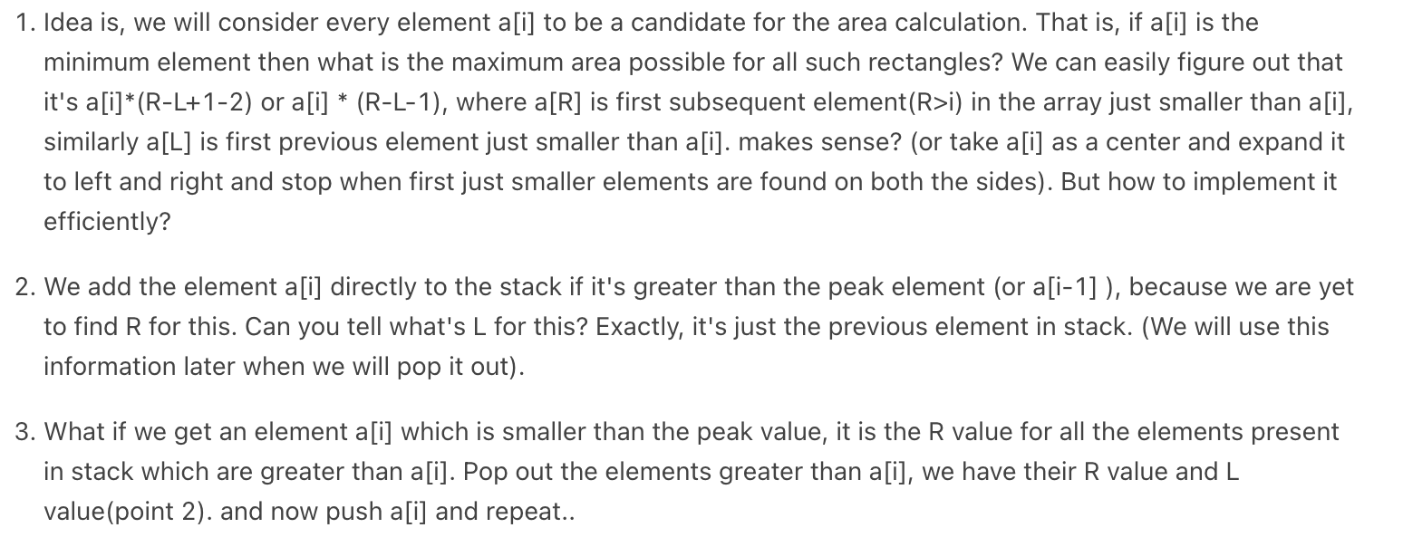

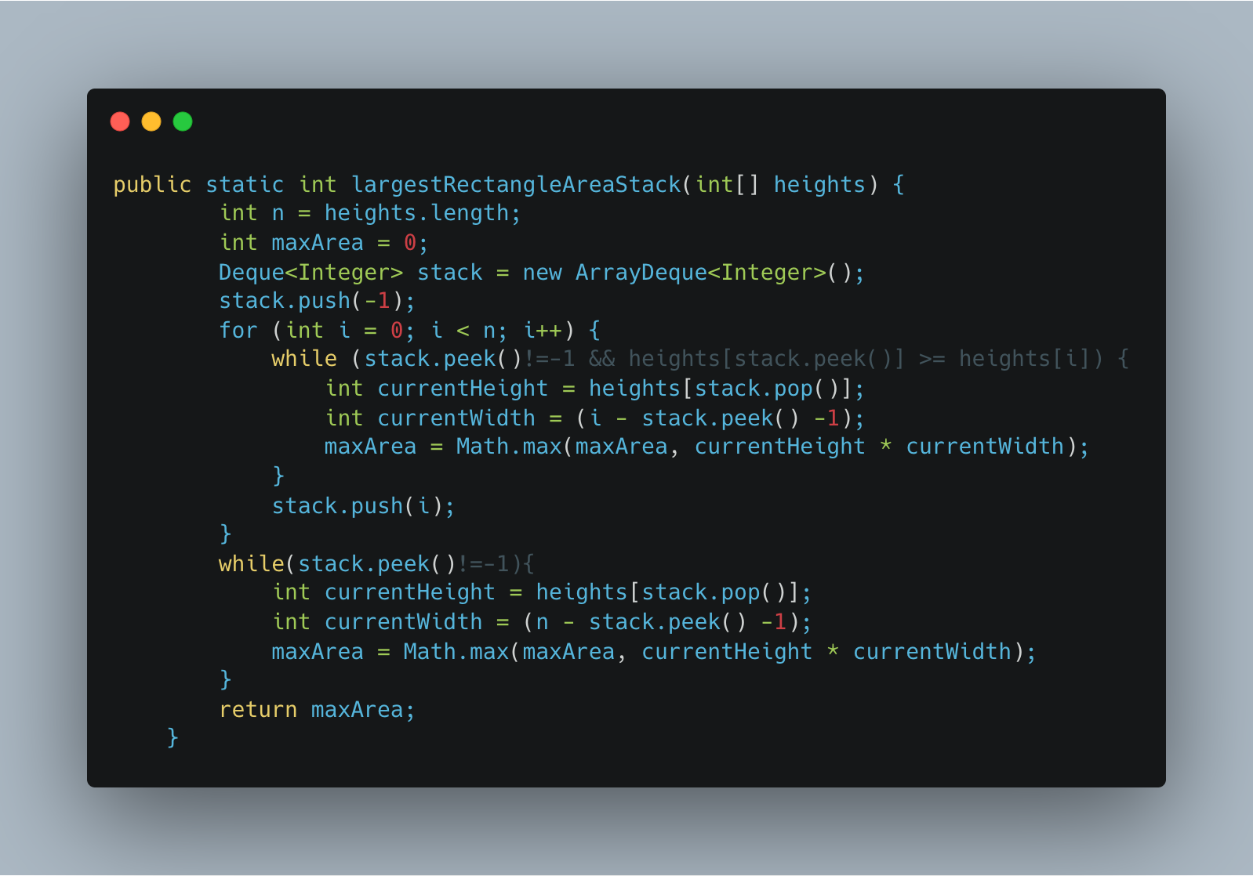

1. [Max Rectangle](https://practice.geeksforgeeks.org/problems/max-rectangle/1)

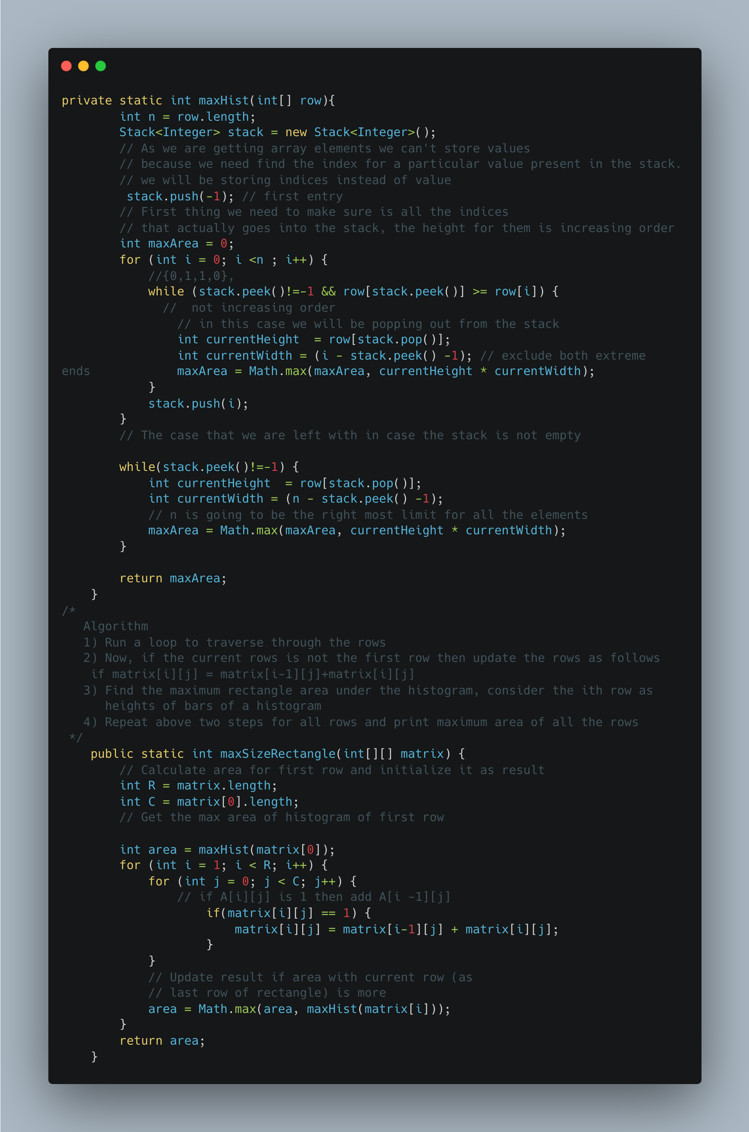

1. Find Median of row wise sorted matrix

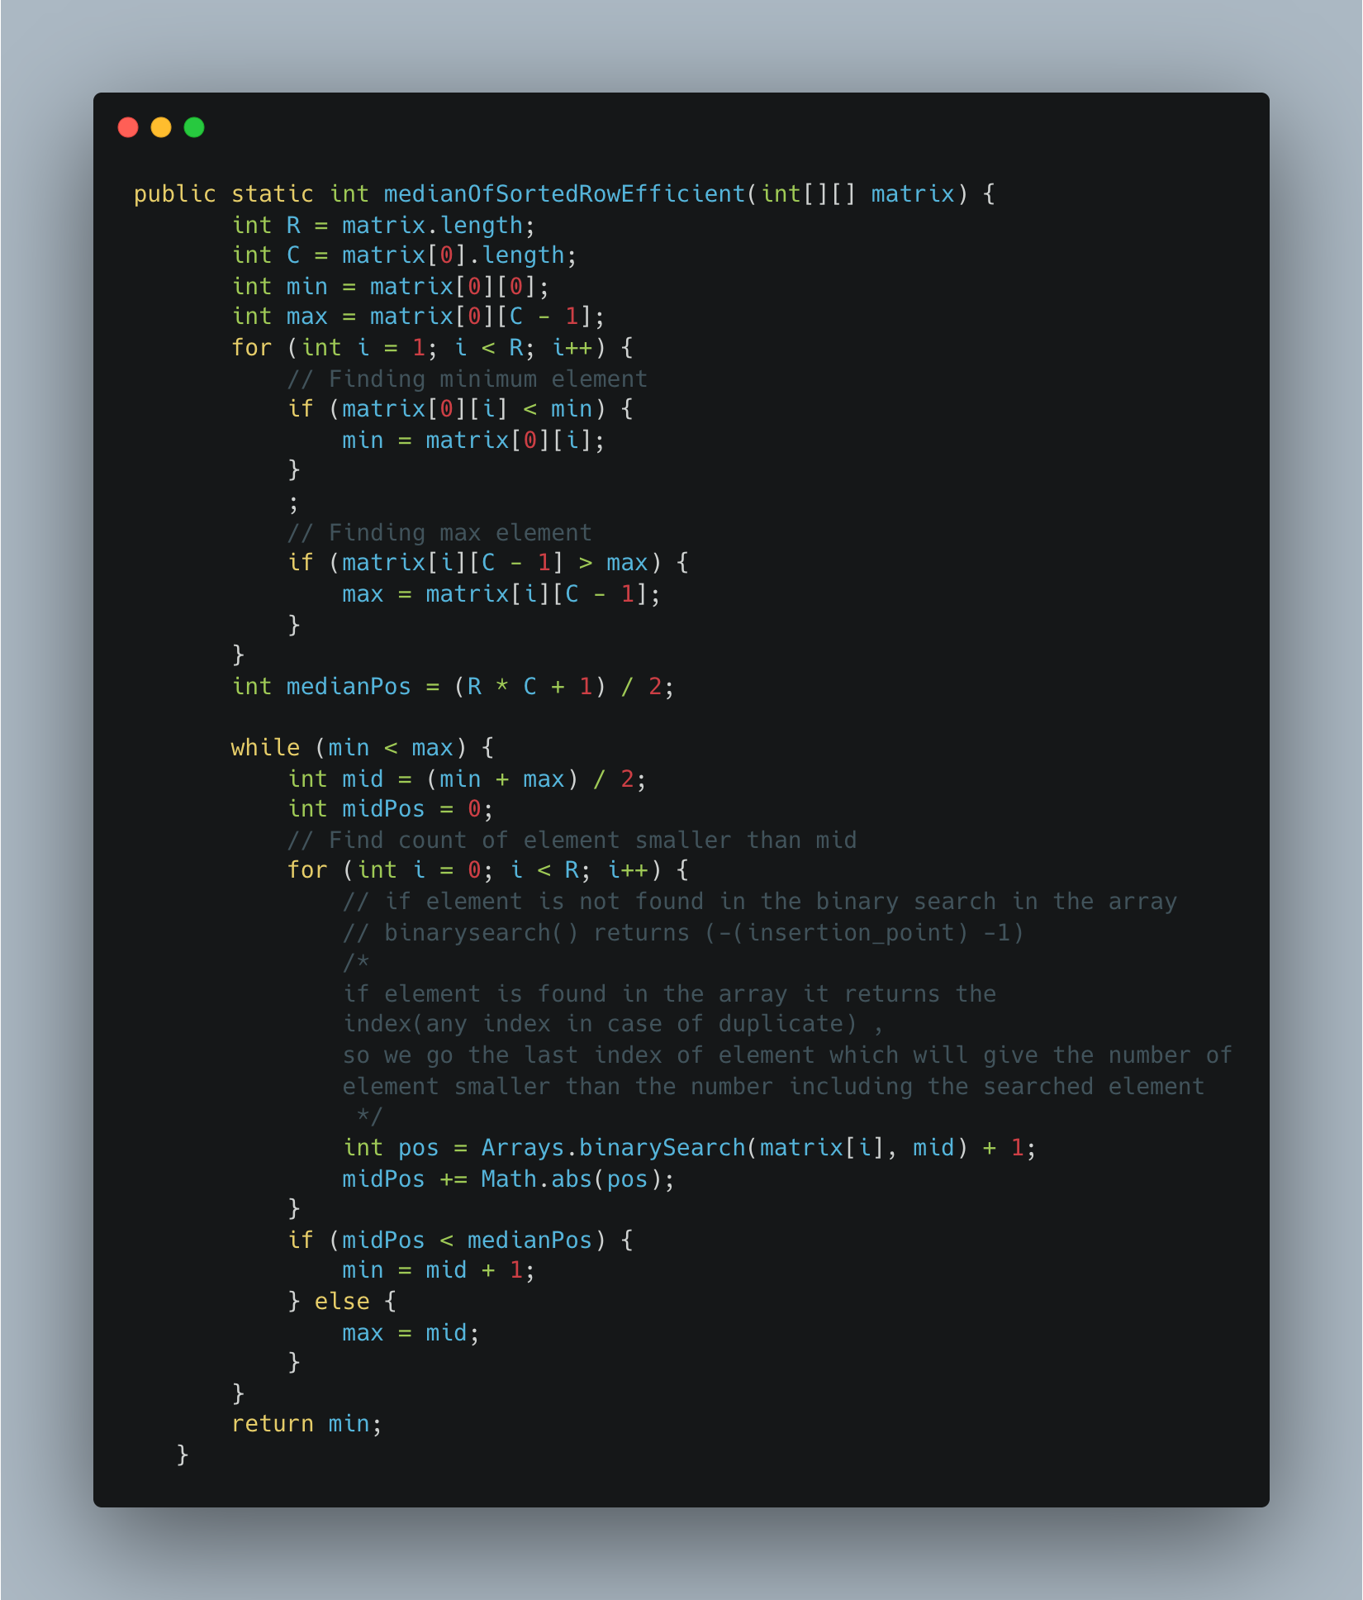

1. Find a subarray with given sum

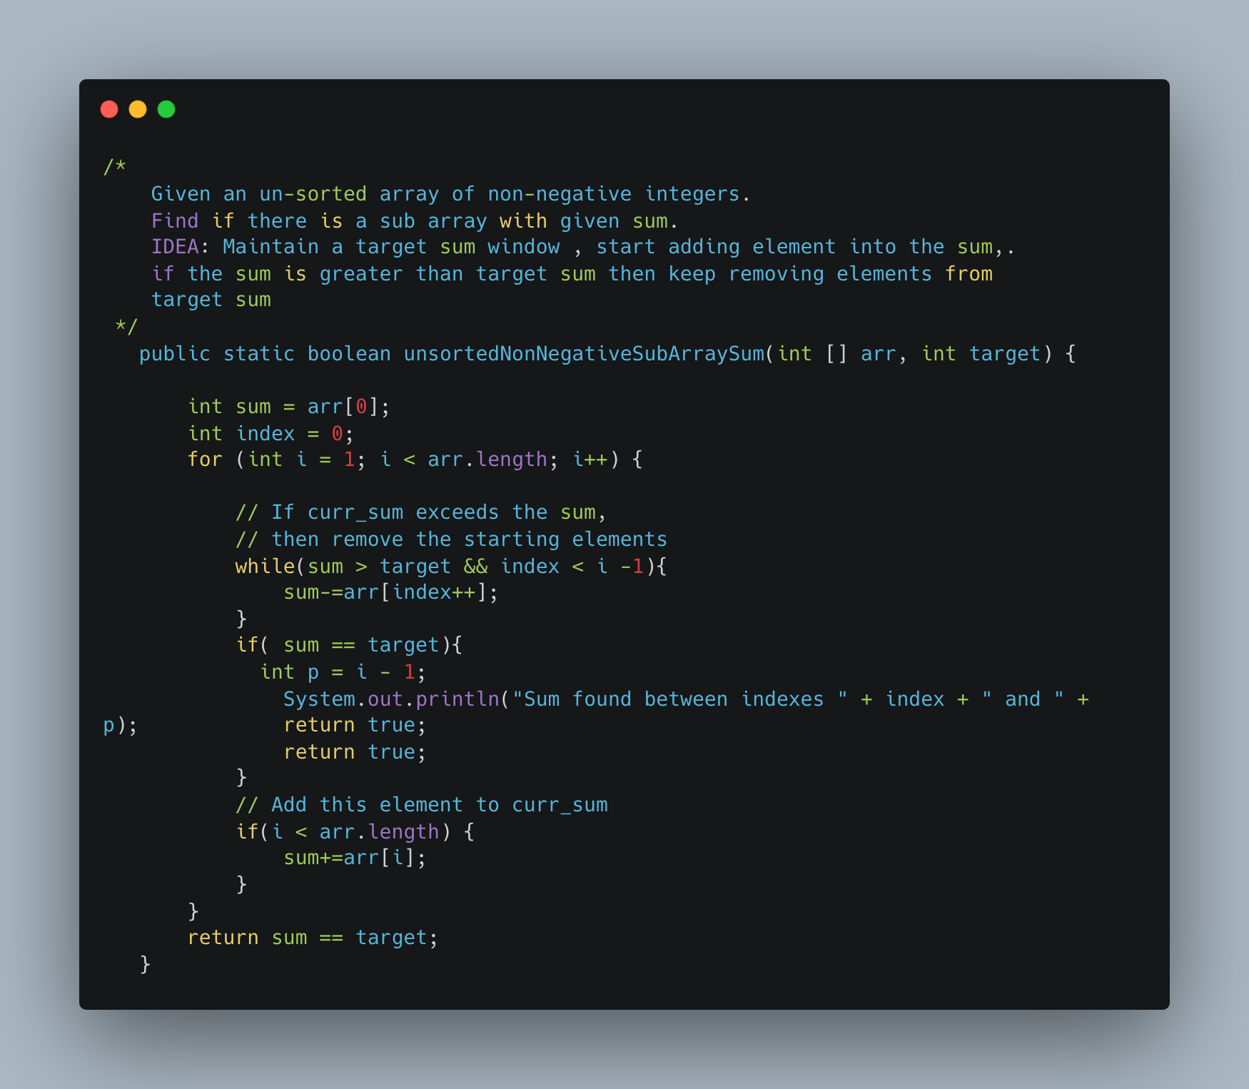

1. [Find Valid Matrix Given Row and Column Sums](https://leetcode.com/problems/find-valid-matrix-given-row-and-column-sums/)

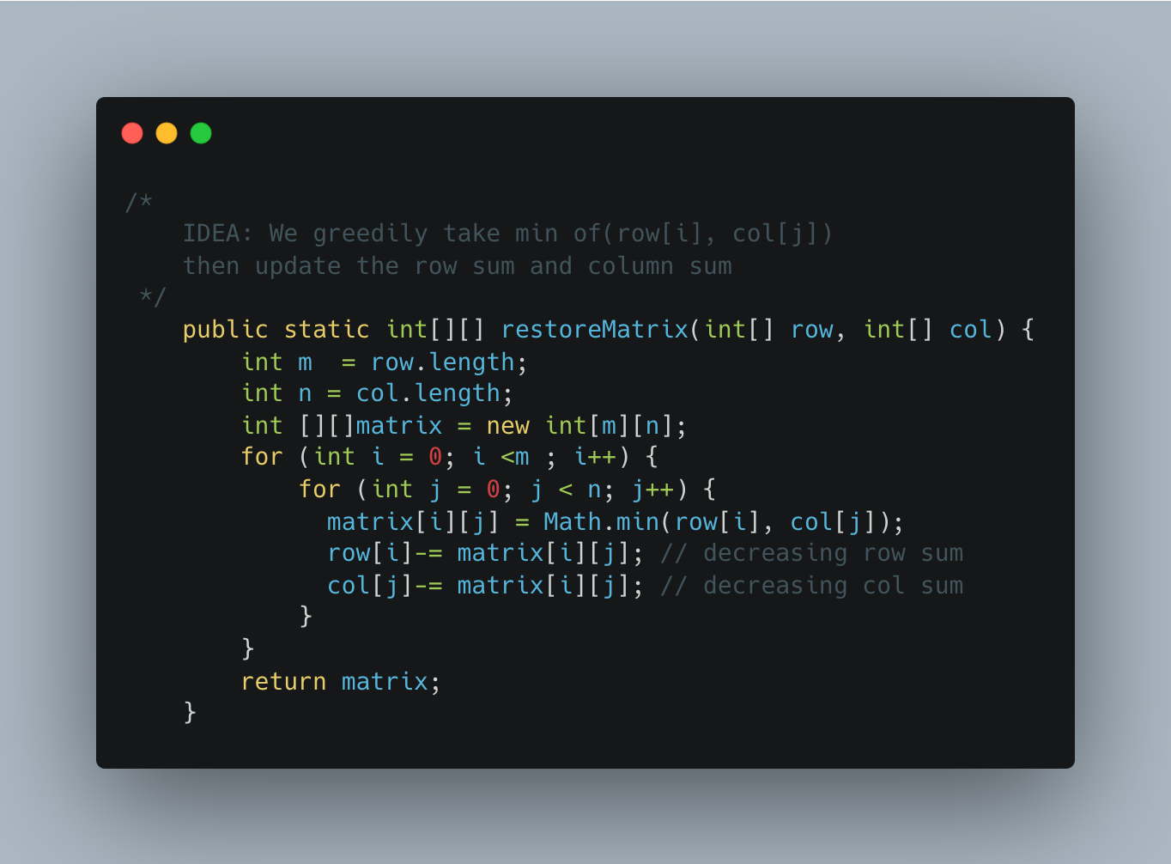

1. [Reorder Data in log Files](https://leetcode.com/problems/reorder-data-in-log-files/)

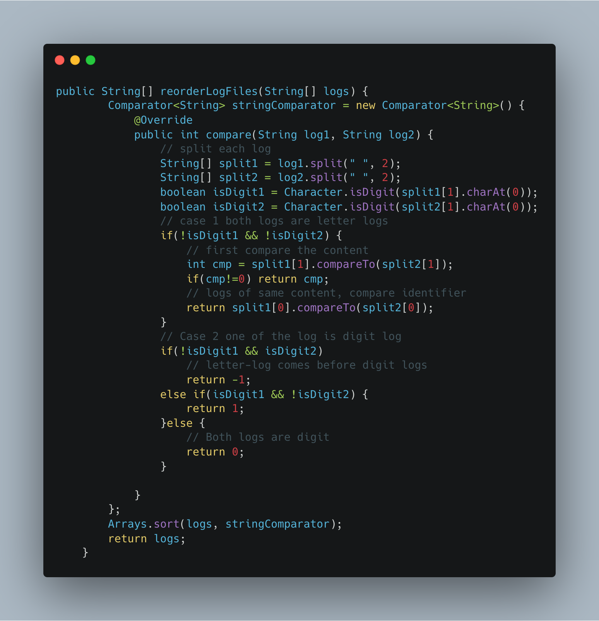

1. [Capacity to Ship Packages Within D Days](https://leetcode.com/problems/capacity-to-ship-packages-within-d-days/)

